CONNECTED CARE – TRANSFER OF CARE NOTIFICATIONS

The Transfer of Care Notifications report helps GP Surgeries identify their registered patients who are currently inpatients or have recently attended A&E.

How to Access

- Login to Connected Care https://connectedcare.uk.com
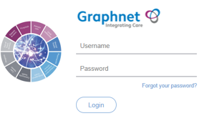

- Go to Dashboards and open Virtual Ward GP View
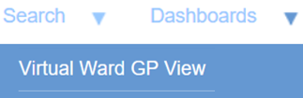

- Click TC Notifications tab
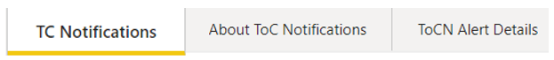

Included in the Report

Live Notifications of Patients who are currently:
- Inpatients at Berkshire Healthcare, Frimley Park, Heatherwood, Royal Berkshire and Wexham Park
- In A&E/ED at Wexham Park and Royal Berkshire Hospitals
And Patients who have recently attended Frimley Park Hospital A&E

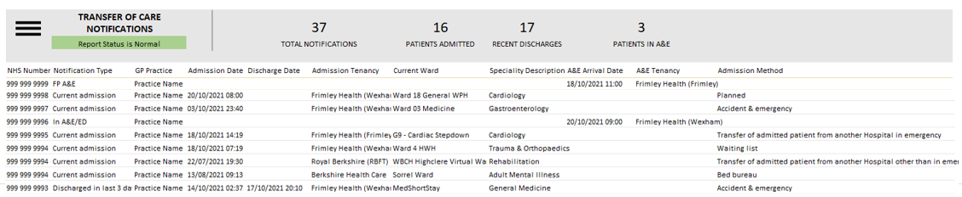

How to Request a Connected Care Account

Please email fhft.connectedcare@nhs.net subject: Connected Care TOCN Logon Request and provide your name, email address, role, and practice name.

More information coming soon

Development work continues with the aim of presenting Live notifications of patients currently In Frimley A&E/ED, we will let you know as soon as this additional information becomes available.

Kind regards
Connected Care Team

