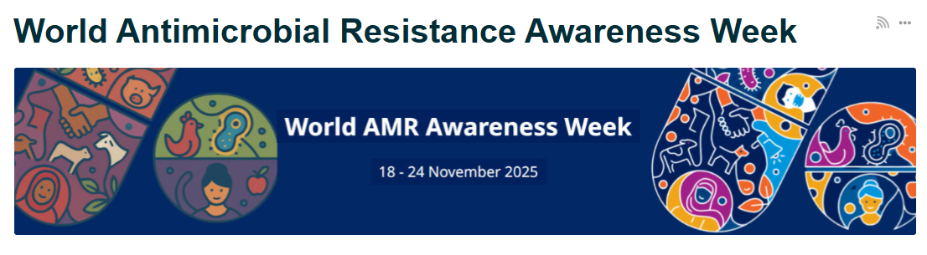
World Antimicrobial Resistance Awareness Week, 18 - 24 November 2025
The 2025 theme, Act Now: Protect Our Present, Secure Our Future, encourages everyone to educate themselves about antimicrobial resistance (AMR), advocate for bold commitments, and take concrete actions to combat AMR. By making informed choices, we can help prevent the spread of antibiotic resistance and protect future health.
In Frimley, a key objective is to deliver TARGET training and reduce our use of antibiotics in children. To book TARGET training email frimleyicb.prescribing@nhs.net . Review your prescribing of antibiotics in children here.
Call to action, what can I do?
Please register for one of the National webinars
- Monday 17th November, 12.30-1.30pm: AMR in Focus: Empowering Health Professionals in the Fight Against AMR
- Wednesday 19th November, 3:00pm - 4:00pm: Seen and not heard – a gut feeling antibiotic use and AMR in children is a secondary consideration
- Monday 24th November, 12:30 - 1:30pm: Optimising the Blood Culture Pathway: Audit Insights and Regional Success Stories
Make an Antibiotic Guardian pledge
Please visit the Antibiotic Guardian website and choose one simple pledge about how you’ll make better use of antibiotics and help save these vital medicines from becoming obsolete: https://antibioticguardian.com/
Please use the PIL resources on Frimley Healthier Together: Safety netting & parent info sheets :: Frimley HealthierTogether and Leaflets to discuss with patients: Self-care Leaflet | RCGP Learning , all available in non-English languages.
Use the National WAAW resources and toolkit
This toolkit aims to provide quick and ready-to-use resources to support local World AMR Awareness Week (WAAW) campaigns. The toolkit is focused on digital messaging to support speed and ease of communication, while including a wide variety of suggestions for engagement with engagement with healthcare professionals, patients and members of the pubic. The toolkit is available here: https://www.gov.uk/government/publications/european-antibiotic-awareness-day-resources-toolkit-for-healthcare-professionals-in-england/world-antimicrobial-awareness-week-waaw-and-european-antibiotic-awareness-day-eaad

