FHFT Emergency Department (ED) discharge summary - notification of streaming to Frimley Park Hospital Urgent Treatment Centre (UTC)
When patients are transferred from Frimley Park Hospital Emergency Department (ED) to the Urgent Treatment Centre (UTC), discharge summaries are issued from both services. The ED discharge summary includes a note under ‘Disposition’ indicating that the patient has been “Streamed to FPH UTC’, as illustrated in the screenshot provided below. This notification informs primary care that the patient attended the ED but was subsequently transferred to the UTC, and that a more detailed discharge summary will be forthcoming from the UTC.
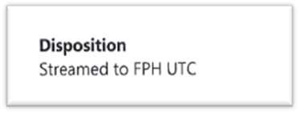
It has come to our attention that several of these discharge summaries have been mistakenly rejected by primary care in Docman, under the assumption that they are duplicate copies. We wish to clarify that these are not duplicates. Therefore, we kindly request that both the ED and UTC discharge summaries be accepted in Docman, unless the patient is no longer registered at the practice. This will ensure the maintenance of a complete record for the patient.
Many thanks for your ongoing support and should you have any further questions relating to this matter please contact our FHFT GP Interface support team: fhft.gpcommunications@nhs.net

