
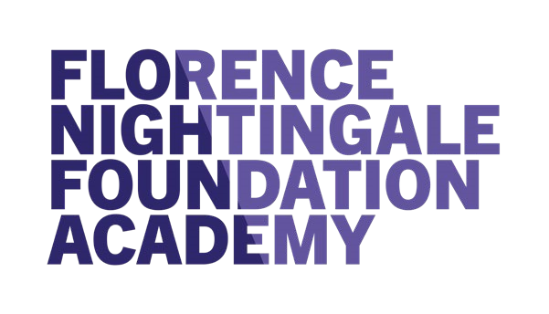
The Florence Nightingale Foundation (FNF) has a renowned reputation across
the UK for our bespoke
leadership training.
Our prestigious programmes are
designed to build confidence, authority and influence in our delegates,
enabling them to contribute to changes in
practice at a local and national level
to improve patient care and health outcomes.
Dates
•
Monday 7
th
November 2022
Live compulsory introductory open session
:
•
Four x 2 hour IPC focused sessions to be completed at your leisure.

Drop in support sessions available
•
Monday 21
st
November 2022
live IPC consolidation session
:
•
Followed by online co consulting action learning sets to
consolidate learning
Eligibility Criteria
•
IPC Champions in England e.g. Health Care support
Workers, Allied Healthcare Professionals
who have an
interest in improving IPC
•
Confirmed support from line manager
To apply please https://forms.office.com/r/4sWc7xYP6z
Closing Date for applications
06
October 2022
Key
components of the programme
•
Good understanding of the fundamentals in IPC
•
Personal leadership style
•
Greater self-presence and personal impact
•
Deeper understanding of the impact of self on others
•
Improved confidence in speaking up
•
Ability to understand and lead improvement
•
Greater awareness of personal approach to leadership
•
Lead with greater presence to improve patient and health outcomes
Infection Prevention & Control (IPC)
Leadership programme for IPC Champions (e.g. Healthcare
Support Workers/Allied Healthcare Professionals. Cohort 3 is
to start in November 2022

