BSPS Business Office - Communications Request Form

PLEASE NOTE THAT ALL COMMS TO BE DISTRIBUTED ON THE SAME DAY, WILL NEED TO BE
RECEIVED BY THE BUSINESS OFFICE BY 2.00 p.m.
Comms request submitted by: | Name: Gemma Brahams
Comms request submitted by: | Job title: Lead Biomedical Scientist
Comms request submitted by: | Email: gemma.brahams@nhs.net
Comms request submitted by: | Telephone: 01932 723049
Comms request submitted by: | Request date: 11/06/2024
Contact for queries:  (this section must be completed, otherwise the Comms request will not be accepted) | Name: Virology
 | Job title:
 | Email: virology.asph@nhs.net
 | Telephone number: 01932 723049
Details of Senior Executives authoring the Comms: | Emails attached  Authorised by:……P Ruwona…………………………… Date: …12/06/2024……....  Authorised by:…N Newman………………………… Date: …12/06/2024……....
Reason for the Comms
Urgency
Comms title | Brief sentence around what the comms relates to  Change in sample type for Virology STI testing – Go Live Confirmed
Information to be communicated | Dear Colleagues  New analytical equipment in Virology, go-live Monday 1st July 2024  We are writing to inform you that the Virology Laboratory will be going live on 1st July with new analytical equipment as part of the Abbott Laboratory Automation Implementation at St Peter’s Hospital. This will have benefits of increasing throughput, enhancing service resilience and simplifying processes with a unified sample type for NAAT identification of sexually transmitted infections (STI).  The following tests are moving onto a new analytical platform:  - Chlamydia trachomatis RNA  - Neisseria gonorrhoea RNA  - Mycoplasma genitallium RNA  This will result in changes for these tests including a NEW sample type. These changes are detailed below and comments will be added to results highlighting the changes. There will be a transition period to allow for the change to sample type for the STI testing whilst the current (Aptima) sample type is replaced. The deadline for this will be requests up to and including Friday 12th July. AFTER THIS DATE, APTIMA TUBES WILL BE REJECTED FOR TESTING.  Change to sample type:  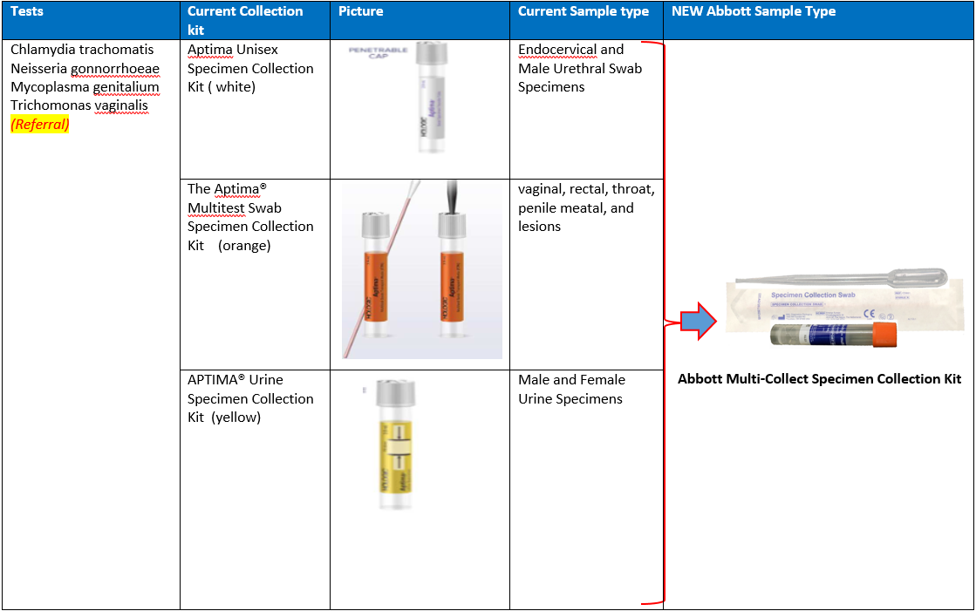  The electronic ordering of these tests will be updated to reflect the change to the sample collection device.  Note that Trichomonas vaginalis can also be requested and tested on the same sample, although it is not performed in house and will be sent to a reference laboratory.  Please order the new Abbott Multi-Collect Specimen Collection kit via the same BSPS ordering system you are currently using. The old collection devices will not be listed. Any issues, please email: fhft.bspshelpline@nhs.net for any queries.  On delivery of the new tubes, BSPS transport are happy to return any unused Hologic swabs to support your transition to the new tube type.  If you have any specific questions regarding the changes or any specific patient pathways that you feel may be impacted, please do not hesitate to contact virology.asph@nhs.net  Kind regards,  Patricia Ruwona Dr Bruce Stewart  BSPS Chief Operating Officer Associate Medical Director BSPS
Target audience for the comms | GPs (ICBs)  (If specific GP Practices/ ICBs, please state)…………………………………………………………  ALL BSPS hospitals                        Specific Internal BSPS hospitals only (please select those that apply)  Ashford Hospital     St. Peter’s Hospital     Frimley Park Hospital Wexham Park Hospital  Royal Surrey County Hospital SASH  Royal Berkshire Hospital  External BSPS Trusts                     MOD only                          All Commercial Clients  Specific recipients only:    (Please state):…………………BHFT……………………………………………………………………

