Early May Bank Holiday Posters - 6 May 2024 - which pharmacies will be open across Southeast England

Please find attached two amended posters.

The amendments on these posters are as follows:
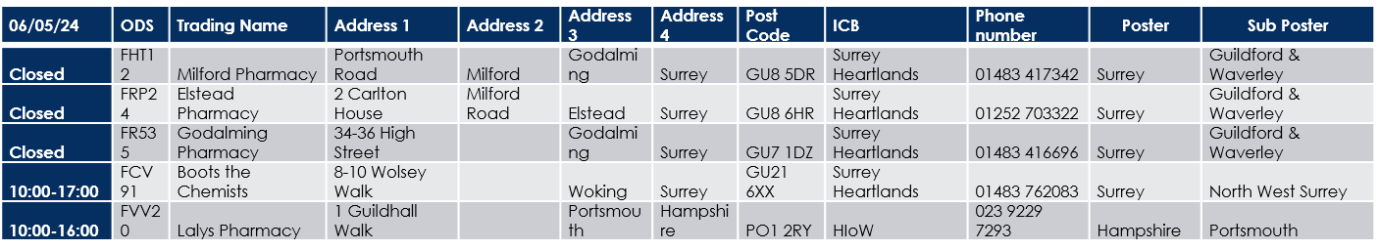
Please find attached two amended posters.
The amendments on these posters are as follows:

