Cntrl + Click to open the links below


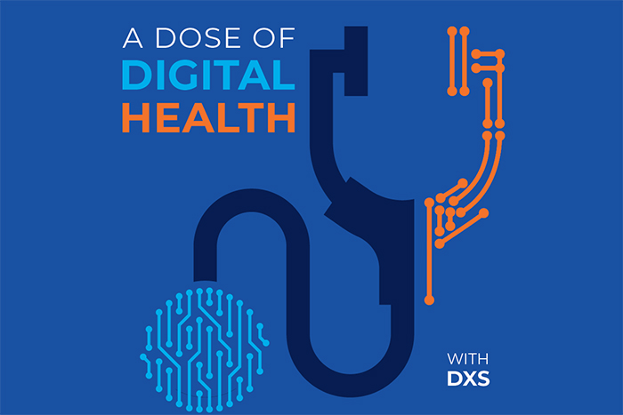

A Dose of Digital Health

Latest Episode: Community Health is an Art, as well as a Science
In our new episode, meet inspirational GP, Priya Kumar, sharing how the unique challenges within her community have led to a focus on improving outcomes via digital health.
Join us for in-depth conversations about digital health solutions and healthcare delivery in our time.

Click on the following links to watch or listen





  DXS Training
  Visit our Training website for Point-of-Care training videos and user guides and more.
  
  DXS News
  Up to date on the latest DXS news? Catch up on all things DXS on our website.
  


Suite 3, 1st Floor, Ash House, Tanshire Park, Shackleford Rd,
Elstead, Godalming, GU8 6LB
 |  | 

HOME | ABOUT | CONTACT

Unsubscribe rose.elhamamy@nhs.net from this list.
Our mailing address is:
Copyright (C) 2024 DXS International Plc All rights reserved.
Forward this email to a friend
Update your profile

