Please do not forward this message to anyone outside your organisation as the information below may not be relevant to them.

Weekly roundup: EMIS-X available for all GP England practices, Searching Patients by NHS Number, Shingles Vaccination Alerts, EMIS Web 9.24.2 and more
Publish Date: 19/04/2024 15:32:01 BST
Hello!
Please find the latest updates from EMIS Web in primary care, including new releases and functionality, upcoming events, guidance and top-tips!
For your information
New:
EMIS-X available for all GP England practices
- EMIS-X is now live for all practices across England. Used alongside EMIS Web, the first features include new staff messaging, Clinical Views, single-sign-on to EMIS Now and RSS Feed
- Get started with user guides on EMIS Now, our EMIS Academy course, or rewatch our EMIS-X Webinar where we take you through all the new functionality and future plans
- Don't forget to verify your email address in EMIS Web to access EMIS-X
- We'll continue to keep you updated as new features and functionality becomes available
Key Enhancement - Searching Patients by NHS Number
- When searching for a patient in Patient Find using their NHS number, the number can now be in any format (including or excluding spaces) and the patient will be returned as expected.
- This allows for the NHS Number to be copied from an external document or location, saving you time as you do not need to edit NHS numbers to bring up your patients.

UPDATE: Incorrect Shingles Vaccination Alerts
- Following on from our previous communications sent Thursday 28th March 2024, tonight (Monday 8th April 2024), we will be releasing a new active Shingles Alert protocol to all GP practices in England. We will also be retiring the previous protocol which caused incorrect shingles alerts.
- The Shingles (herpes zoster) alert v2 can be located within the EMIS Library > EMIS Protocols > Immunisation Protocols.
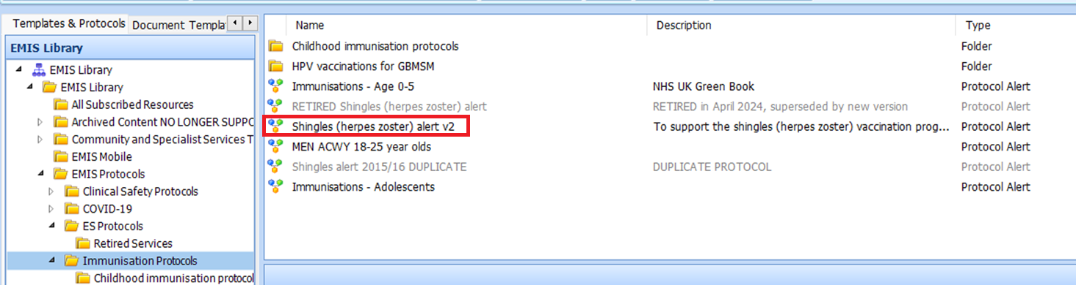
- This new protocol will no longer contain alerts for ‘non-payment’ codes and all possible Shingles vaccination codes have been considered to suppress the alert if already found on eligible patient records.
- We thank you for your patience and apologise for any inconvenience this may have caused.
Reminder:
EMIS Roadshows 2024: Staffordshire, 16th May
- The EMIS Roadshow events are taking place across the country, to give our users an opportunity to learn more about EMIS-X, EMIS Web and what's new in 2024. As well as speak with the EMIS team and network with other local organisations.
- Our next roadshow event is taking place in Staffordshire on Thursday 16th May.
- Register for free here. More dates and locations to be announced.

Subscribing to Service Status’ on EMIS Now
- We use the Service Status page on EMIS Now to keep users informed of significant disruptions to services, as well as planned maintenance and third-party issues which may be impacting our services. If you are affected by an issue, you can easily raise a case with the Service Desk using the 'I'm Affected Too' button.
- You can subscribe to specific Service Statuses to ensure you receive updates via email. Visit the Service Status page and click on the envelope icon next to the relevant category to subscribe.

Are you following our Primary Care Facebook page?
- Follow our EMIS for Primary Care Facebook page where we are sharing highlights of new features, functionalities and releases as well as top tips for users.
- You'll also find details on free training webinars and other customer events.

Release News
EMIS Web 9.24.2.0200 is now in controlled rollout
- EMIS Web 9.24.2 contains an array of enhancements. You can view the full release notes on EMIS Now.
MKB version 209 is now in controlled rollout
- You can view the latest code and drug updates included in this MKB on EMIS Now.

Training
Click below to register for our free EMIS Live sessions:
Date/Time | Session
Wednesday 24 April  13:00 - 14:00 | Shaping the future of health technology with EMIS-X  This session provides an overview of EMIS-X functionality and how it will benefit you and your teams.

Top Tip
- In some circumstances, documents from external organisations using non EMIS Web systems may be sent in relation to patients at your practice.
- You may want to import this information to carry out tasks such as batch coding and sending mail merges to these patients.
- You can import a list of these patients when the results are saved locally (as a .txt file) and contain the patient's NHS numbers.
- To import the patient list, navigate to the EMIS Ball > Reporting > Population Reporting > Add > Patient > List of Patients > Import > choose required document > Open

Keep Updated
- Keep up to date with the latest EMIS Web Hardware/Software requirements as well as EMIS Web Performance and Housekeeping Advice on EMIS Now.
- View all the latest communications you have received in the ‘My News’ tab on EMIS Now.
- Check the RSS Feed in EMIS Web for latest news. Hit the refresh icon to make sure you're receiving the latest updates throughout the day.
- Subscribe to notifications on the Service Status page on EMIS Now to keep informed of any service interruptions.
- View the GP Practice Handbook to find out how you can contact our Service Desk, manage your cases and access training materials.
Thanks,
EMIS


