National MMR Call and Recall UPDATE

- Coding of vaccine events
The source data for national call and recall is the general practice record. MMR vaccine event data is extracted from general practice records by GPIT suppliers in accordance with a national MMR data extract specification.

For records to be extracted successfully, they must be coded properly so that they can be mapped to the codes within the national extract specification.

General practices identifying an uncoded vaccine event must resolve this as soon as reasonably practical. To do so, the vaccine event must be coded using a current, valid SNOMED code. The steps to achieve this are set out below and guidance on how to find the relevant SNOMED codes is appended at the end of this document.

Practices should be aware that applying codes to previously uncoded records may create duplicate or erroneous payment claims if not done correctly. This scenario might arise where the practice has already claimed payment for the vaccination but did not code it at the time, or where a patient has moved in from overseas, or historical notes have been scanned into the record but not previously coded.

Practices do not being asked to re-code retrospectively any vaccine events that are already coded.

- Instruction for actioning retrospective coding of an MMR vaccine event without triggering an item of service fee

  - Vaccinations administered by the general practice where an item of service payment has already been claimed

- Backdate the event date of the vaccination SNOMED code to reflect the correct date when the vaccination was given
- Set the GMS flag to ‘No’ (for EMIS and Cegedim practices) or the ‘Event done’ flag to ‘No’ (for TPP practices)*
- Add free text associated with the vaccination SNOMED code to note the date the vaccine was given and where.

* The purpose of the GMS flag is to denote when an activity was delivered in fulfilment of the practice’s GMS (applies also to PMS and APMS) contract (GMS=True), or delivered by the practice outside of the GMS contract, or delivered by another healthcare provider (GMS=False). TPP does not have a GMS flag, but offers similar functionality in the form of an ‘Event done’ flag which, if set to ‘False/No’, denotes that the practice did not deliver the activity. Applying this flag will prevent a second item of service claim going through when a claim has already been made.

  - Vaccinations not administered by the practice which should not attract and item of service payment:

- Backdate the event date of the vaccination SNOMED code to reflect when the vaccination was delivered.
- Set the GMS flag to ‘No’ (for EMIS and Cegedim practices) or the ‘Event done’ flag to ‘No’ (for TPP practices)*
- If the vaccination is for MMR or Shingles, use the “MMR vaccination given by other healthcare provider” or “Shingles vaccination given by other healthcare provider” SNOMED code.**
- Add free text associated with the vaccination SNOMED code to note the date the vaccine was given and where.

* As above, the purpose of the GMS flag is to denote when an activity was delivered in fulfilment of the practice’s GMS (inclusive of PMS and APMS) contract (GMS=True), or either delivered by the practice outside the GMS contract or delivered by another healthcare provider (GMS=False). TPP does not have a GMS flag, but offers analogous functionality in the form of an ‘Event done’ flag which, if set to False/No, denotes that the practice did not deliver the activity.
** ‘Vaccination given by other healthcare provider’ SNOMED codes exist for a limited number of vaccines. MMR and Shingles are the only vaccinations in QOF with a ‘vaccination given by other healthcare provider’ code available.
- Notes on overseas vaccination history, vaccinations delivered in other settings
When a patient or their representative reports that a vaccination has been delivered overseas or in another setting, individual clinicians should exercise their judgement to determine that a vaccination has been given and to record it in the patient record. The Green Book states, “If children and adults coming to the UK do not have a documented or reliable verbal history of immunisation, they should be assumed to be unimmunised and a full course of required immunisations should be planned.” Patients arriving from overseas with a “documented or reliable verbal history of immunisation” can be assumed to be immunised and recorded as such in the GP patient record – though in the case of reliable verbal histories, it may not be possible to record the batch number or exact vaccination date.
- Current and valid SNOMED codes
Current MMR SNOMED codes in use to support payment are available at Primary Care Refset Portal
To find the cluster content, select ‘Open the Primary Care Domain Reference Set Portal’, select ‘PCD refsets’ in the Navigate box, then select ‘Measles, mumps and rubella (MMR)’ from the ‘Ruleset’ dropdown menu.

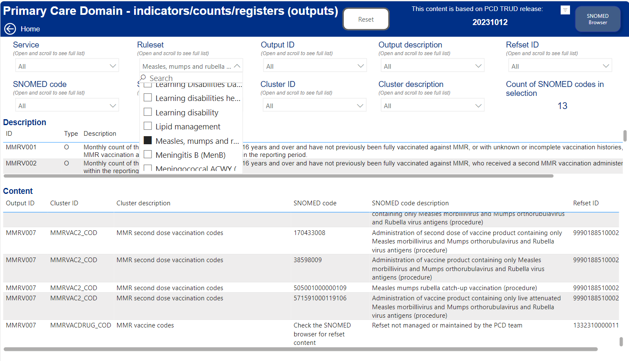

This gives you the content of the PCD clusters/refsets – but not the MMR drug codes
The current content of MMRVACDRUG_COD can be found by searching the SNOMED CT Browser for its refset number: 133231000001105, then click the green search mode button, then select one of the ‘Enhanced Services general practice extraction’ optinos and select the ‘Members’ tab on the right-hand side.

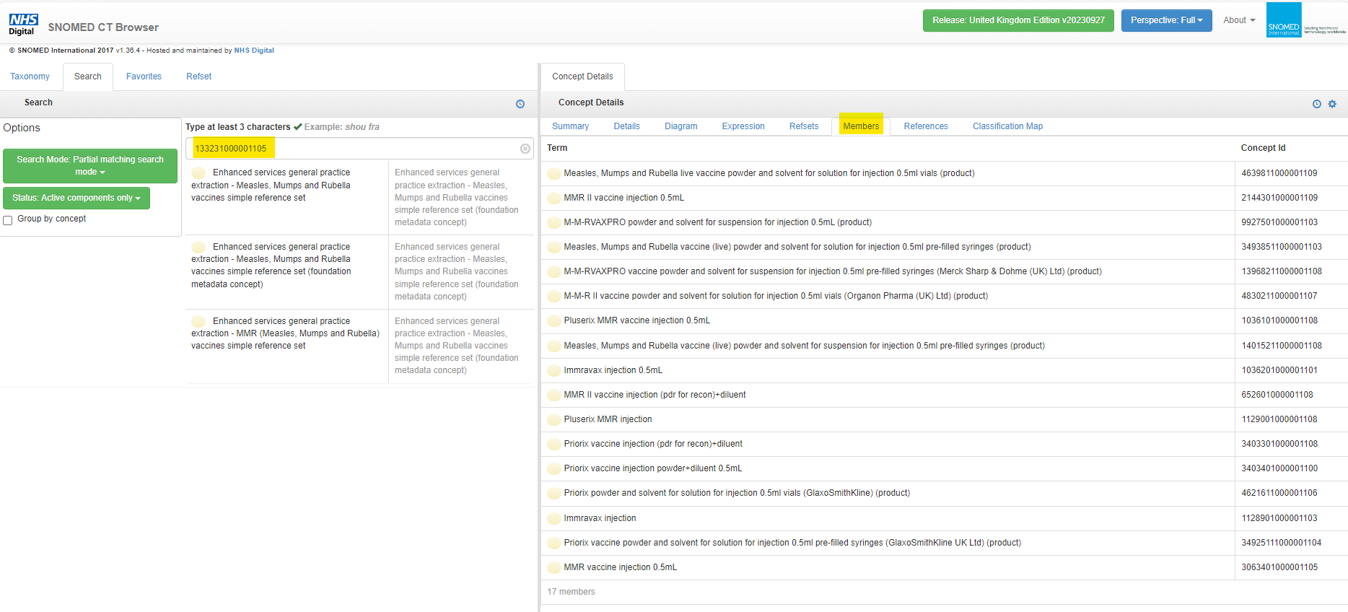

Please note, there is a direct link from the PCD Refset Portal to the SNOMED browser at the top right hand of the page, so the MMRVACDRUG_COD refset ID above can be copied and searched.

