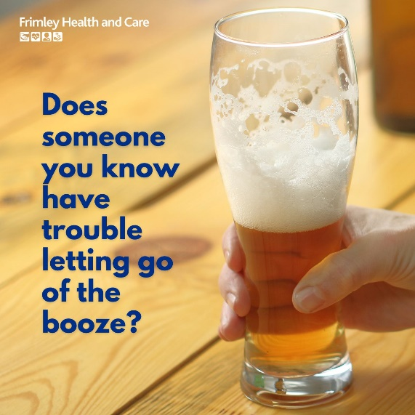
New resources have been created to support partners in raising awareness around the dangers of alcohol.
This is in recognition of the contributory role alcohol plays in many chronic health conditions and deaths and the increase in the incidence of alcohol-related serious illness.
We hope that by raising awareness among the wider population we can reach not only the drinkers but also those around them who often don’t know what they can do to help.
An Alcohol Awareness section has been added to the Frimley Health and Care website to support both heavy drinkers and those around them to identify and tackle the problem they face.
In addition, a press release has been issued and social media resources have been produced, which will be used in the coming weeks and months to highlight the issue. These materials are all available here, should you want to use them for your own websites and channels.
People with alcohol dependence may be the last to realise – or may be in denial – and that’s why we’re using some of the materials to catch the attention of the families and friends of drinkers. We want them to know what to look out for and also for them to understand that there are things they can do to help.
The new web pages include information on what alcohol is, what it does to your body and your mind, links to tools you can use to work out where you stand with alcohol and links to local and national support and advice.

