- The space between the Menu at the top and the search bare to be corrected. If we can move it to a space that works that’ll be great

- Please make the map image on the Home page large so you can see text in the image better

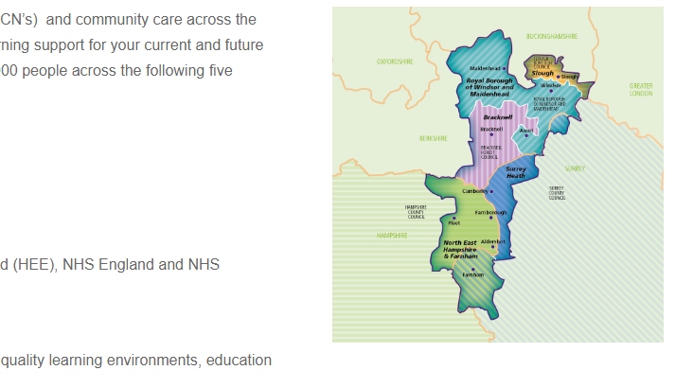
- Youtube video below to be removed. There will be another video in place that I will attach below:
Functional Skills information for primary care - YouTube
Apprenticeships in Primary Care – Thames Valley - YouTube

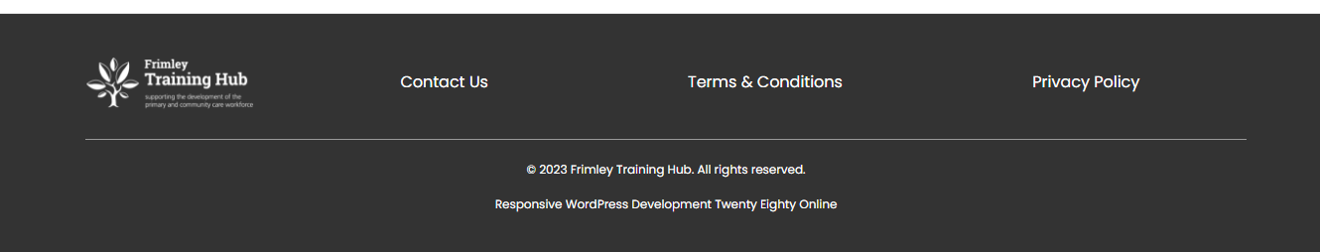
- Right at the bottom please add the information of the training hub. I will attach below:

Contact Us – Redirect to Contact us Page on home page Menu
Terms and Conditions Page Text (Just copy and paste the text below) - Welcome to our website. If you continue to browse and use this website, you are agreeing to comply with and be bound by the following terms and conditions of use, which together with our privacy policy govern the Frimley Training Hub relationship with you in relation to this website. If you disagree with any part of these terms and conditions, please do not use our website.
The term ‘Frimley Training Hub’ or ‘us’ or ‘we’ refers to the owner of the website whose office address is Aldershot Centre For Health, Hospital Hill, Aldershot, Hants GU11 1AY. The term ‘you’ refers to the user or viewer of our website.
The use of this website is subject to the following terms of use:
- The content of the pages of this website is for your general information and use only. It is subject to change without notice.
- This website uses cookies to better the users experience while visiting the website.
- Neither we nor any third parties provide any warranty or guarantee as to the accuracy, timeliness, performance, completeness or suitability of the information and materials found or offered on this website for any particular purpose. You acknowledge that such information and materials may contain inaccuracies or errors and we expressly exclude liability for any such inaccuracies or errors to the fullest extent permitted by law.
- Your use of any information or materials on this website is entirely at your own risk, for which we shall not be liable. It shall be your own responsibility to ensure that any products, services or information available through this website meet your specific requirements.
- This website contains material which is owned by or licensed to us. This material includes, but is not limited to, the design, layout, look, appearance and graphics. Reproduction is prohibited other than in accordance with the copyright notice, which forms part of these terms and conditions.
- All trademarks reproduced in this website, which are not the property of, or licensed to the operator, are acknowledged on the website.
- Unauthorised use of this website may give rise to a claim for damages and/or be a criminal offence.
- From time to time, this website may also include links to other websites. These links are provided for your convenience to provide further information. They do not signify that we endorse the website(s). We have no responsibility for the content of the linked website(s).
- Your use of this website and any dispute arising out of such use of the website is subject to the laws of England, Northern Ireland, Scotland and Wales.
- Your details are not passed on to any third parties.

Privacy Policy - The policy: (Just copy and paste the text below)
This privacy policy notice is for this website; https://frimleytraininghub.co.uk/ and served by Frimley Training Hub hosted by OxFed Health & Care Ltd Northway Community Centre (2nd Floor), Dora Carr Close, Oxford, OX3 9RF and governs the privacy of those who use it. The purpose of this policy is to explain to you how we control, process, handle and protect your personal information while browsing or using this website, including your rights under current laws and regulations. If you do not agree to the following policy you may wish to cease viewing / using this website.
Policy key definitions:
- “I”, “our”, “us”, or “we” refers to the Frimley Training Hub
- “you”, “the user” refer to the person(s) using this website.
- GDPR means General Data Protection Act.
- PECR means Privacy & Electronic Communications Regulation.
- ICO means Information Commissioner’s Office.
- Cookies mean small files stored on a users computer or device.
Processing of your personal data
Under the GDPR (General Data Protection Regulation) we control and / or process any personal information about you electronically using the following lawful bases.
- We are registered with the ICO under the Data Protection Register.
- Lawful basis: Consent
The reason we use this basis: The Frimley Training Hub requires your consent in order to be able to process your information and book you on to a training programme, event or meeting.
We process your information in the following ways: The website collects basic personal information about you including name, email address, job title. We also ask for some sensitive information such as dietary and access requirements. This is to ensure that your needs are taken into account so that suitable measures are put in place to make the training, event or meeting meet your requirements.
Data retention period: We will continue to process your information under this basis until you withdraw consent or for a period of 4 months after the training/event/meeting series completes.
Sharing your information: We do not share your information with third parties.
If, as determined by us, the lawful basis upon which we process your personal information changes, we will notify you about the change and any new lawful basis to be used if required. We shall stop processing your personal information if the lawful basis used is no longer relevant.
Your individual rights
Under the GDPR your rights are as follows. You can read more about your rights in details here;
- the right to be informed;
- the right of access;
- the right to rectification;
- the right to erasure;
- the right to restrict processing;
- the right to data portability;
- the right to object; and
- the right not to be subject to automated decision-making including profiling.
You also have the right to complain to the ICO [www.ico.org.uk] if you feel there is a problem with the way we are handling your data.
We handle subject access requests in accordance with the GDPR.
Internet cookies
Cookies are small text files that are placed on your computer by websites that you visit. They are widely used in order to make websites work, or work more efficiently, as well as to provide information to the owners of the site. Unless you have set your browser to block cookies, this site will place the following cookies on your computer.
Most web browsers allow some control of most cookies through the browser settings. To find out more about cookies, including how to see what cookies have been set and how to manage and delete them, visit www.aboutcookies.org.
We store cookies relating Google Analytics and WordPress – To find out more about them, see the following links:
https://codex.wordpress.org/WordPress_Cookies
https://developers.google.com/analytics/devguides/collection/analyticsjs/cookie-usage
Data security and protection
We ensure the security of any personal information we hold by using secure data storage technologies and precise procedures in how we store, access and manage that information. Our methods meet the GDPR compliance requirement.
Transparent Privacy Explanations
We have provided some further explanations about user privacy and the way we use this website to help promote a transparent and honest user privacy methodology.
Sponsored links, affiliate tracking & commissions
Clickable affiliate links may be displayed as a website URL like this; https://www.northeasthampshireandfarnhamccg.nhs.uk/ or as a titled text link like this: North East Hampshire & Farnham Clinical Commissioning Group.
Clicking on any affiliate links may track your actions by using a cookie saved to your device. You can read more about cookies on this website above. Your actions are usually recorded as a referral from our website by this cookie.
If you have any concerns about this we suggest you do not click on any affiliate links found throughout the website.
Email marketing messages & subscription
Under the GDPR we use the consent lawful basis for anyone subscribing to our newsletter or marketing mailing list. We only collect certain data about you, as detailed in the “Processing of your personal date” above. Any email marketing messages we send are done so through AcyMailing.
Email marketing messages that we send may contain tracking beacons / tracked clickable links or similar server technologies in order to track subscriber activity within email marketing messages. Where used, such marketing messages may record a range of data such as; times, dates, I.P addresses, opens, clicks, forwards, geographic and demographic data. Such data, within its limitations will show the activity each subscriber made for that email campaign.
Any email marketing messages we send are in accordance with the GDPR and the PECR. We provide you with an easy method to withdraw your consent (unsubscribe) or manage your preferences / the information we hold about you at any time. See any marketing messages for instructions on how to unsubscribe or manage your preferences, you can also unsubscribe from all MailChimp lists,.
Our EMS provider is; AcyMailing We hold the following information about you within our EMS system;
- Email address
- I.P address
- Subscription time & date
- Areas of interest
Resources & further information
- Overview of the GDPR – General Data Protection Regulation
- Data Protection Act 1998
- Privacy and Electronic Communications Regulations 2003
- The Guide to the PECR 2003
- Google Privacy Policy
- Mailchimp Privacy Policy
Privacy Notice Policy Base: V.1.0

- On the Contact US page if you could change the text and keep the form already on there. In the form they can add their first and last name, email, practice or organisation, role, subject and query. Social media links can be attached on this page also with just the symbols, I believe you have the links I sent previously. Please add social media links/symbols to the left black space in the same colour as ‘We’d love to hear from you’
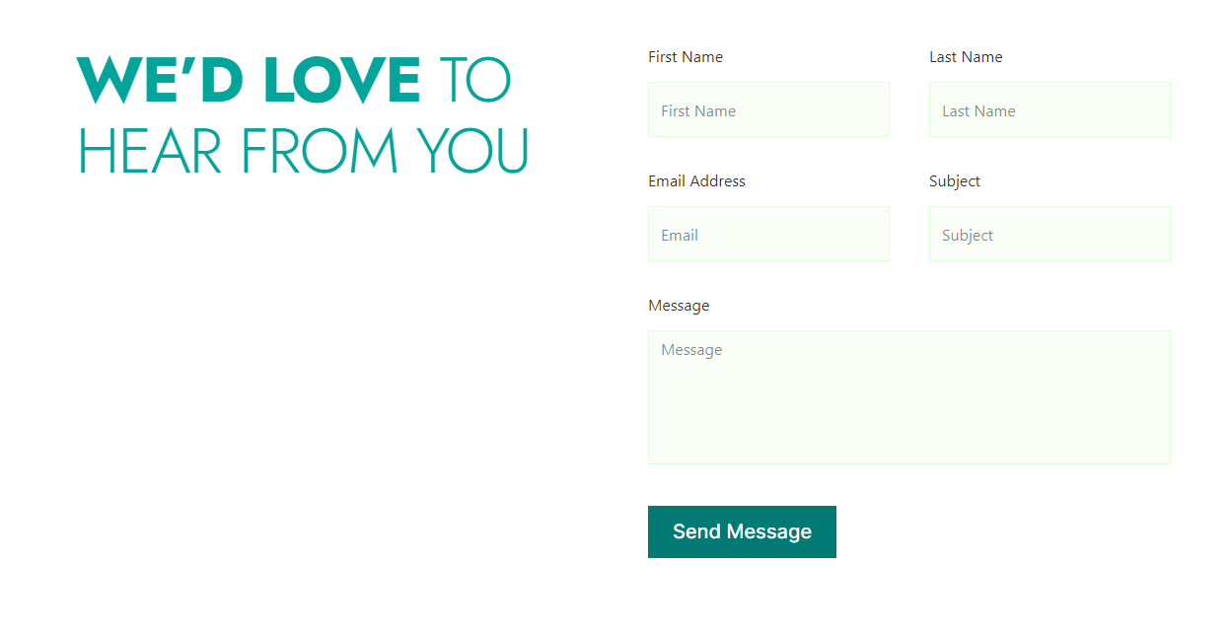
- Please add this image for the Contact Us Page

- Training and events page – please make it clear the search symbol is there to search for events by adding a text bar for the search and making the symbol slightly larger. Under the text at the top please add ‘To search for a specific event please search below’
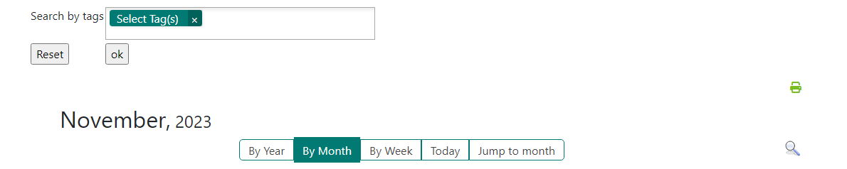

- On the training calendar please add the hyperlink where it says ‘Click here to register or login’
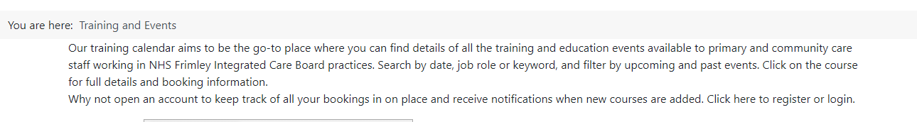
- Please add these pictures to the Home page for the carousel feature and check feature is moving every few seconds


This would be the first picture, order doesn’t matter for the other images.


- Erase the Students Page – Content will be added eventually.

- So for the ACYMAILING – to connect our email you’ve requested for the training hub outlook login details:

Frimley.traininghub@nhs.net
Password: EducationPrimaryCare2023!

