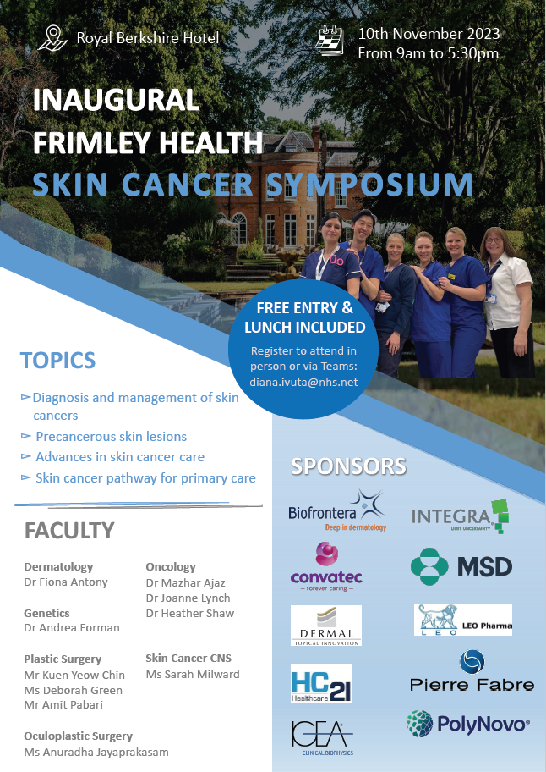

1st Frimley Health Skin Cancer Symposium 2023
Friday 10th November 2023 - Royal Berkshire Hotel, Ascot
We would like to invite you to the first skin cancer meeting this year for updates on treatment and an opportunity to meet the Consultants and staff.

Programme
08.30 - Arrival, coffee, Registrations
09:00 - Introduction (Mr Kuen Y Chin) and Welcome speech by Chief Executive Neil Dardis
09.15 - Diagnosis and management of non-melanoma skin cancer (Mr Amit Pabari)
09.45 - Diagnosis and management of pigmented lesions and melanoma (Ms Deborah Green)
10.15 - Management of actinic keratosis (Dr Chun Man Lee)
10.45 - Skin cancer referral pathway
11.00 - Coffee break
11.15 - Surgical management of skin cancer (Mr Kuen Y Chin)
11.45 - Diagnosis and management of periocular skin cancer (Ms Anuradha Jayaprakasam)
12.15 - Lunch
13:15 - Role of nurse practitioner in skin cancer care (Mrs Sarah Milward)
14:15 - Dermatological Findings in Cancer Predisposition Syndromes- (Dr Andrea Forman)
15:15 - Radiotherapy in skin cancer (Dr Joanne Lynch)
15.45 - Break
16:00 - Advanced skin cancer- big antibodies and small molecules (Dr Heather Shaw)
16:30 - Special situations in Melanoma (Dr Ajaz Mazhar)
17.00 - Q&A
17:30 - Close

