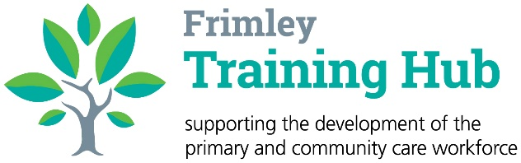
NB Medical Spring Webinars

We are pleased to let you know that bookings are now open for our Spring Primary Care NB Medical Hot Topic Live Webinars:

- Saturday 11th March – Diabetes (access code: FRIM-1103)
- Saturday 15th April – Mental Health (access code: FRIM-1504)
- Saturday 20th May – Cancer (access code: FRIM-2005)

These fully funded courses are open to GPs, GP Trainees, Nurse Practitioners and any other clinicians with a specialist interest in topic areas working across the Frimley ICB footprint.

For more information or to book your space
visit www.nbmedical.com/bespoke/access
and quote the relevant access code above.

