

Epic Electronic Patient Record coming to Frimley Health Update - June 2022

On 11 June 2022 we will be going live with our new Epic Electronic Patient Record (EPR) system, an ambitious programme to transform patient care across all our hospital and community sites.
Having all the information about our patients in one place is an important part of our improvement strategy. Epic will replace over 200 digital and paper-based systems and will hold a complete record for every patient.
We are now close to go live and we would like to ensure that you are up to date with the key information on what Epic means for Primary Care, including what changes it will bring.

What does Epic mean for Primary Care?
As a primary care clinician, referrals processes and requests to Frimley Health will remain largely unchanged. You will continue to receive clinical documentation through the same channels as described below However, the clinical documentation you receive from us will change significantly, though it will continue to adhere to Professional Record Standards Body (PRSB) standards as appropriate.
This guide makes references to ‘Frimley North’ meaning Wexham Park-facing GP practices, and ‘Frimley South’ meaning Frimley Park-facing GP practices.

- Changes to ICE
Once Epic goes live, ICE will only be used as an ordercomms solution for Pathology and Radiology. It will no longer be used for referrals/information management (currently available for some services in Frimley North).

The table below provides an overview of the timeline of the upgrades for ICE:
Practice location | Access | Dec-21 | Jan-22 | Feb-22 | Mar-22 | Apr-22 |  | May-22 | Jun-22 |  | Jul-22 | Aug-22 | Sep-22 | Oct-22 | Nov-22 | Dec-22 | Jan-23 | Feb-23 | Mar-23 | Apr-23 | May-23 | Jun-23 | Q3
Frimley South – FPH ICE facing practices | Radiology ICE access | Currently radiology orders are requested manually (except 3 practices) |  |  |  |  |  |  |  | Will use Wexham ICE from Epic go live of 11 June |  |  |  |  |  |  |  |  |  |  |  |  | Migration to Universal ICE (v8.3) TBC
Frimley South – FPH ICE facing practices | Pathology ICE access | Remain on Surrey ICE instance – currently on v6.3 |  |  |  |  |  |  |  |  |  |  |  |  |  |  |  |  |  |  |  |  | Migration to Universal ICE (v8.3) TBC
Frimley North – WPH ICE facing practices | Radiology ICE access | Will remain on Wexham ICE (currently v6.2.0) until 16 April |  |  |  |  | Will remain on Wexham ICE (upgraded to v6.2.3) on 16 April |  |  |  |  |  |  |  |  |  |  |  |  |  |  |  | Migration to Universal ICE (v8.3) TBC
Frimley North – WPH ICE facing practices | Pathology ICE access |  |  |  |  |  |  |  |  |  |  |  |  |  |  |  |  |  |  |  |  |  | Migration to Universal ICE (v8.3) TBC
ICS system wide | Epic Care Link (GPs view of Epic) |  |  |  |  |  |  |  |  | Epic goes live on 11 June (including the Epic Radiant module)  GPs will continue to use ICE (above), ICE will send radiology orders to Epic and then results back to ICE for GPs  EpicCare Link (GP view of Epic system) will be available to practices that register. |  |  |  |  |  |  |  |  |  |  |  |  | Migration to Universal ICE (v8.3) TBC
ICS system wide | Rad-Alert | *Currently in business case development phase (interim process in place via generic email addresses – see drafted SOP)
ICS system wide | I-refer | *i-refer (radiology decision support tool) feasible with v7 or v8

1.1 Pathology and ICE
Pathology will continue to be ordered through ICE with results being returned via ​ICE into GP Practice systems.

1.2 Radiology and ICE
- Radiology requests will be via a single (upgraded) version of ICE in both Frimley North and South (as shown in the table above).
- For Frimley South - practices can make Radiology requests through ICE, you will no longer use paper requesting for Radiology. Your practice will receive new staff codes for Wexham Park ICE requesting.
- Frimley North practices will continue to log in as usual for requesting Radiology.
- The upgraded version of ICE will have a more comprehensive catalogue (see example of the changes below).
- To allow ICE Radiology requests to be compatible with Epic, some rules / alerts have been simplified within ICE. It is therefore even more important that Primary care are familiar with referral criteria e.g., for U/S and X-ray, prior to requesting. These referral criteria can be found on DXS under the Radiology Frimley Health folder and on the relevant DXS speciality pages. There are also limited scenario’s where MRI/CT would be approved (see Radiology DXS landing page).
- For appointed procedures (e.g., ultrasound) you will need to indicate which hospital site you/patient prefers the test to be done.
- Radiology results will continue to be reported via ICE into practice systems e.g., EMIS, therefore it is vital that all practices set up the new trading partner code This needs to be completed in advance of the EPIC go-live on June 11, 2022. The risk to this task not being carried out will prevent Radiology reports being returned to your practice system. Please follow the link for practice instructions on how to do this. To find instructions on how to do this please go to: https://www.fhft.nhs.uk/gps/gp-centre/epic-epr-at-frimley-health/
- Help and Support ICE/Radiology Ordercomms during Epic Go Live. If GPs experience any ICE related issues for Radiology order comms during the Epic go live period, please e-mail fhft.iceepicsupport@nhs.net, which will be monitored by BSPS / Frimley-Epic team from 9-5 Monday to Friday. If urgent, please call BSPS: on 0300 613 3600.

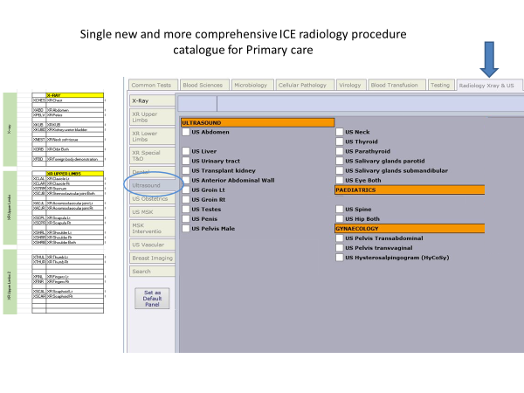

1.3 ICE Referrals - Frimley North GPs only

From 11 June the referrals functionality in ICE will no longer be available
The table below shows the service route closing on ICE and the alternative route to access these services e.g., via a new email address or eRS service. For those services highlighted in green, we would encourage you to start using these services with immediate effect (rather than ICE).

Speciality | Service route closing on ICE | Alternative route to contacting Service - to use from the 11th of June (or sooner if showing in green) | New Service Route Opening Date
ENT | Nasal Fracture & ENT SHO Emergency Clinic | fhft.entemergency@nhs.net | Live from 11th June
Gynaecology | EPU & Gynae Emergency Clinic | fhft.earlypregnancyandugccwph@nhs.net  GPs can also call 0300 615 4429. Please note, the phone line is managed by the clinical team so it may not be answered straight away. For further service details click on link: https://www.fhft.nhs.uk/gps/gp-centre/sdec-including-ambulatory-care/ | Live from 11th June
Cardiology | GP Cardiology Diagnostic Request | To come in via the Cardiology RAS Triage service | Live Now
Cardiology | Rapid Access Syncope | Service on eRS - Rapid Access Syncope Triage Service | Live from 11th June
Respiratory | AIRS (Adult Integrated Respiratory Service) | Service on eRS - Respiratory Medicine Adult Integrated Resp (AIR) Triage | Live Now
Respiratory | Tuberculosis Clinic Referrals | Service on eRS - Tuberculosis Triage Service | Live Now
Occupational Therapy | OT Rheumatology/ Hands - OP | Service on eRS - Hand Therapy Triage Service | Live Now
Physiotherapy (Adult)  Physiotherapy (Adult) | Physio- OP Amputee's | Service on eRS- Physiotherapy - Triage Service | Live Now
Physiotherapy (Adult)  Physiotherapy (Adult) | Physio Walking Aid Referral | Service on eRS- Physiotherapy - Triage Service | Live Now
Physiotherapy (Adult)  Physiotherapy (Adult) | Physio MSK (Adult) | Service on eRS- Physiotherapy - Triage Service | Live Now
Physiotherapy (Adult)  Physiotherapy (Adult) | Physio Neuro (Adult) | Service on eRS - Physiotherapy - Neurological Triage | Live Now
Physiotherapy (Adult)  Physiotherapy (Adult) | Physio Obstetrics | Service on eRS - Pelvic Health (Obstetric/Urogynae/Colorectal) Triage service | Live Now
Physiotherapy (Adult)  Physiotherapy (Adult) | Physio  Uro-Gynae | Service on eRS - Pelvic Health (Obstetric/Urogynae/Colorectal) Triage service | Live Now
Physiotherapy (Paediatrics) | Physio MSK (Paediatric) | Service on eRS - Physiotherapy - Paediatric Triage | Live Now
Other
Death Notifications* | All Departments | GP notification of death letter built within Epic. Once completed the letter will be sent via docman to the appropriate GP recipient. * | Live from 11th June
Acute Kidney Injury | Not a Referral only link to advice | This is not a referral; it was advice for GPs on how to support AKI’s - A&G is available for Nephrology on eRS & guidance will be added to DXS / FHFT GP Centre. | New location of guidance to follow
* Frimley South practices currently receive death notifications via email. In line with the new Frimley North process, they will also receive death notifications through this new form on Epic that will be sent to practices via Docman.

- Referrals (and Advice and Guidance)
Please continue to refer via the usual routes which are predominately via eRS. If you are unsure, please see information on the FHFT GP Centre Referrals & key contacts | NHS Frimley Health Foundation Trust (fhft.nhs.uk) or email: fhft.gpcommunications@nhs.net.

2.1 Services on eRS
In preparation for Epic, the existing eRS CAS (Clinical Assessment Services) will be moving to eRS RAS (Referral Assessment Services). This means you will no longer need to book your patients into fictitious appointments, you will just need to select ‘Send for Triage’ on the selected triage service which we hope is positive news for everyone. We will communicate these changes via the usual channels: GP Bulletin/ICS Referral Management Teams Channel.

2.3 Triaging and the booking of patient’s appointments
Currently when a GP refers via eRS the referral is triaged by clinicians in the service location i.e., Wexham or Frimley. When Epic goes live all referrals for a particular speciality will be grouped into one triage work queue. This means that patients will have access to appointments at all our Frimley Health sites for that service (providing appointments are available). Patients will be assigned predominantly by their location, but they may be offered (and can choose) to travel further e.g., for a shorter wait.

- Discharge summaries and outpatient letters
Discharge summaries and outpatient letters will be generated in Epic and will be PRSB compliant. They will continue to be delivered to GPs via Docman.
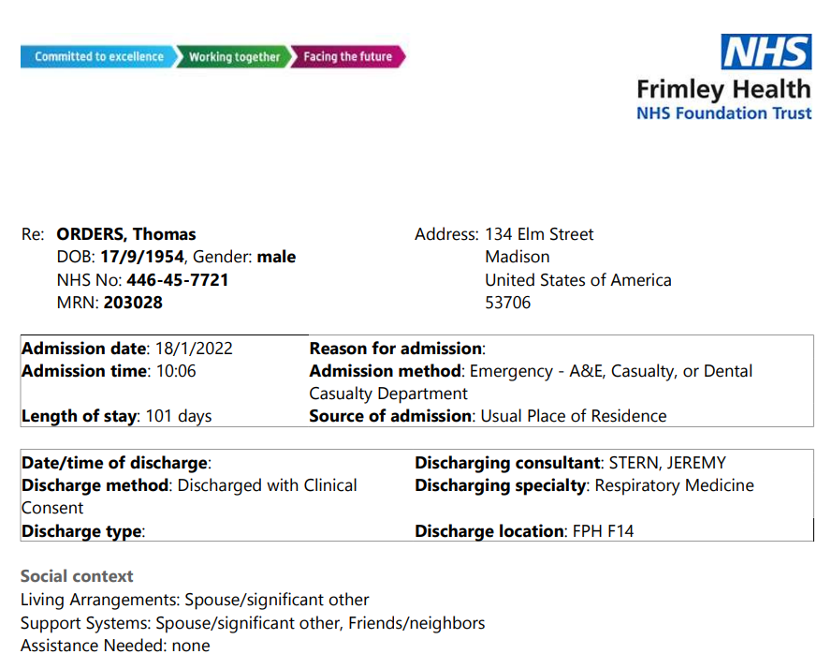

Patients will also receive a patient-friendly after visit summary:
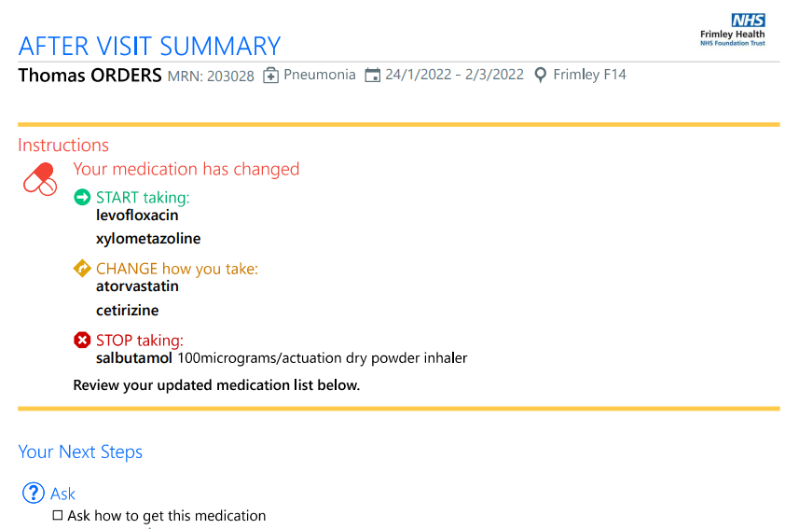
- FHFT EpicCare Link
FHFT EpicCare Link is a real time, read only secure web-based portal that grants our community members (including primary care clinicians and teams) real-time web access to view their patient’s Frimley Health chart. GPs can use EpicCare Link to drill into clinical visits that occur at the Trust to view discharge summaries, medication changes, notes, results, and more.
In EpicCare Link, you will also be able to see notes, encounters, medications, allergies, and problems documented at other Epic NHS trusts:
- Currently live on Epic: Cambridge, Royal Devon & Exeter, University College London, Great Ormand Street Hospital.
- Future Epic sites: Manchester (Autumn ’22), Guy’s & St Thomas’ (Spring ’23), Northern Ireland (Spring ’23), and the Royal Marsden (Spring ’23).
Each FHFT EpicCare Link site will have at least one site administrator whose role will include requesting and monitoring user accounts for that site / practice.

EpicCare link registration opened on 28 April - please follow the below link to register.
https://www.fhft.nhs.uk/gps/gp-centre/epic-epr-at-frimley-health/: Click on the login button on the webpage to submit registration details.
The deadline for a log in in place for Go live was 20 May. Any requests after this date will receive access after go-live. Additional FAQ’s and a Quick Start User Guide for GPs has been created for EpicCare Link and will be made available on the website: https://www.fhft.nhs.uk/gps/gp-centre/epic-epr-at-frimley-health.

EpicCare Link Icon on Desktops in Primary Care
We are working with the Frimley ICS Digital team to install the Icon for EpicCare Link. We will provide further updates when this has been actioned as we are aiming to have this in place for go live. Please note you will only be able to use this Icon and log in (from 13 June) providing you have registered your practice and received logins.

5. Further Support & Next Steps
If you have any questions, please email the EPR team at fhft.epr@nhs.net. For further information on Epic please visit the FHFT website: https://www.fhft.nhs.uk/gps/gp-centre/epic-epr-at-frimley-health/
Other Key contacts (see Frimley Health Key Contacts on the concertina): https://www.fhft.nhs.uk/gps/gp-centre/referrals-key-contacts/).
Help and Support ICE/Radiology Ordercomms during Epic Go Live.
If GPs experience any ICE related issues for Radiology order comms during the Epic go live please e-mail fhft.iceepicsupport@nhs.net, which will be monitored by BSPS / Frimley-Epic team from 9-5 Monday to Friday. If urgent please call BSPS on 0300 613 3600.

