Instructions for adding the new Radiology Trading partner to EMIS

Reason: There is a new Radiology system going live shortly in the Trust as part of the EPIC EPR project.

Risk: Failure to perform this will prevent Radiology reports being returned to your practice system.

- Create a new trading partner in Workflow configuration, called FHFT Radiology, exactly as the example highlighted below, attached to mailbox 69230PM. Go to Workflow Manager > Configuration > Organisation Options > Trading Partners

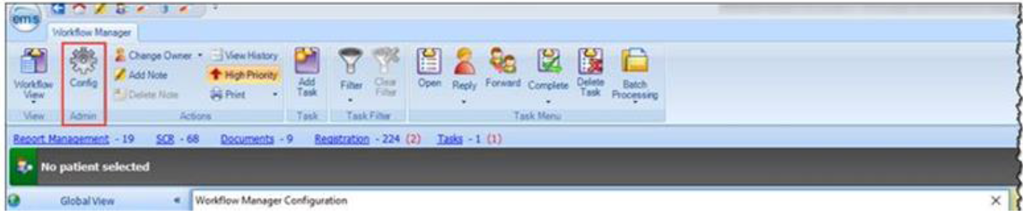

- Add a MEDRPT NHS002 message version with the trading partner cypher of 140000119200010

- Add your organisation cypher against this (hint: you will already have this set up against all of your current providers) Click link and press OK to save it. You are now ready to receive the new Radiology system reports.
See next page for step by step instructions

How to do this step by step

1.Adding the trading partner
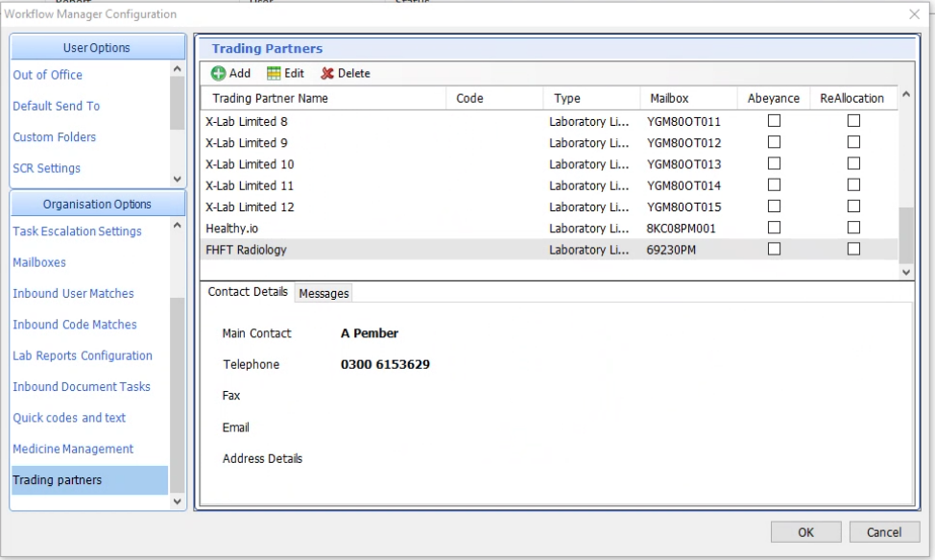

First page. Fill in as shown here:
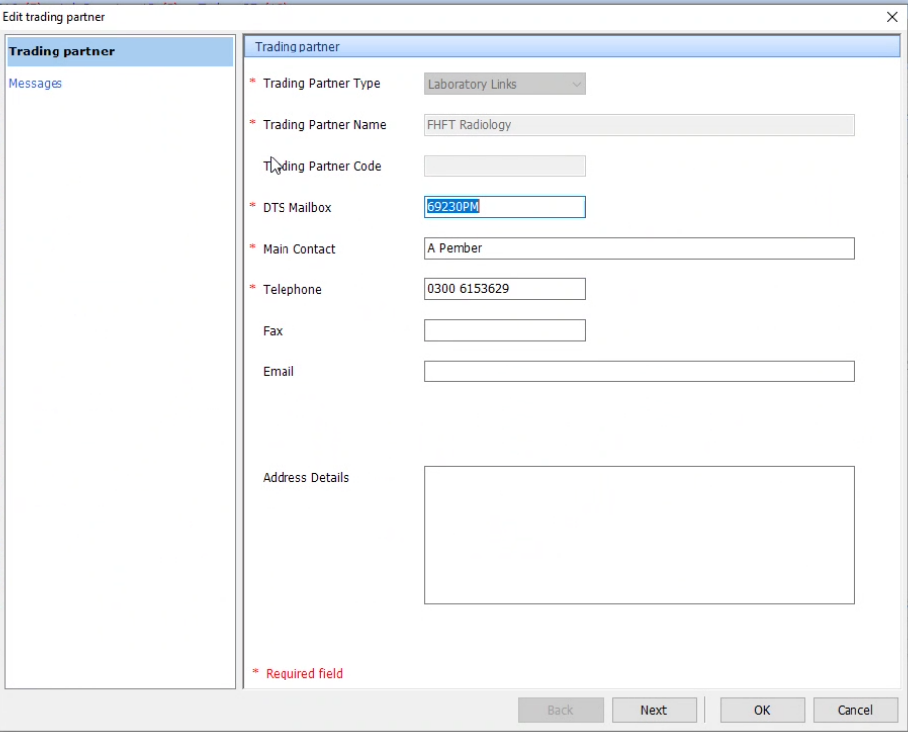
Click next.

This will open the message set up.

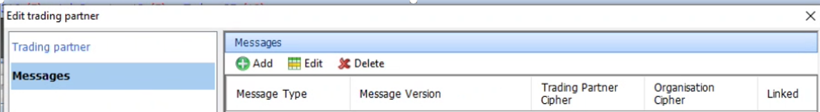

Add details as shown here.
Add your practice Organisation cypher (ending in 0005) You can view what this is by looking at your other live link for Pathology.

Click Add
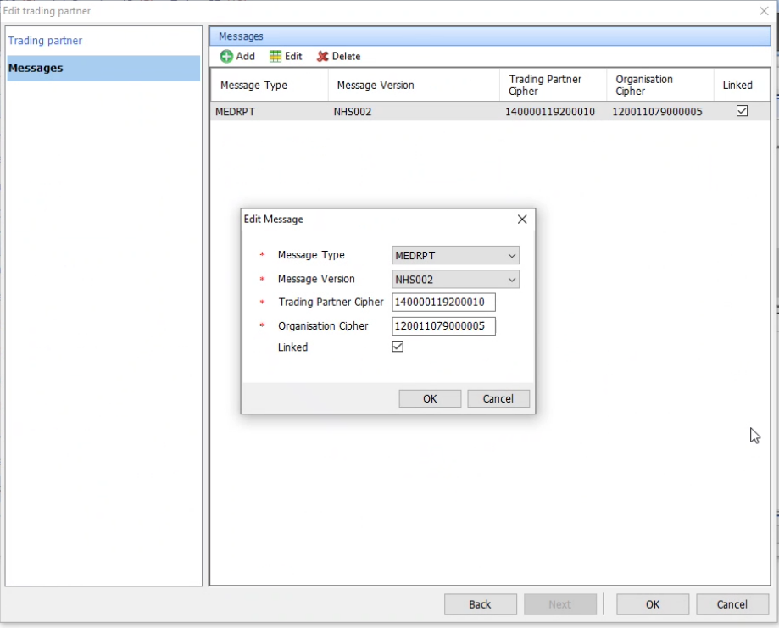
Click OK
Click OK

