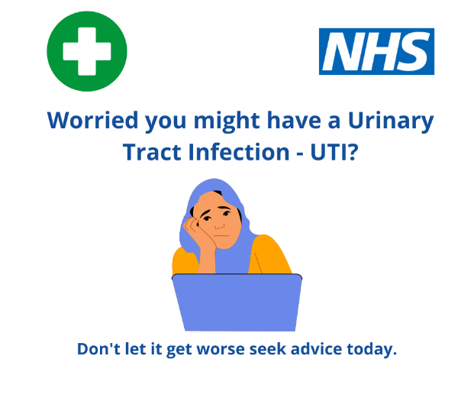
Following the success of the roll out of the NHS Community Pharmacist Consultation Service (CPCS) in 2019, further additions to services have been made including the Hypertension case finding service and from 27th July, support with the treatment of uncomplicated urinary tract infections (UTI's) in women.

Chosen due to the high numbers of cases and clear treatment guidelines, from 27th July local community pharmacies have been able to provide advice and support to women between the ages of 16-64yrs who are not pregnant or breastfeeding, in managing uncomplicated urinary tract infections - where necessary, suppling medication which is made available to patients who are exempt and non-exempt from prescription charges.

The service is offered on a walk in or referral basis to female patients presenting with 2 or more of the key UTI symptoms, not showing any symptoms of complications and who meet the below criteria:
- Registered with a Frimley GP practice
- Female
- Aged 16-64 years
- Not pregnant/breastfeeding
- No catheter/complications
Those who do not fit the criteria will be advised to continue to seek assistance through their GP practice.

This information is now being shared with the public and partners, to raise awareness of both the service and of symptoms. It has also been highlighted on the Frimley ICS Think Pharmacy webpage which you can find HERE.

