
Improving Immunisation Uptake Team – April 2022
MMR National Catch-up Campaign 2022
Dear colleagues,
With the rollout of the MMR national catch-up campaign, there are lots of ways primary care colleagues can get involved and support this campaign. The IIUT have put together some key points which could make a huge difference to the success of the campaign.
Practices can promote the campaign by displaying promotional resources (links below) in the surgery and on their website, it is important that all staff are aware of this and can support in the booking of appointments.
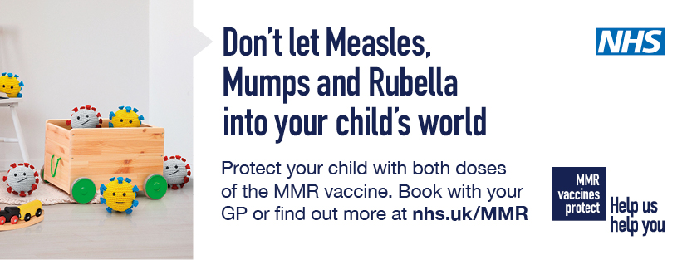
- Current national coverage of the MMR vaccine is 86.6% and this has dropped during the pandemic.
- Second doses are at the lowest uptake in a decade - the aim of the campaign is to get this coverage up to 95%.
- There is lowest coverage for children in urban areas and those born to mothers under 20 or over 40.
As part of the national campaign, parents/guardians of children who are not up to date with MMR will be sent a reminder letter in April. As a result of the campaign, practices are likely to receive an increase in enquiries from parents regarding their children’s MMR status. The IIUT are encouraging staff to be prepared to have clinical conversations regarding the importance of children being protected from Measles, Mumps and Rubella. Facts like ‘Measles is a highly infectious viral disease which can lead to serious complications such as pneumonia and encephalitis (inflammation of the brain)’ can make the diseases “more real” to parents.
Top Tips
- Ensure appointments are available, accessible and make every contact count.
- Take the opportunity when a child attends for immunisations to review their history and ensure that all due/overdue vaccinations are given, in partnership with the parents.
- Direct parents to useful information such as the Oxford Vaccine Knowledge website, (links below).
- Remember that children need two valid doses of MMR over the age of 1 year, 1st at one year (any dose given before age one is not a valid dose and needs repeating). The second dose is given at 3 years 4 months with the preschool booster. Any second dose given at or after 18 months can count as a valid booster dose, often it is given earlier abroad.

Parents trust health professionals and often want the opportunity to ask questions about vaccinations.
Useful links -https://campaignresources.phe.gov.uk/resources/campaigns/135-childhood-vaccination-2022/resources
Vaccine Knowledge (ox.ac.uk)
www.nhs.uk/conditions/vaccinations/mmr-vaccine/
As always, the IIU team are happy to assist colleagues with any immunisation queries, so please get in touch via our email address - scwcsu.improvingimmsuptake@nhs.net.

Please do also visit our webpage on the SCW website
https://www.scwcsu.nhs.uk/services/improving-immunisation-uptake
for information about our service, recent case studies and other useful tools/resources and blogs from the team.

