Asthma bundle of care project
Frimley Health Foundation Trust
Paediatric Respiratory Nursing Service
The Paediatric Respiratory Nursing service comprises of a team of 4 Respiratory Specialist Nurses, 2 Allergy Specialist Nurses and 2 Cystic Fibrosis Specialist nurses, split between Wexham Park Hospital and Frimley Park Hospital. There is a cross site Lead Respiratory Nurse who supports the team. The team focuses on atopic conditions (Asthma, Allergy, Eczema and Allergic Rhinitis) as well as supporting families and patients with Cystic Fibrosis.
We regularly review Asthmatic patients in weekly nurse led clinics and daily on the ward. We provide training for School Nursing teams and schools across the borough along with hospital staff and Doctors.
One of our primary goals, to upskill practice nurses and general practitioners by inviting staff to join us in clinic has not been realised. Clearly, the main barrier is releasing staff from their existing heavy workload.
With the new Asthma bundle of care budget, we are now able to provide these clinics in house at the GP surgery, with the idea that the Practice Nurse is upskilled in Paediatric Asthma Reviews and subsequently part of a respiratory network with ongoing support.

Role Modelling Clinic
Aim: To establish a shared learning paediatric asthma clinic rotating across the borough.
- Weekly clinic staffed by asthma clinical nurse specialist (CNS) from FHFT and joined by local practice nurse (PN)
- Runs for 6 weeks at an individual practice and then rotates. 7 x 30 mins slots per clinic.
- PN attends for the 6 weeks
- Known frequent attenders from that practice and other patients identified through a database search that is run in advance by GP Practice booked into 6 week slots. Responsibility for booking patients would be from the practice
- The first week starts with an hour of education between CNS and Practice Nurse, followed by CNS reviewing 5 patients with Practice Nurse observing. 2nd week 7 patients booked in for CNS to review with PN observing.
-Weeks 3-5, PN reviews 7 patients with CNS support
-Week 6, PN reviews 5 patients with CNS support. Final hour involves feedback and debrief between PN and CNS.
- Scheduled 1 hour MDT at agreed time during 6 weeks; attended by Respiratory CNS, GP and Practice nurse to discuss programme and Paediatric Asthma moving forward.
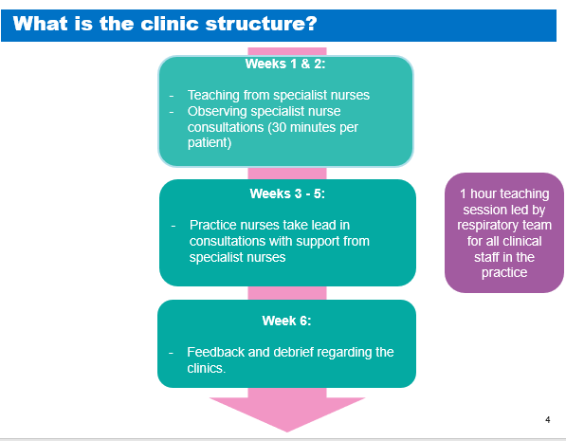
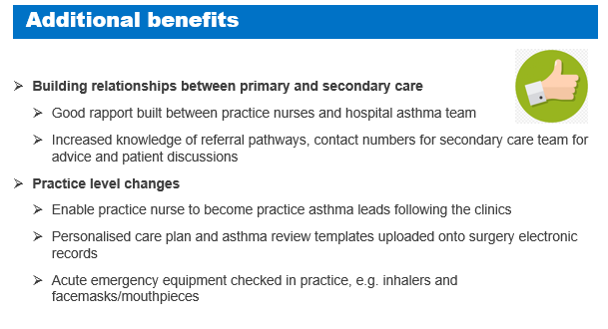

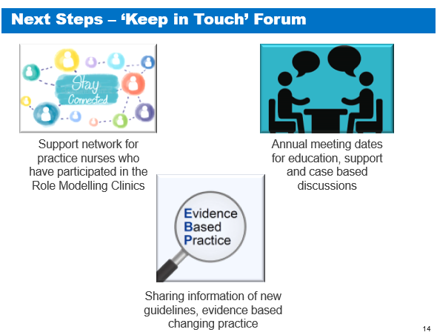

We would like to invite all GP’s across Frimley Health to be involved with the project and will be contacting each surgery in due course.
If you would like to know more information in the meantime, please do not hesitate to contact us:
Rebecca.mcdonnell4@nhs.net 07798746081
Becca McDonnell
Lead Nurse for Respiratory (Paediatrics)

