FHFT Haematology Services changing from a CAS to a RAS on NHS eRS on the 14th of March 2022

We are writing to inform you that from the 14th of March 2022 the below Services will be transitioned from a CAS service to a RAS service.

The services can be accessed by selecting the relevant RAS service below on eRS. Frimley Health will contact the patient directly to book a virtual or face to face outpatient appointment, a secondary care diagnostic test, or management advice may be sent back to you. Those returned with management advice will appear on your Referrer Action Required Worklist. Please action in accordance with the comments on the worklist. Where a detailed response is required, the clinicians will write a dictated letter to you and copy in the patient.

Advice & Guidance will also be offered alongside this service to provide specialist advice. This can be accessed by selecting the request type ‘advice’ on the eRS services below.

Please ensure you are referring to the correct eRS service and have checked the eRS Directory of Services (DoS):

Frimley South – RAS Triage Service

Specialty | Service | Site
Haematology | Haematology RAS TRIAGE Service- Frimley Health Foundation Trust- RDU01 Details | Frimley

Frimley North – RAS Triage Service

Specialty | Service | Site
Haematology | Haematology RAS TRIAGE Service- Frimley Health NHS Foundation Trust Details | Wexham

Key Contacts (this can also be found on https://www.fhft.nhs.uk/gps/gp-centre/referrals/

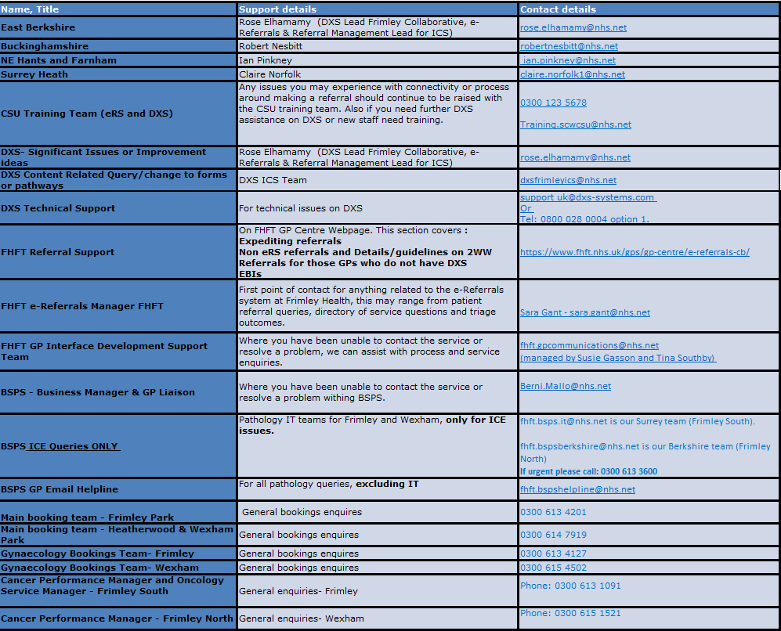

Key Pages within the FHFT website (GP Centre): https://www.fhft.nhs.uk/GPcentre. Key pages can also be accessed via the DXS home page and relevant speciality landing pages:
- Urgent Advice Service Directory: https://www.fhft.nhs.uk/gps/gp-centre/urgent-advice/
- Routine Advice Service Directory: https://www.fhft.nhs.uk/gps/gp-centre/routine-advice/
- SDEC Service Directory (including the Ambulatory Emergency Care Unit): https://www.fhft.nhs.uk/gps/gp-centre/sdec-including-ambulatory-care/
- Referral Support: https://www.fhft.nhs.uk/gps/gp-centre/referrals/. This section covers expediting referrals, non-eRS referrals and details/guidelines on 2WW Referrals for those GPs who do not have DXS
- Current status of services: https://www.fhft.nhs.uk/gps/gp-centre/latest-news-and-gp-newsletter/ – supporting advice including opening times of services etc:

