Context
At Frimley Health NHS Foundation Trust, we know that having a baby is a big event and it's really important to us that women and their families feel supported throughout pregnancy, birth and the postnatal period.
As every pregnancy is different, it’s important that we provide care that is personalised to the individual. To do this we need to be able to build a picture of everything that might affect a pregnancy journey; including experiences of previous pregnancy, family circumstances and personal birth choices.
We know expectant mums are the experts in what matters to them. We want local women to be able to share their views and choices and access trusted information, so that together we can decide on the care that is best for individuals and their baby.
To help us understand what matters most, we’ve created The Frimley Health Personalised Maternity Care Plan app where mums to be can document their thoughts, feelings and questions ready to discuss with healthcare providers.
We would appreciate your assistance is sharing the news of this new app and you can access assets to support you with this below.

News post – Short Copy
A new app that helps women to navigate their pregnancy journey with Frimley Health is now live.
The Maternity Plan app was developed by the local maternity and neonatal system (LMNS) in collaboration with Frimley Health NHS Foundation Trust, exclusively for women under the care of Frimley Health's maternity teams.
Frimley Health are proud to offer high-quality maternity services with a woman-centred focus, supporting approximately 9500 expectant mothers a year who come from across Hampshire, Surrey, East Berkshire and South Buckinghamshire and the app, co-designed with mums to be and midwives, is another tool we have developed to support our women centred focus.
Designed to be simple and easy to use, the app will guide mums to be through every stage of pregnancy, birth and beyond. Women are encouraged to download the app, which is available on both apple and android, as early in their pregnancy as possible to get the full benefits.
If you would like to download the app you can find it in the App store here
And on android play store here
Please note - No personal data is collected through the app and information is not shared with anyone unless you chose to do so. This is a record for expectant families to help guide them through their options.

News post – Long Copy
A new app that helps women to navigate their pregnancy journey with Frimley Health is now live.
The Maternity Plan app was developed by the local maternity and neonatal system (LMNS) in collaboration with Frimley Health NHS Foundation Trust, exclusively for women under the care of Frimley Health's maternity teams.
Frimley Health are proud to offer high-quality maternity services with a woman-centred focus, supporting approximately 9500 expectant mothers a year who come from across Hampshire, Surrey, East Berkshire and South Buckinghamshire and the app, co-designed with mums to be and midwives, is another tool we have developed to support our women centred focus.
Designed to be simple and easy to use, the app will guide mums to be through every stage of pregnancy, birth and beyond. Women are encouraged to download the app, which is available on both apple and android, as early in their pregnancy as possible to get the full benefits.
As well as helping women to track appointments, the app will signpost them to support and advice on the Frimley Health and Care website, which covers pregnancy, labour and birth, and caring for yourself and your baby, among other topics. There are plenty of places to make notes and these can be exported from the app into a pdf to save, print or share with family or a midwife.
Katie Watkins, LMNS midwife, said: “We’re delighted to be launching our Maternity Plan app, which will give pregnant women more ownership of their care. Throughout their pregnancy, it will prompt them to consider their thoughts, feelings and choices for their care that they can then discuss with the maternity team.”
It will be available for IOS and Android and can be found on most app stores.
If you would like to download the app you can find it in the App store here
And on android play store here
Please note - No personal data is collected through the app and information is not shared with anyone unless you chose to do so. This is a record for expectant families to help guide them through their options.
Supporting image
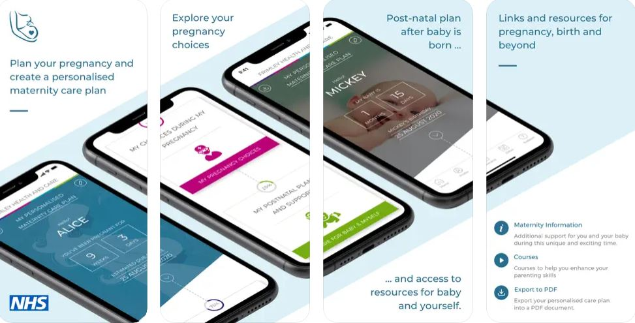

Social Media Posts

1st post
A new app has launched, helping mums to be make and share choices around their pregnancy and birth. Designed alongside mums and midwives, the Frimley Maternity Plan app will guide you through your options for care during your pregnancy and the birth and help you note questions or concerns. Download today and start making your plans.
With video

2nd post
There's lots to think about & plan when you're pregnant but Frimley Health is making it slightly easier. Download the new maternity app for information and guidance designed to help you make informed choices around your pregnancy and birth.
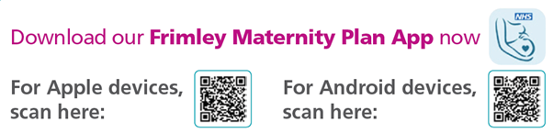
Available today from the App or android play store.

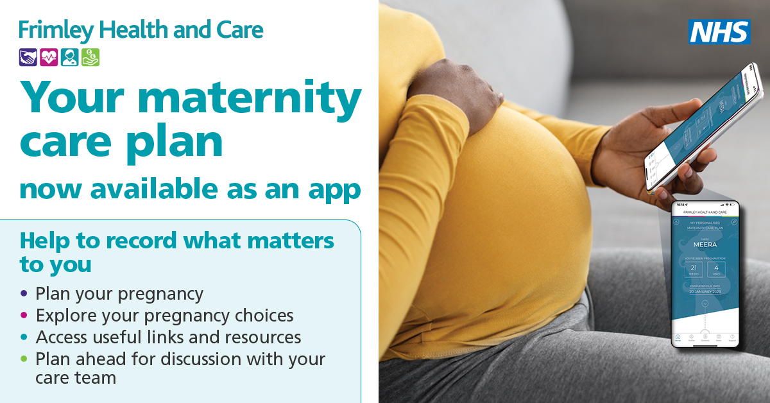
#FrimleyMaternityPlan #PersonalisedCare
3rd post
Ever had that feeling where you know you wanted to ask something but now can’t remember what it was? How about if you want to find out information to help you decide but you’re not sure where to look? Mums have told Frimley Health this has happened to them before, but don’t worry, the Frimley Maternity Plan app is here to help! If you are planning a birth under the care of Frimley Park or Wexham Park, download the app today to work through your choices, think about the care you would like during pregnancy, birth and when your baby is born and share all this with your midwife.
Download today from the App or android play store. #FrimleyMaternityPlan #PersonalisedCare
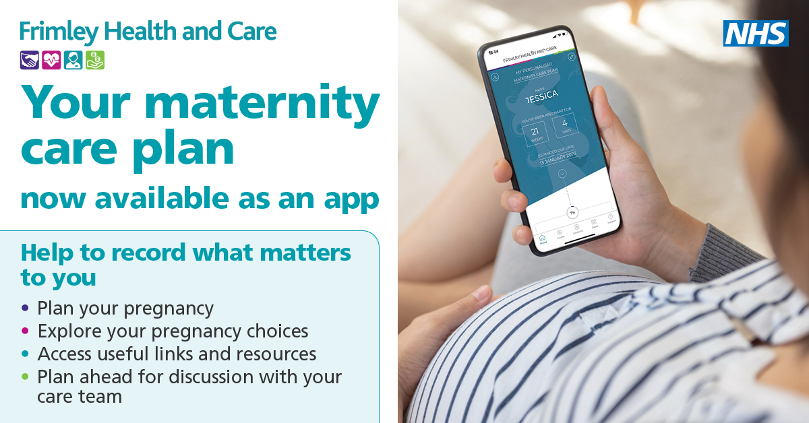

4th post
Have you seen the new Frimley app for expectant mothers? It helps plan pregnancy and birth, is free and easy to use - so go on, download it today!
Download today from the App or android play store.
#FrimleyMaternityPlan #PersonalisedCare
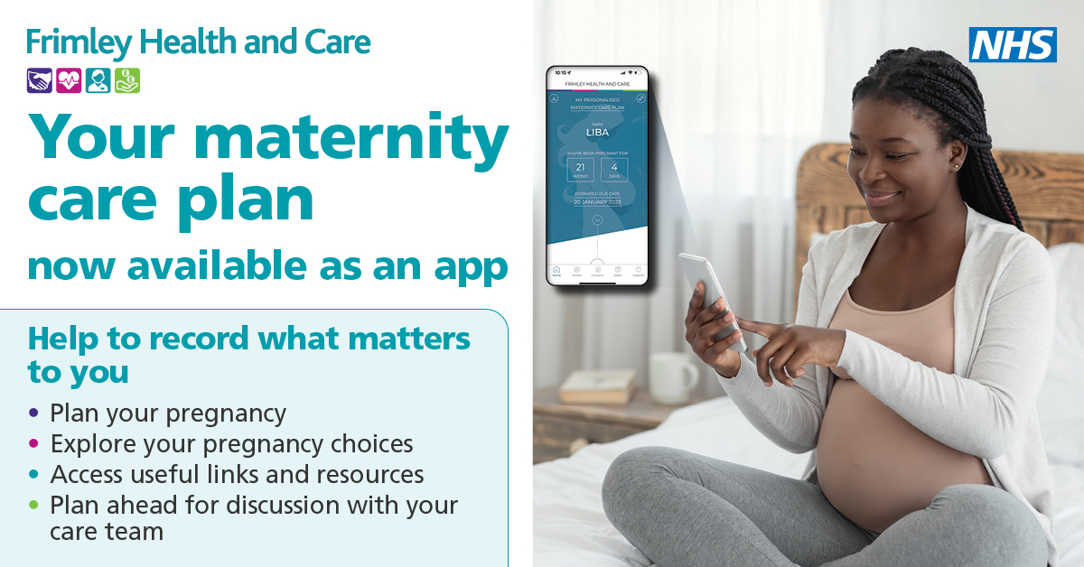

5th post
Too much choice can be overwhelming especially if you’re expecting, but Frimley Health is here to make it a little easier for mums to be with the new Maternity Plan app. Download today for help in knowing your options and sharing your wishes. Find out more in the video here.

