Please ONLY refer to NEW teleDermatology service
- 129 referrals received to date versus expected 1200
This means just 12% of new referrals are benefiting from faster turnaround times (majority under 2 weeks) and 88% of patients have been added to the backlog who will continue to wait as below, despite the investment and solution provided.
- 55-85+ weeks for routine 1st OP appt
- Up to 6 weeks for a suspected cancer referral

Important clarification for GP’s referring

GP’s do NOT have to provide images themselves
Choose the option below on Cinapsis landing page.
The provider will….
Book your patient, takes mandated images, adds them to your referral and sends them on to virtual triage on your behalf.

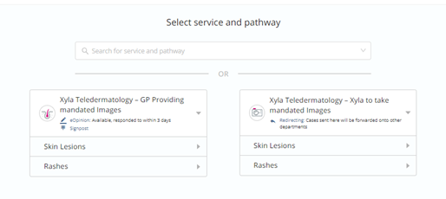

Practices that have not enabled Cinapsis for referrals
Check here to see whether your practice has not set up Cinapsis and to request support.

Additional Information about the teleDermatology Service
Click here for additional information about the new service, including medical photography and training.

Contact for Support
Please contact philippa.may@nhs.net if you have any queries or require further support

Additional Information about the teleDermatology Service
Contact philippa.may@nhs.net for advice and queries


New Dermatology Pathway
Go Live 5th September

- Remind me please – what is this?
This newly commissioned service means new provision of…..
- Consultant Virtual triage from new provider for all dermatology onward referrals via new software called Cinapsis.
Exception of SH, who will only access this new pathway for onward referrals NOT suitable for their Sussex Dermatology Community provider.
- New provider will complete onward referrals where required
- NEHF provision of a See and Treat Community Service

- But Virtual Triage requires images……
Unless you already have, or wish to take and upload required images yourself
Simply select the option to refer via Medical Photography:
- New provider will book patient to a photography clinic
- Images will be taken including Dermatascopic images for lesions and suspected cancer
- Referral will be sent onward for virtual triage with images attached
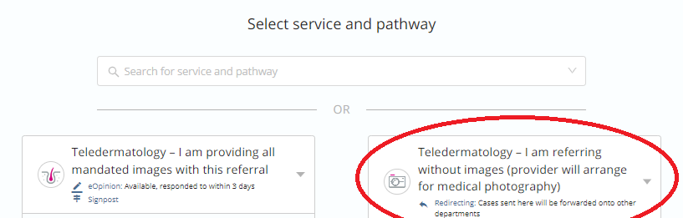

- teleDermatology timescales
Medical Photography Clinics
- 2 working days for suspected cancer referrals
- 5 working days for urgent patients
- 10 working days for routine patients

Virtual Triage
- Maximum of 2 working days on receipt (on referral with attached images)

- What do I need to do differently?
Use the Cinapsis toolbar to refer. The application is already uploaded on your practice desktop and is compatible with EMIS; choose between 2 referral forms:
- Via medical photography if you do not have adequate images to send with your referrals (suspected cancers and lesions require dermatascope images)
- Straight to virtual triage when you have the required images for upload
Please note if you prefer the form on DXS and wish to use this instead, you or your administrator can attach this to the Cinapsis referral.

- Is training available?
Step-by-step guides for clinicians, administrators and medical secretaries are available via the Help Section within Cinapsis, once users have an account: Get started – Cinapsis Support
GP Training
A standalone training video is available for clinicians. The Appendix below shows times for each section so you can fast forward as appropriate. 9 minutes to learn how to refer
https://vimeo.com/709058051
Password: Dem0nstr@tion
13:58 Start a new case (complete the form and attach files)

Training for Administrators and Medical Secretaries
There is also a standalone training video for administrators and medical secretaries. Medical secretaries can start the video from minute 26:23. Timings are provided in the Appendix.
https://vimeo.com/688468752
password: Cinapsis_dem0

- Cinapsis hasn’t been activated by my practice
We have been in communication with Practice Managers and requested some actions to ensure this service is available across our area.

Please if anyone is unsure or requires support, contact philippa.may@nhs.net who can liaise with your practice and organise set up.

__________________________________________________________________________________

Appendix
GP training video
Choose the times in the video to access what you need to know
00:00 Training objectives
00:23 Logging in and overview of the mobile app
04:07 Take photos in the Cinapsis app
09:39 Logging in and overview of the Cinapsis toolbar
13:58 Start a new case (complete the form and attach files)
22:28 Check if your case has had a response
24:12 Specialist workflow (optional)
30:40 Where the report goes and how to review it

Admin / Med Secretary training video
00:00 Training objectives
00:11 Logging in and overview of the administrator homepage
02:15 User management
08:10 Managing permissions from the dedicated Permissions tab
09:21 Changing your practice details
10:42 Check available services to the practice and the audit log
11:50 Using case analytics
14:21 Filing cases into the patient’s record
19:13 Reviewing cases and reports in the Practice Inbox – allows you to file cases into the patient’s record
21:41 Logging in and overview of the Cinapsis toolbar (GP workflow)
26:23 Start a new case and sending it to the secretarial team [Start of Medical Secretary Training]
32:41 Find the case sent to the secretarial team in your Drafts
33:35 Secretarial homepage
37:36 Claiming the case and completing it on behalf of the GP (Secretary workflow)
44:22 Specialist workflow (optional)
48:26 Filing the report into EMIS (as a Cinapsis admin or as a secretary)
51:01 Reviewing the specialist report in EMIS

