Official Sensitive
In Confidence: QIVe Usage in the Seasonal Influenza Vaccination Programme
Following review of flu vaccine prescribing data, coupled with concerns raised elsewhere in the country, NHS England South East region is investigating reported administration of QIVe to patients aged 65 years or older by a number of primary care providers (GP practices and community pharmacies) across the region.
As you will be aware, QIVe is not recommended for use in this age group due to its poor effectiveness. The recommendations on which vaccines to use for which cohort are set out in multiple national documents including the national flu letter, PGDs and national guidance for healthcare professionals.

Data from Foundry shows the following number of QIVe vaccines as recorded as being given to people aged 65 and over.

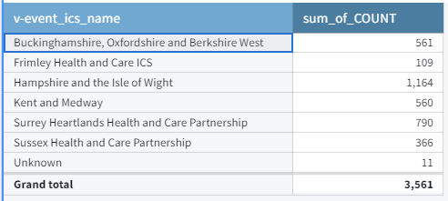

Data from Pharmoutcomes (pharmacy data only) correlates well with the picture on Foundry.

We have contacted those community pharmacies and GP practices directly where the highest numbers of QIVe vaccines have been recorded in order to identify whether this is a recording/coding error, or genuine administration of QIVe. Early investigation suggests that there is a mix of both, with recording errors dominating.

If any patient aged 65 or over has received QIVe, we will be asking the provider to treat this as an incident. Patients will need to be contacted, informed of the error, its potential implications and offered the opportunity to receive a vaccine that is appropriate for their age group.

We will also be writing to all providers again today to remind them that they must not use QIVe in the older age cohort. This follows earlier messaging, reinforcing the content of the national flu letter and various national guidance, via Pharmoutcomes and the regional weekly flu bulletin.

At this early stage, we ask you not to take any direct action in relation to the potential for an incident. However, we ask your teams to continue to reinforce messages about the correct use of vaccine through your usual channels so that we can ensure that all patients are given a recommended vaccine that will confer optimum protection.

Although this situation is replicated nationwide, incidents are being managed regionally.

We will keep you informed as the situation develops and the picture becomes clearer.

If you have any queries on this matter, please raise them with the relevant regional Public Health Commissioning Team.

england.htvphcontracting@nhs.net - Hampshire and the Isle of Wight, Berkshire, Oxfordshire and Buckinghamshire, Frimley
phst@nhs.net - Kent and Medway
PHE.Screening-ImmsSSAT@nhs.net - Surrey and Sussex

South East Region Public Health Commissioning Teams

