Rheumatology Pathways on DXS

Rheumatology Pathways are now available on the DXS Frimley ICS Rheumatology landing page (please see screenshots below). These new pathways will be available in the Frimley Health and Care – Rheumatology folder

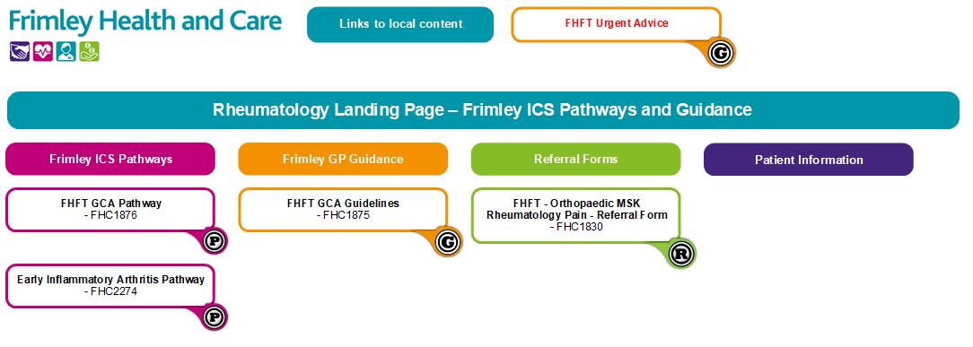

Two new Rheumatology pathways have been added to DXS;
- Giant Cell Arteritis – GCA is the most common large vessel vasculitis
  - It is a medical emergency and can cause blindness in up to 20% of patients
  - Patients with suspected GCA should be commenced immediately of steroids and be referred, via a fast-track pathway, to Rheumatology for further investigation and management.
  - Patients with visual disturbance require a same day referral to ophthalmology, in addition to Rheumatology.
  - The pathway includes contact numbers for the eye department and the referral process to enable the Rheumatology team to see the patient.
- Early Inflammatory Arthritis
  - These referrals will be treated as urgent and should be directed to the ‘early inflammatory arthritis’ service on eRS and not via the general Rheumatology eRS service.

If you wish to refer into Rheumatology, there is a combined form for MSK or Orthopaedics/Pain and Rheumatology. This can be found in the Orthopaedic MSK folder and a link on the Rheumatology Landing Page. Against each condition it will state clearly which service on eRS the referral should be sent to via eRS.

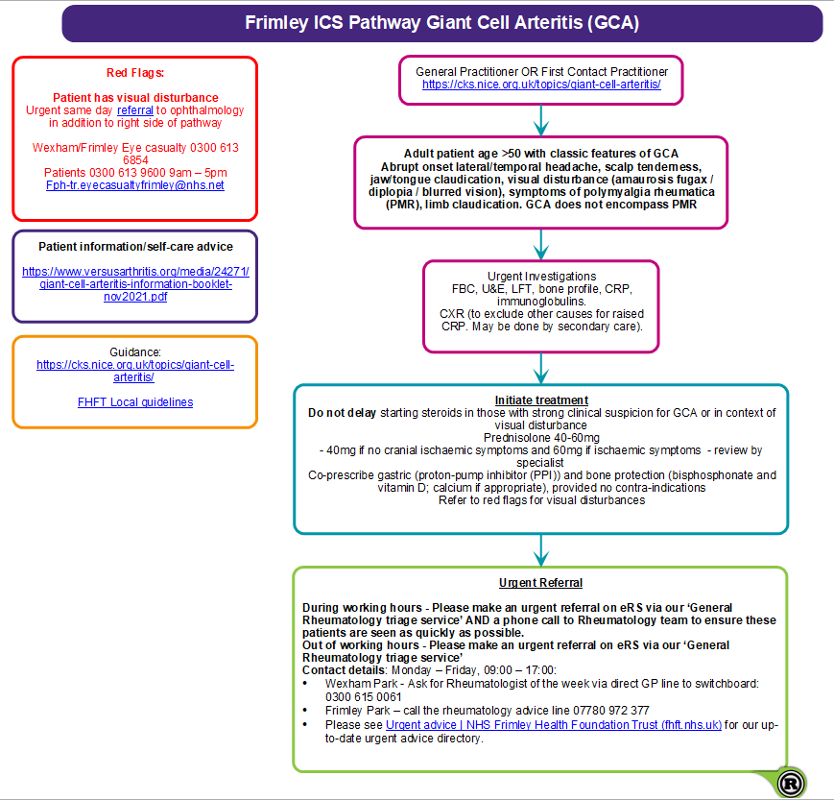

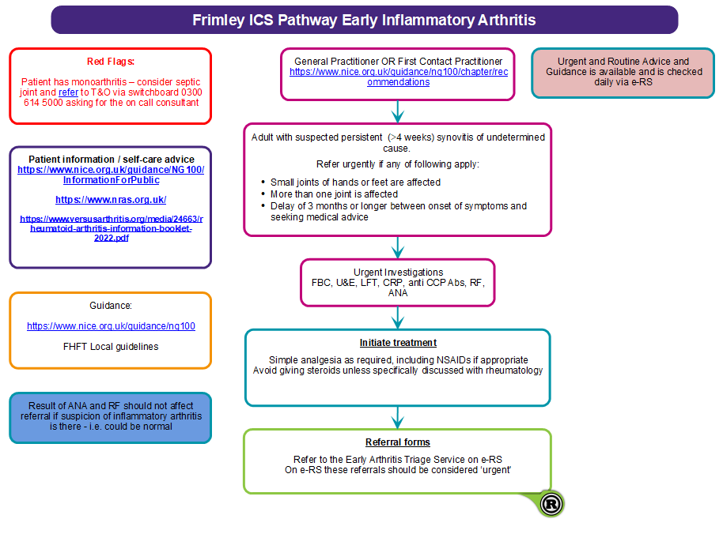

Key Contacts (this can also be found on https://www.fhft.nhs.uk/gps/gp-centre/referrals/

Key Pages within the FHFT website (GP Centre): https://www.fhft.nhs.uk/GPcentre. Key pages can also be accessed via the DXS home page and relevant speciality landing pages:

- Key Contacts (this can also be found on https://www.fhft.nhs.uk/gps/gp-centre/referrals/
- Urgent Advice Service Directory: https://www.fhft.nhs.uk/gps/gp-centre/urgent-advice/
- Routine Advice Service Directory: https://www.fhft.nhs.uk/gps/gp-centre/routine-advice/
- SDEC Service Directory (including the Ambulatory Emergency Care Unit): https://www.fhft.nhs.uk/gps/gp-centre/sdec-including-ambulatory-care/
- Referral Support: https://www.fhft.nhs.uk/gps/gp-centre/referrals/. This section covers expediting referrals, non-eRS referrals and details/guidelines on 2WW Referrals for those GPs who do not have DXS
- Current status of services: https://www.fhft.nhs.uk/gps/gp-centre/latest-news-and-gp-newsletter/ – supporting advice including opening times of services etc:

