Physiotherapy Services going live on NHS e-RS – Frimley North ONLY

We are writing to inform you that from the 21st of February 2022 the below Physiotherapy Services will be available on e-RS for Frimley North ONLY.

The services can be accessed by selecting relevant RAS service below on e-RS. Frimley Health will contact the patient directly to book a virtual or face to face outpatient appointment, a secondary care diagnostic test, or management advice may be sent back to you. Those returned with management advice will appear on your Referrer Action Required Worklist. Please action in accordance with the comments on the worklist. Where a detailed response is required, the clinicians will write a dictated letter to you and copy in the patient.

Please ensure you are referring to the correct service on NHS e-Referrals and please check the Directory of Services (DoS) before referring.

Specialty | Service | Site
Physiotherapy | Physiotherapy - Neurological Triage Frimley Health NHS Foundation Trust | Heatherwood
Physiotherapy | Physiotherapy - Musculoskeletal Triage Frimley Health NHS Foundation Trust | Heatherwood
Physiotherapy | Pelvic Health Physio Obstetric/Urogynae/Colorectal Triage - Frimley Health NHS Foundation Trust | Wexham
Physiotherapy | Hand Therapy Triage Service Frimley Health NHS Foundation Trust | Wexham
Physiotherapy | Physiotherapy - Paediatric Triage - Frimley Health NHS Foundation Trust | Wexham

Frimley South Physiotherapy Referrals

The team are working on transitioning their services onto eRS and however in the meantime For musculoskeletal physiotherapy please continue to refer in the usual way to fhft.therapies@nhs.net

For any further support please see contact details below:

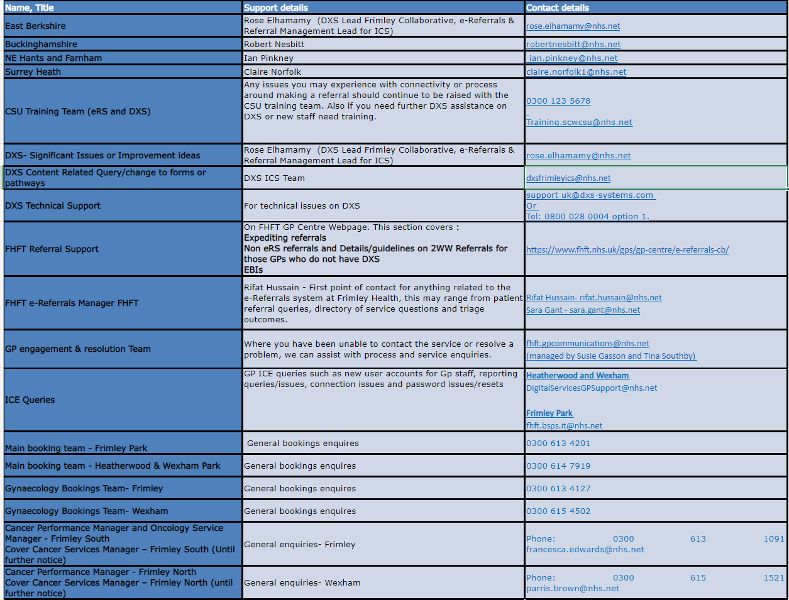

Key Pages within the FHFT website (GP Centre: https://www.fhft.nhs.uk/GPcentre also available via the DXS home page):
- Urgent Advice Service Directory Lines: https://www.fhft.nhs.uk/gps/gp-centre/urgent-advice/
- Routine Advice Service Directory: https://www.fhft.nhs.uk/gps/gp-centre/routine-advice/
- SDEC Service Directory (including Ambulatory Emergency Care Unit): https://www.fhft.nhs.uk/gps/gp-centre/sdec-including-ambulatory-care/
- Referral Support: https://www.fhft.nhs.uk/gps/gp-centre/referrals/ this section covers expediting referrals, non eRS referrals and details/guidelines on 2WW Referrals for those GPs who do not have DXS
- Current status of services – supporting advice on opening times etc: https://www.fhft.nhs.uk/gps/gp-centre/latest-news-and-gp-newsletter/

