

Frimley Health and Care – DXS Point-of-Care Content Relocation
This email is to inform you that all local Frimley CCG content can now be found in the Frimley Health and Care content subscription on DXS Point-of-Care.
The seamless folder structure approach provides access to ICS-wide content listed first, followed by local content split into localities – East Berkshire, North East Hampshire and Farnham, and Surrey Heath. Landing pages are also now consolidated. Please see an example below.
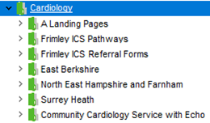
As of 28 January 2022, the primary subscriptions shown below will be fully removed as they are now obsolete.
For any feedback, suggestions or content requests, please contact DXSfrimleyICS@nhs.net
Kind regards,
DXS Team

