
Improving Immunisation Uptake Team – April 2022
Ukrainian Refugees - access to vaccinations
Dear colleagues,
As you will all be aware, the UK are providing asylum for Ukrainian refugees. Access to vaccinations for refugees will be needed to protect the most vulnerable among them from vaccine preventable diseases. Protecting the health of all, including refugees is a priority concern for WHO as the humanitarian crisis in Ukraine continues to unfold. Among other health needs, refugees require access to vaccines.
Useful information for GP practices
- Practices need to continue efforts to ensure their resident populations are fully vaccinated
- Vaccination should be offered and made accessible to all refugees on your caseload.
- The WHO have highlighted that Ukrainian childhood vaccination coverage is generally much lower than its neighbouring countries and in particular Polio and Hep B. The WHO have recommended that refugee children under 6 are offered vaccinations such as Polio, Measles and Rubella as a priority.
- Refugees from Ukraine are at elevated risk of infectious diseases, as living conditions during
transit or upon arrival may increase the risk of transmission and/or susceptibility to disease.
- Families are also likely to have greater vulnerability due to poor shelter and overcrowded living
conditions, alongside exacerbating factors such as nutritional stress and exposure to cold weather.
- Outbreaks of respiratory and diarrhoeal infections are to be expected.
- Languages spoken in the Ukraine include:- Ukrainian 67.5%, Russian 29.6% and others 2.9%. Practices should utilise available translation services to ensure full vaccination histories are obtained, so that children can be offered the right vaccinations to bring them in line with the UK schedule.

Useful links
WHO Ukrainian immunisation schedule – WHO vaccine-preventable diseases: monitoring system. 2020 global summary
Migrant health leaflet in Ukrainian –https://www.healthpublications.gov.uk/ViewArticle.html?sp=Smovedtotheukmigranthealthimmunisationleafletukrainian-1920
Government guidance- https://www.gov.uk/guidance/ukraine-migrant-health-guide
Vaccination of individuals with uncertain or incomplete immunisation status - GOV.UK (www.gov.uk)

Ukraine Crisis public health situation crisis analysis (WHO).
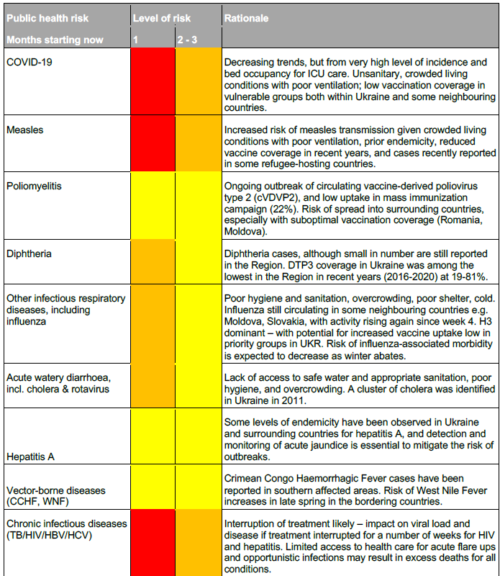

As always, the IIU team are happy to assist colleagues with any immunisation queries, so please get in touch via our email address - scwcsu.improvingimmsuptake@nhs.net.

Please do also visit our webpage on the SCW website
https://www.scwcsu.nhs.uk/services/improving-immunisation-uptake
for information about our service, recent case studies and other useful tools/resources and blogs from the team.

