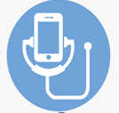
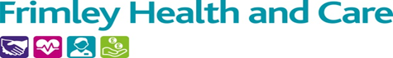
Frimley ICS Digital and Frimley CCG would
like to invite you to join them in a virtual event to showcase Remote Monitoring technology

Remote Monitoring will allow digitalisation of vital information when a residents health deteriorates which results in:
Improved Resident / Patient care ;
Saves time for carers and practice staff;
Reduced hospital admissions and length of stay;
Timely identification of early signs of deteriorating health;
Creates a central hub to communicate with carers and teams providing a faster and more informed response

Remote Monitoring In Care Homes
Date: Wednesday 11th May 2022
Time: 12—1pm
Open To: All Care Home Managers and Leads, GPs and PCN Leads
Meeting Link; https://teams.microsoft.com/l/meetup-join/19%3ameeting_Y2Q5ZWM4MGItNmUwMi00Mjg1LThlN2QtYTgxMzM3Mjg5NzZl%40thread.v2/0?context=%7b%22Tid%22%3a%2237c354b2-85b0-47f5-b222-07b48d774ee3%22%2c%22Oid%22%3a%2223120050-4667-4674-ac09-42de858ed439%22%7d
https://teams.microsoft.com/l/meetup-join/19%3ameeting_Y2Q5ZWM4MGItNmUwMi00Mjg1LThlN2QtYTgxMzM3Mjg5NzZl%40thread.v2/0?context=%7b%22Tid%22%3a%2237c354b2-85b0-47f5-b222-07b48d774ee3%22%2c%22Oid%22%3a%2223120050-4667-4674-ac09-42de858ed439%22%7d

