Social media plan – 23 May – 5 June for GP practices

Facebook | Twitter | Animation/image
Prepare for the weekend (from 23rd May – 1 June)
As local areas prepare to celebrate the Queen’s Platinum Jubilee from the 2-5 June. The NHS is encouraging people to celebrate with care and think ahead and stay healthy over the extended weekend.  GP practices will be closed on the 2 and 3 June. Check if you need to order/collect repeat prescriptions for any regular medications.  Some local pharmacies will have restricted opening times on the 2 and 3 June– click here for details https://www.england.nhs.uk/south-east/our-work/pharmacy-opening-hours/  Prepare ahead. | The NHS is encouraging people to celebrate with care and think ahead and stay healthy over the Platinum Jubilee.  GP practices will be closed on the 2 and 3 June.  Some local pharmacies will have restricted opening times 2-3June– click here for details https://www.england.nhs.uk/south-east/our-work/pharmacy-opening-hours/ | Image GP practices will be closed plan ahead Facebook gp-practices-will-be-closed.jpg (940×788) (frimleyhealthandcare.org.uk)  Image for Twitter: gp-practices-will-be-closed-twitter.png (1600×900) (frimleyhealthandcare.org.uk)  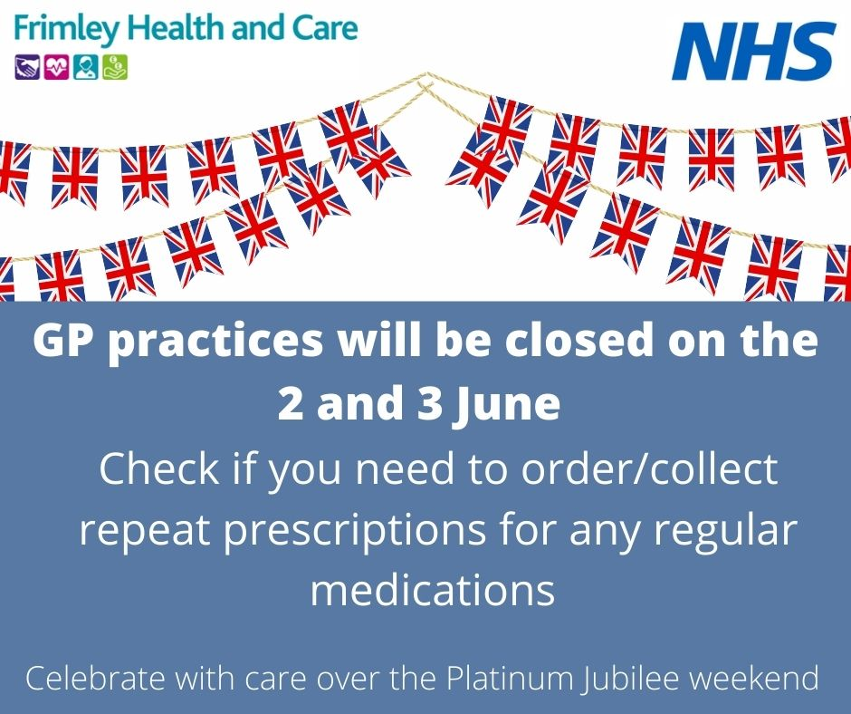
Pharmacy opening hours may be different on the 2&3 June for the Platinum Jubilee weekend. Order and collect any repeat prescriptions in time as GP practices will be closed 2&3 June.  Details of local pharmacies open 2&3 June can be found here: https://www.england.nhs.uk/south-east/our-work/pharmacy-opening-hours/  Or by searching via this map  https://www.google.com/maps/d/viewer?mid=1FdOJEqjNEAfK4v3Ko-yYroeRSQp3kgKl | Pharmacy opening hours may be different on the 2&3 June for the Platinum Jubilee weekend. Order and collect any repeat prescriptions in time as GP practices will be closed 2&3 June.  Details of local pharmacies open 2&3 June https://www.google.com/maps/d/viewer?mid=1FdOJEqjNEAfK4v3Ko-yYroeRSQp3kgKl | Pharmacy opening times Facebook image: pharmacy-opening-times.jpg (940×788) (frimleyhealthandcare.org.uk)  Twitter: pharmacy-opening-times-twitter.png (1600×900) (frimleyhealthandcare.org.uk)  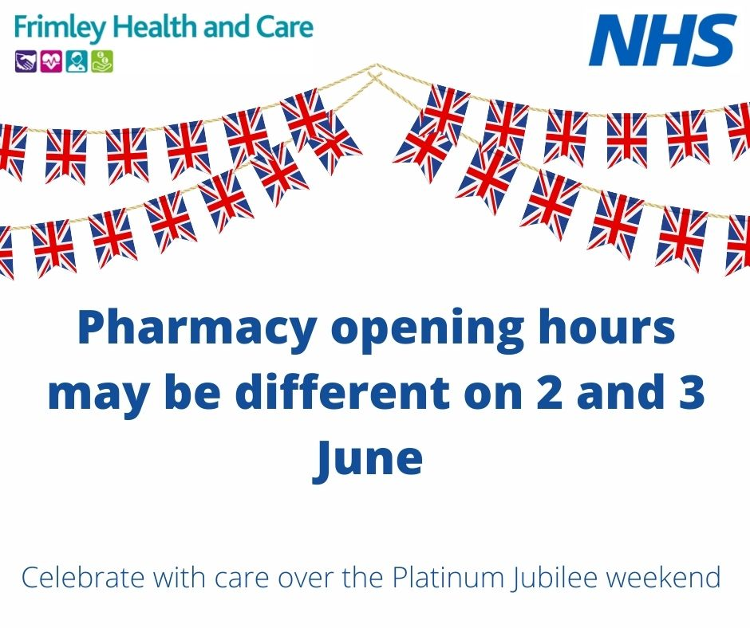
Celebrate with care from (from 23rd May – 5 June)
Celebrate with care over the Platinum Jubilee weekend. Here are a few simple steps people can plan ahead and avoid unnecessary trips to the local A&E departments:  - Check if you need to order/collect repeat prescriptions for any regular medications. Your GP practice will be closed 2 and 3 June so plan ahead.  - Stock up on self care essentials like painkillers, plasters  - Celebrate sensibly and if you need medical advice think NHS 111 online first 111.nhs.uk  - Check what local pharmacies are open. Click https://www.google.com/maps/d/viewer?mid=1FdOJEqjNEAfK4v3Ko-yYroeRSQp3kgKl to view opening times. | Celebrate with care over the Platinum Jubilee weekend. Here are a few simple steps people can plan ahead and avoid unnecessary trips to the local A&E departments.  Search for pharmacies open on 2 and 3 June https://www.google.com/maps/d/viewer?mid=1FdOJEqjNEAfK4v3Ko-yYroeRSQp3kgKl | Celebrate with care plan ahead Facebook image celebrate-with-care-advice.jpg (940×788) (frimleyhealthandcare.org.uk)  Twitter image: celebrate-with-care-advice-twitter.png (1600×900) (frimleyhealthandcare.org.uk)  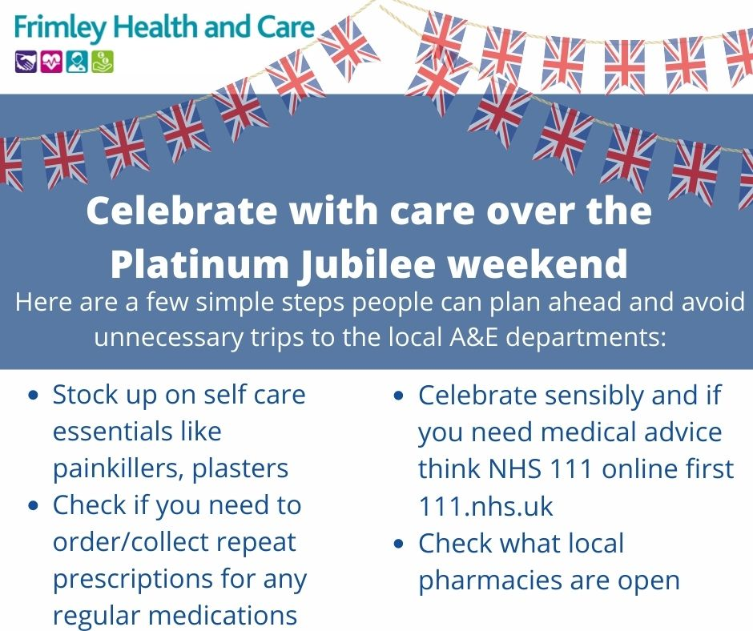
The NHS will be busy over the Platinum Jubilee weekend. Celebrate with care, and if you do need medical advice over the weekend remember you will be seen quicker if you:  - Visit a local pharmacy  Check local pharmacies that may be open on 2 and 3 June here https://www.google.com/maps/d/viewer?mid=1FdOJEqjNEAfK4v3Ko-yYroeRSQp3kgKl – you can search for your postcode to find local pharmacies open near you  - Contact NHS 111 online, or call 24 hours a day, 7 days a week  - For minor injuries visit the Minor Injury Unit at Brants Bridge in Bracknell – open 8am-8pm 7 days a week. X-ray available Sunday to Friday | The NHS will be busy over the Platinum Jubilee weekend.  Some pharmacies may have restricted opening hours on the 2 and 3 June.  https://www.google.com/maps/d/viewer?mid=1FdOJEqjNEAfK4v3Ko-yYroeRSQp3kgKl | Know where to go when feeling unwell Facebook image: kwtg-medical-advice.jpg (940×788) (frimleyhealthandcare.org.uk)  Twitter image: kwtg-services-available-twitter.png (1600×900) (frimleyhealthandcare.org.uk)  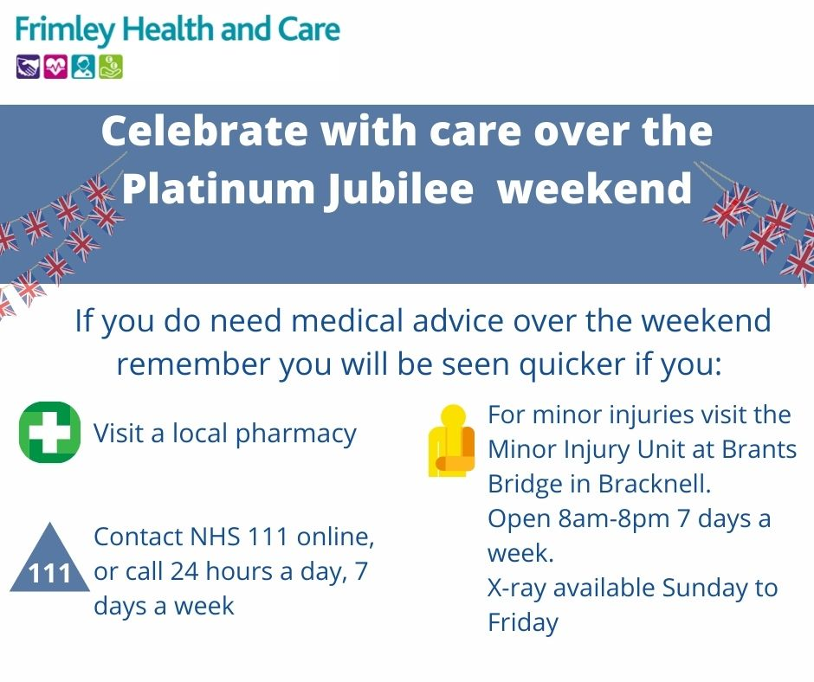
NHS 111 from 2 – 5 June
Celebrate with care over the Platinum Jubilee weekend. If you’re organising street parties or heading off to local celebrations across local parks and other attractions over the Jubilee weekend - Remember if you need medical advice think NHS 111 first. Visit www.111.nhs.uk  It will be quicker than going to A&E. | If you’re organising street parties or heading off to local celebrations across local parks and other attractions over the Platinum Jubilee weekend celebrate with care. Remember if you need medical advice think NHS 111 first. Visit www.111.nhs.uk  It will be quicker than going to A&E. | NHS 111 image nhs-111.jpg (940×788) (frimleyhealthandcare.org.uk)  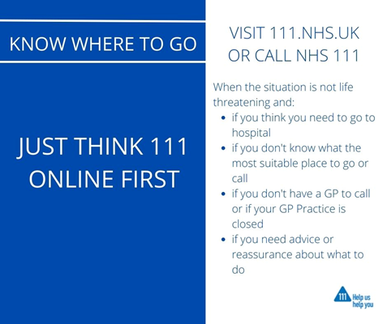
Celebrate with care over the Platinum Jubilee weekend. NHS services will be busy, and you will be waiting for a long time if you do go to A&E. Remember to think NHS 111 first www.111.nhs.uk  Help us help you be seen by the most appropriate services for your healthcare needs and leave A&E for those who really need it. | Celebrate with care over the Platinum Jubilee weekend. NHS services will be busy, and you will be waiting a long time if you do go to A&E. Remember to think NHS 111 first www.111.nhs.uk  Help us help you be seen by the most appropriate services for your healthcare needs and leave A&E for those who really need it. | NHS 111 video  Think NHS 111 - YouTube
Minor Injuries Unit in Bracknell from 2 – 5 June
Celebrate with care over the Platinum Jubilee weekend. If you are out and about and have a minor injury, you will wait longer if you go to A&E. For minor injuries like cuts, grazes, minor head injuries or sprains and strains, the Minor Injuries Unit located at Brants Bridge, Bracknell, RG12 9RT. It is open every day from 8am until 8pm, x-ray available Sunday-Friday.  http://www.frimleyhealthandcare.org.uk/living-here/helping-you-to-stay-well/know-where-to-go-when-feeling-unwell/ | Celebrate with care over the Platinum Jubilee weekend. If you are out and about and have a minor injury, you will wait longer if you go to A&E. For cuts, grazes, minor head injuries or sprains and strains, visit the Minor Injuries Unit located at Brants Bridge, Bracknell, RG12 9RT. Open every day from 8-8pm. | Image https://www.frimleyhealthandcare.org.uk/media/3009/minor-injuries-know-where-to-go-insta.jpg  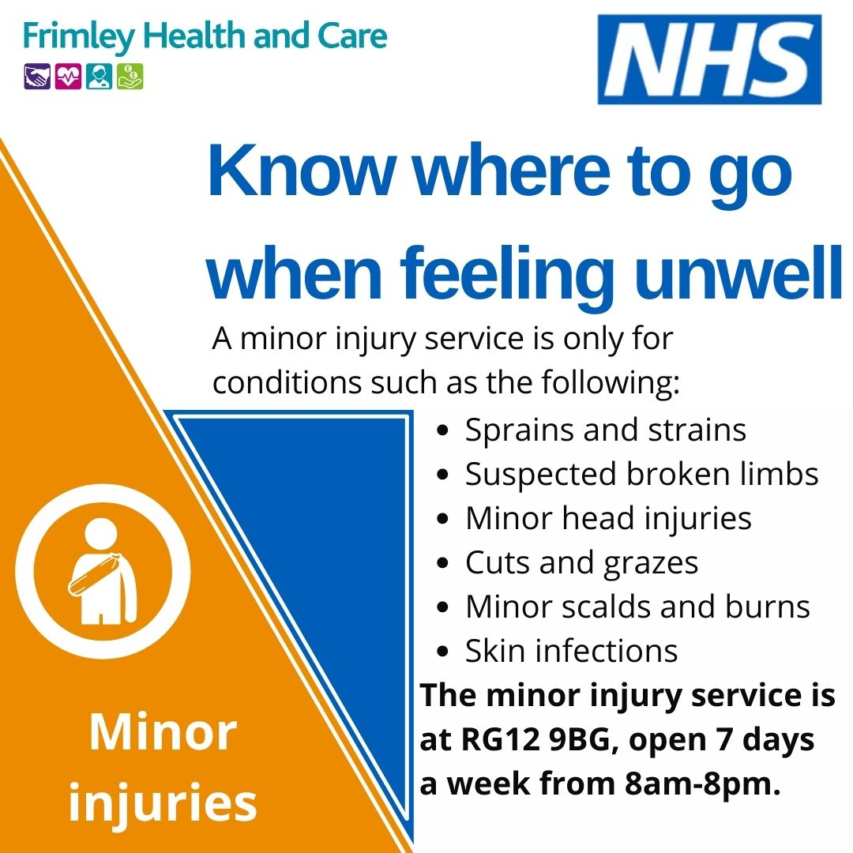
Pharmacy from 2 – 5 June
Celebrate with care over the Platinum Jubilee weekend and remember to ask your pharmacist first.  They are qualified healthcare professionals who can offer clinical advice and over the counter medicines.  Help us help you get seen quicker and visit your local pharmacy.  http://www.frimleyhealthandcare.org.uk/living-here/helping-you-to-stay-well/know-where-to-go-when-feeling-unwell/ | Celebrate with care over the Platinum Jubilee weekend and remember to ask your pharmacist first.  They are qualified healthcare professionals who can offer clinical advice and over the counter medicines.  Help us help you get seen quicker and visit your local pharmacy.  http://www.frimleyhealthandcare.org.uk/living-here/helping-you-to-stay-well/know-where-to-go-when-feeling-unwell/ | Feeling unwell pharmacy image  feeling-unwell-pharmacy.png (1080×1080) (frimleyhealthandcare.org.uk)  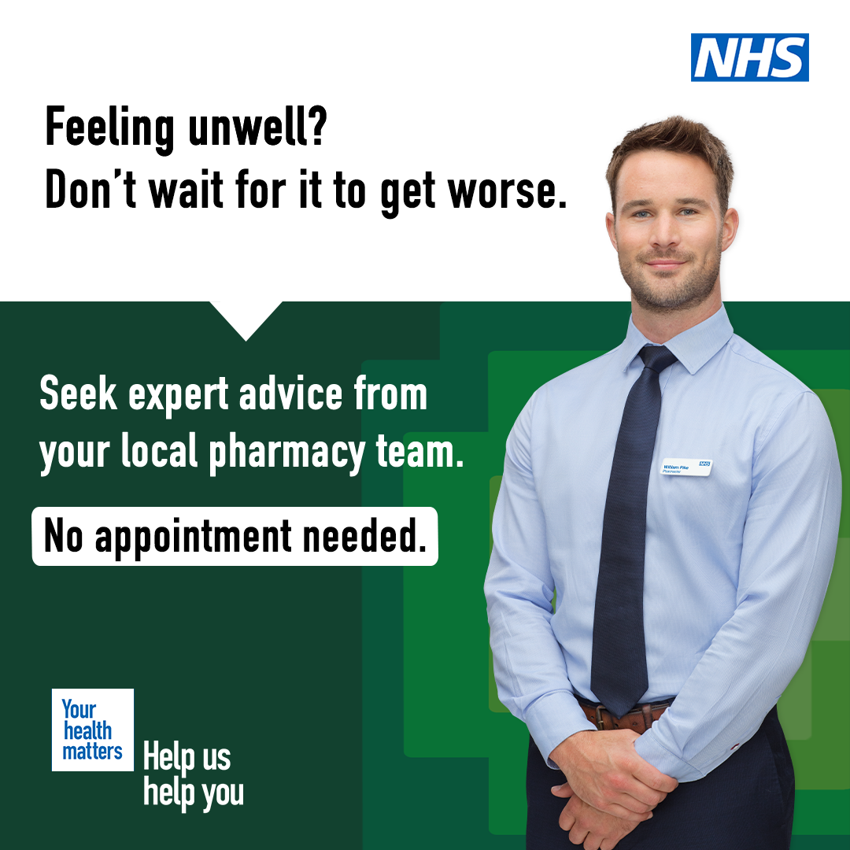
Healthier Together from 2 – 5 June
The Platinum Jubilee weekend is going to be a great celebration. The NHS is encouraging everyone to celebrate with care.  A&E will be busy, so help us help you and if your  If your child is unwell visit https://frimley-healthiertogether.nhs.uk/ first for clear information on common childhood illnesses, including advice on what 'red-flag' signs to look out for and where to seek help if required. | The Platinum Jubilee weekend is going to be a great celebration. The NHS is encouraging everyone to celebrate with care.  A&E will be busy, so help us help you and if your  If your child is unwell visit https://frimley-healthiertogether.nhs.uk/ first. | Healthier Together image: know-where-to-go-2.png (940×788) (frimleyhealthandcare.org.uk)

