Tele-Dermatology launching in September
A tele-Dermatology service has recently been commissioned for the ICS, together with a new community service within NEHF to address current inequalities of provision. This service is intended to:
- Increase patient access and reduce waiting times
- Reduce the incidence of clinical harm that is associated with long waits
- Improve patient outcomes

This service is scheduled to go live in September. From this date all dermatology referrals should be sent via this service by means of an EMIS compatible application called Cinapsis (the only exception to this being the continued use by Surrey Heath of Sussex Dermatology to manage their Urgent & Routine referrals). Referrals will be managed by the tele-dermatology service or directed to primary care (with detailed management plan), relevant community services, or into the acute service provided by Frimley Health as appropriate.

The new service will also include the provision of medical photography services which the Provider will book patients into in cases where it has not been possible for the GP to send referrals through with images.

On receipt of medical photography ALL referrals will be virtually triaged by a Dermatology Consultant within maximum of 2 working days.

Contracted photography clinic timescales for delivery
- 2 working days for suspected cancer referrals
- 5 working days for urgent patients
- 10 working days for routine patients

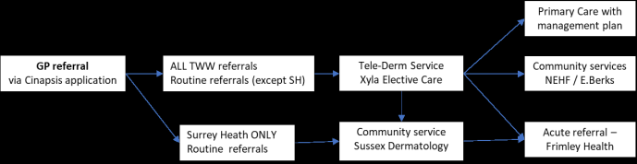
Summary of tele-Derm pathway

