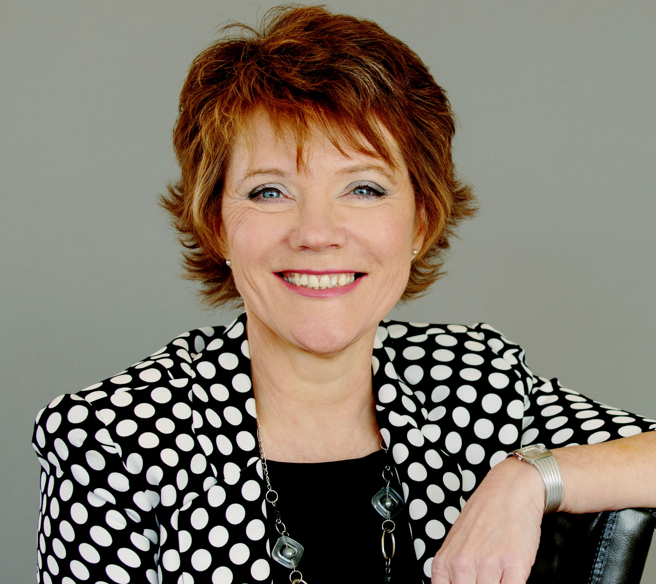
Leadership for a Thinking Environment
An introduction for leaders to the Thinking Environment® with Linda Aspey

The Thinking Environment

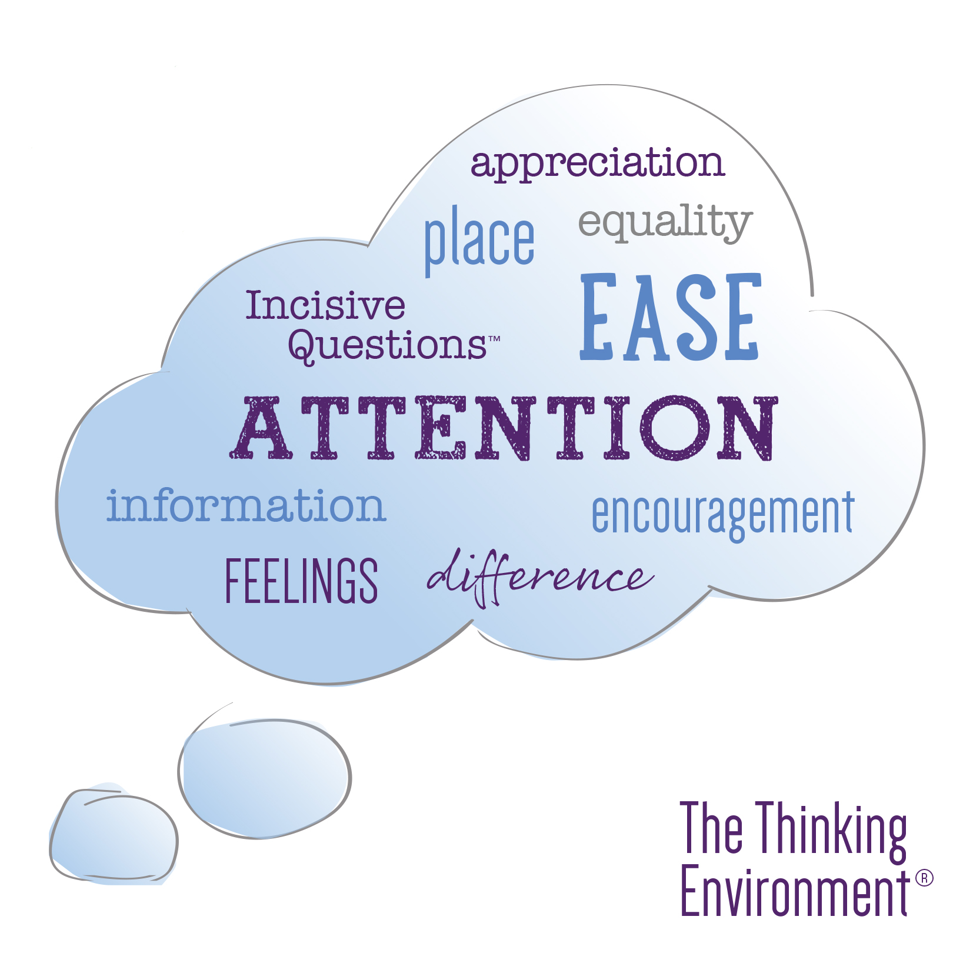
In these complex, changing and fast-paced times, where the reality for many is workforce shortages and excessive workloads the imperative on us all as leaders to build effective teams has never been more important. One of the most important things that we can do as leaders not just in the working environment but in all aspects of our lives is to develop our own and others’ thinking skills, because the quality of everything we do depends on the quality of the thinking we do first.

We have spent many years observing and testing out the kinds of conditions where people can think well – both for themselves and for others. And we have found that the quality of people’s thinking depends mostly on the way that people treat each other when they’re together. From this and other discoveries, emerged “10 Components of a Thinking Environment” and a set of useful tools for thinking well, together.

The Thinking Environment provides you with a system to support quality thinking, and it reliably and significantly improves day to day conversations, 1:1 coaching and mentoring sessions, team meetings, group events and when applied consistently, whole organisational cultures.

In this 90-minute interactive online session you’ll learn about the impact of the Thinking Environment and discover:

- how a Thinking Environment promotes high quality thinking, trust, creativity and decision-making
- how it can enable individuals, teams and organisations to see what’s holding them back and provide new insights that support change and progress
- a powerful and inclusive approach for having better meetings and for building thriving, inspiring workplace cultures
- three new tools for creating a conducive meeting culture, that you can apply immediately at work.

About Linda I help leaders and teams to discover how to best lead themselves and others, to build strong, trusting relationships, think creatively about challenges, make courageous decisions, and develop practical strategies and plans to deliver results.

I have seen many times how clear thinking and associated skills helps leaders to create powerful, engaging environments where people can think for themselves and contribute their best work. I’ve specialised in the Thinking Environment for almost 15 years and am global faculty at Time to Think. I am also a former nurse (SRN., RSCN) so have some appreciation of the NHS environment and its challenges and opportunities. https://www.linkedin.com/in/lindaaspey

