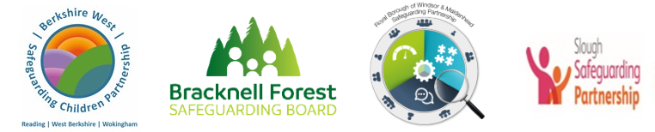
INTRODUCTION TO PAN BERKSHIRE CDOP (Child Death Overview Panel)
Every child death represents a tragedy, a life changing event for families and communities. Aiming to prevent deaths where we can and improve care and support for children, their families and communities, every child death is reviewed in detail, to draw out any learning and to apply those lessons for the future.
In Berkshire we run a joint Child Death Overview Panel, (CDOP) which looks at the causes of death and the services provided for all the Berkshire children that die. Our panel works across the six local authorities in the county, Bracknell Forest Council, Reading Borough Council, The Royal Borough of Windsor & Maidenhead, Slough Borough Council, West Berkshire Council and Wokingham Borough Council. CDOP members come from services that surround children, keeping them safe and well and caring for them and their families when they need it.
https://www.gov.uk/government/publications/child-death-review-statutory-and-operational-guidance-england
The attached guidance (via the link) sets out the full process that follows the death of a child who is normally resident in England. It builds on the statutory requirements set out in Working Together to Safeguard Children and clarifies how individual professionals and organisations across all sectors involved in the child death review should contribute to the process.
All professionals who care for children, or who have a role in the child death review process, should read and follow this guidance so that they can respond to each child death appropriately. This includes people working within:
• Health services (across all sectors: acute, mental health, primary care and community)
• Children’s social care services
• Police
• Coronial services
• Education
• Public health

When will professionals be involved in this process?
A Reporting Form is sent to key professionals including Primary Care involved in the care of the child and family by the Child Death Overview Panel Office via eCDOP – the online recording, casework and reporting of child deaths system that all CDOPs in England use.
These forms gather information which is combined and anonymised prior to the Panel overview.
Completion of the form is your opportunity to contribute to understanding and learning from deaths. Often, relevant information will only be known to one agency. This can be something that seems small or insignificant to the person who has it but can be the missing piece that informs significant learning.

As a professional involved with the child and/or family you may also be invited to the Child Death Review Meeting (CDRM). CDOP and Acute Trusts work together to gather the information for the Process.
For further information about CDOP/eCDOP please contact us on PanBerkshire.CDOP@bracknell-forest.gov.uk
If you think that CDOP are not aware of a child death in your area you can notify your local CDOP at
https://www.ecdop.co.uk/panberkshire/live/Public

