DXS EMAIL FUNCTION ERROR


DXS is aware of an email issue affecting a small number of users. The issue concerns emails failing to send through the Outlook mail client within DXS Point-of-Care. Affected users will receive a bounce-back email notifying them of the failed email delivery. In this instance, the bounce-back email may look as follows:
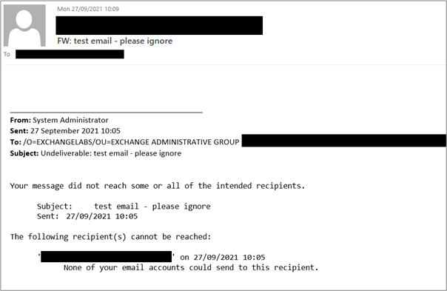
The underlying issue lies in the active directory not finding the user’s common name. Consequently, a string of text appears in the ‘From’ field rather than the actual address, resulting in failed email delivery.
Reasons why the active directory cannot find the user may include the email address used for sending not existing or spelt incorrectly. We recommend system administrators investigate the email address and make the required changes.
The following workarounds can be used:
- Opting to use the inbuilt DXS Point-of-Care mail client.
- Saving the desired document to the patient record/disk and emailing it through Outlook external to DXS Point-of-Care.
- When emailing through Outlook within DXS Point-of-Care, change the sending email address from the long string of text (should it be present) and enter another email address known to work.
Should you have any further questions, please contact our Support Desk using the below details.

Kind regards,
DXS Team
Should you experience any difficulties with DXS, please contact our Support Desk using the details below:
Email: support-uk@dxs-systems.com or Tel.: 0800 028 0004 option 1,
Monday to Friday: 07:30-19:00

