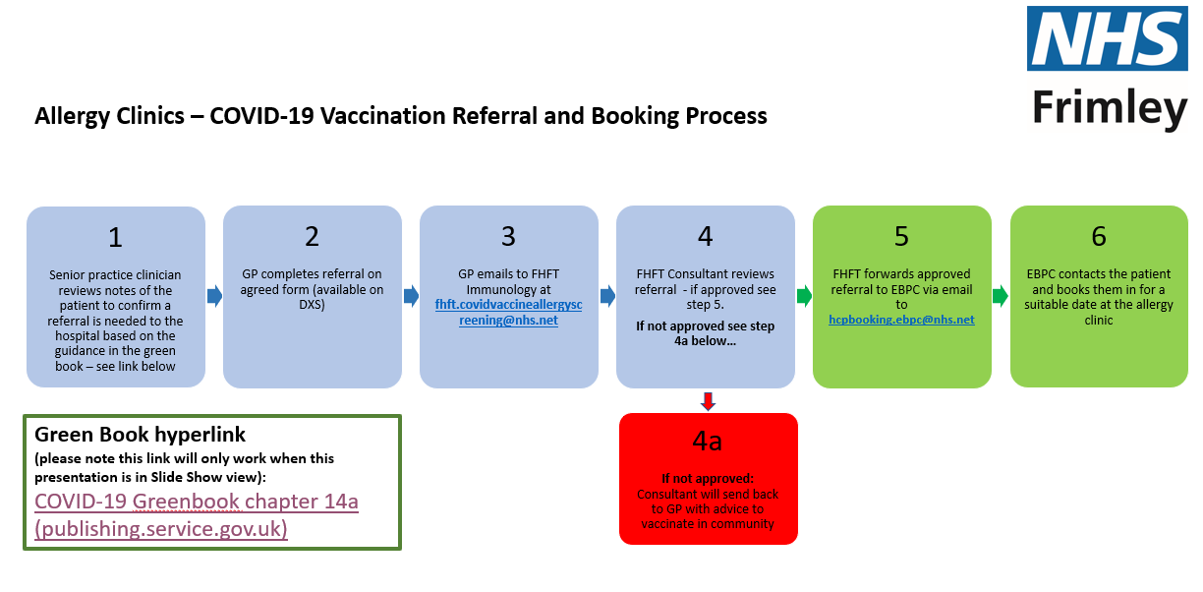
Green Book hyperlink
COVID-19 Greenbook chapter 14a (publishing.service.gov.uk)

PLEASE GO TO REFERRAL FORM AND GUIDANCE OVERLEAF
Referral to the Frimley Heath NHS FT Covid Vaccination triage clinic for patients at high risk of allergic reactions
Please follow the algorithm for referrals (page 4); referrals that do not meet these criteria will be rejected. This is in line with the Green Book guidance at COVID-19 Greenbook chapter 14a (publishing.service.gov.uk)
Referral to be emailed to: fhft.covidvaccineallergyscreening@nhs.net
Patient Name: | Patient Address:
D.O.B: | NHS Number:
Contact tel number: | Patient’s email address:
Patient’s GP:

Details of Referrer (GP or Vaccination site)

Date of Referral
Are you referring for the 1st dose of Covid Vaccination | Yes No
Are your referring for the 2nd dose of Vaccine: | Yes No
Are your referring for a booster dose: | Yes No
Patient’s Allergy History - please give full details of anaphylactic or serious systemic allergic reactions, including triggers where known? (referrals without full details of previous serious allergic reactions will be rejected)

Please list the patient’s medications
Does the patient have a known allergy to PEG? | Yes No
If the referral is for 2nd or booster dose give details of previous doses: | Date of First dose:  Vaccination Name:  Site of first dose:  Details of any reaction to this dose (time of reaction/symptoms / details of medical help needed):  Date of Second dose:  Vaccination Name:  Site of first dose:  Details of any reaction to this dose (time of reaction/symptoms / details of medical help needed):
Any other comments from referring site

A LINK TO THE BSACI VACCINE ALLERGY FAQS FOR GPS:
VACCINE-ALLERGY-FAQs-for-GPs-Final-Website-06.07.21.pdf (bsaci.org)

PLEASE ALSO SEE THE INFORMATION ON THE NEXT PAGE
Request for FHFT Immunology Advice and Guidance for Covid-19 vaccination

There are very few individuals who cannot receive the Pfizer BioNTech (Comirnaty) or Moderna (Spikevax) COVID-19 vaccines. Nuvaxovid can be offered in hospital-based allergy clinics using this referral process, if there is a clinical indication that it is required. Where there is doubt, rather than withholding vaccination, appropriate advice should be sought. Please refer to the Green Book for detailed advice COVID-19 Green Book chapter 14a (publishing.service.gov.uk)

This form above is to be used to support an Advice and Guidance request re Covid-19 vaccination for a patient who is deemed to be high clinical concern due to either a history of allergy/anaphylaxis or a possible allergic reaction to a COVID-19 vaccine. It is intended to ensure a prompt response and clear guidance around the following key questions:-

1. Which Vaccine can I give?
2. Where should the vaccine be administered community/hospital?
3. Should the patient be advised to take an antihistamine pre vaccination?

The tables below summarise the clinical actions required for the Management of patients with a history of allergies and for those patients who have a possible allergic reaction to a previous dose of COVID-19 vaccine.
PLEASE NOTE: THE TABLES BELOW ARE CORRECT AT 18.10.2022. PLEASE CHECK FOR ANY UPDATES TO THE TABLES AT COVID-19 Green Book chapter 14a (publishing.service.gov.uk)

Figure 1 Management of patients with a history of allergy Figure 2 Flowchart for managing patients who have allergic reactions to a previous dose of COVID-19 vaccine
