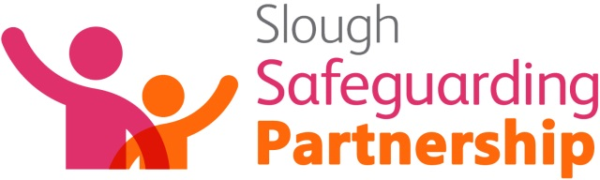

Medical assessments in Child Protection and sexual abuse – a half day conference for experienced practitioners

17th March 2022: 10:00 – 13:00

Do you want to understand more about Child Protection medicals including medicals following suspected child sexual abuse or exploitation?

Do you want to increase your knowledge about the sexual offences legislation and forensic processes surrounding children’s investigations?

If so – this virtual half day conference is a must for you!

It is particularly relevant for social workers and police teams but would be beneficial for all professionals supporting children who may need a child protection medical.

Aims of conference
To improve competencies for partnership working when responding to children who need to undergo a medical assessment for child protection or sexual abuse purposes.

At the end of the conference staff will:

- Have increased understanding of the child protection medical purpose and process including referral, consent and timings.
- Have increased knowledge of the sexual offences legislation and how it applies to children.
- Understand the forensic processes and police investigative processes.
- Have increased knowledge of processes and services available to victims in the Solace Sexual assault Centre (SARC).
- Be better equipped to support clients who have been raped or sexually assaulted
- Have increased confidence to professionally challenge colleagues regarding processes, understanding and decision making.

Who is this conference for - This is an Advanced Course
This conference is an advanced course for practitioners who work with, or come into contact with children/young people where there are concerns about possible sexual abuse, sexual assault or sexual exploitation. It is particularly relevant for:
- Social workers
- Police personnel from CAIU, DAIU and Safeguarding teams
- Ambulance personnel
- School nursing teams
- Health Visitors
- Practitioners who attend child protection conferences for children who may have suffered sexual abuse, sexual assault or sexual exploitation

Conference Presenters
The conference will be presented by local experts from Berkshire Health Care Foundation Trust, Thames Valley Police and the Sexual Assault Service

Presenter Biographies

Dr Louise Watson - Designated Doctor – Children’s Safeguarding & Consultant Community Paediatrician

Louise is a community paediatrician working within Berkshire Healthcare Foundation Trust, and is Designated Doctor for children’s safeguarding in Berkshire East. She regularly sees children for medical assessment in clinic as part of the child protection process, with concerns about injury, neglect and sexual abuse. Louise also has an active role in teaching and training paediatricians and other clinicians, and works with multiagency colleagues in the local strategic safeguarding partnerships.

Detective Inspector Stuart May – TVP East Berkshire Child Abuse Investigation (CAIU)
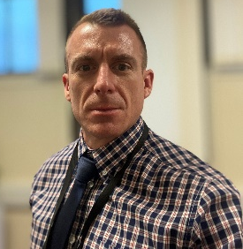
Stuart has been the CAIU DI in East Berkshire for 4 years. Stuart joined Thames Valley Police in December 2003 and has spent the majority of his career in Detective roles. Stuart has worked in both the Child Abuse Investigation Unit and the Domestic Abuse Investigation Unit and is passionate about safeguarding the vulnerable and bringing those who offend against them to justice. Stuart has also trained as a Family Liaison officer and worked on a complex CSE incident room under Major Crime. He is an active member of Slough Safeguarding Partnership and is currently the Vice Chair of the Slough Safeguarding Practice Review Group.

Stuart is married with twin boys aged 10 and enjoys exercising, music and whisky.

Dr Sheila Paul – Clinical Director, Thames Valley Sexual Assault Service
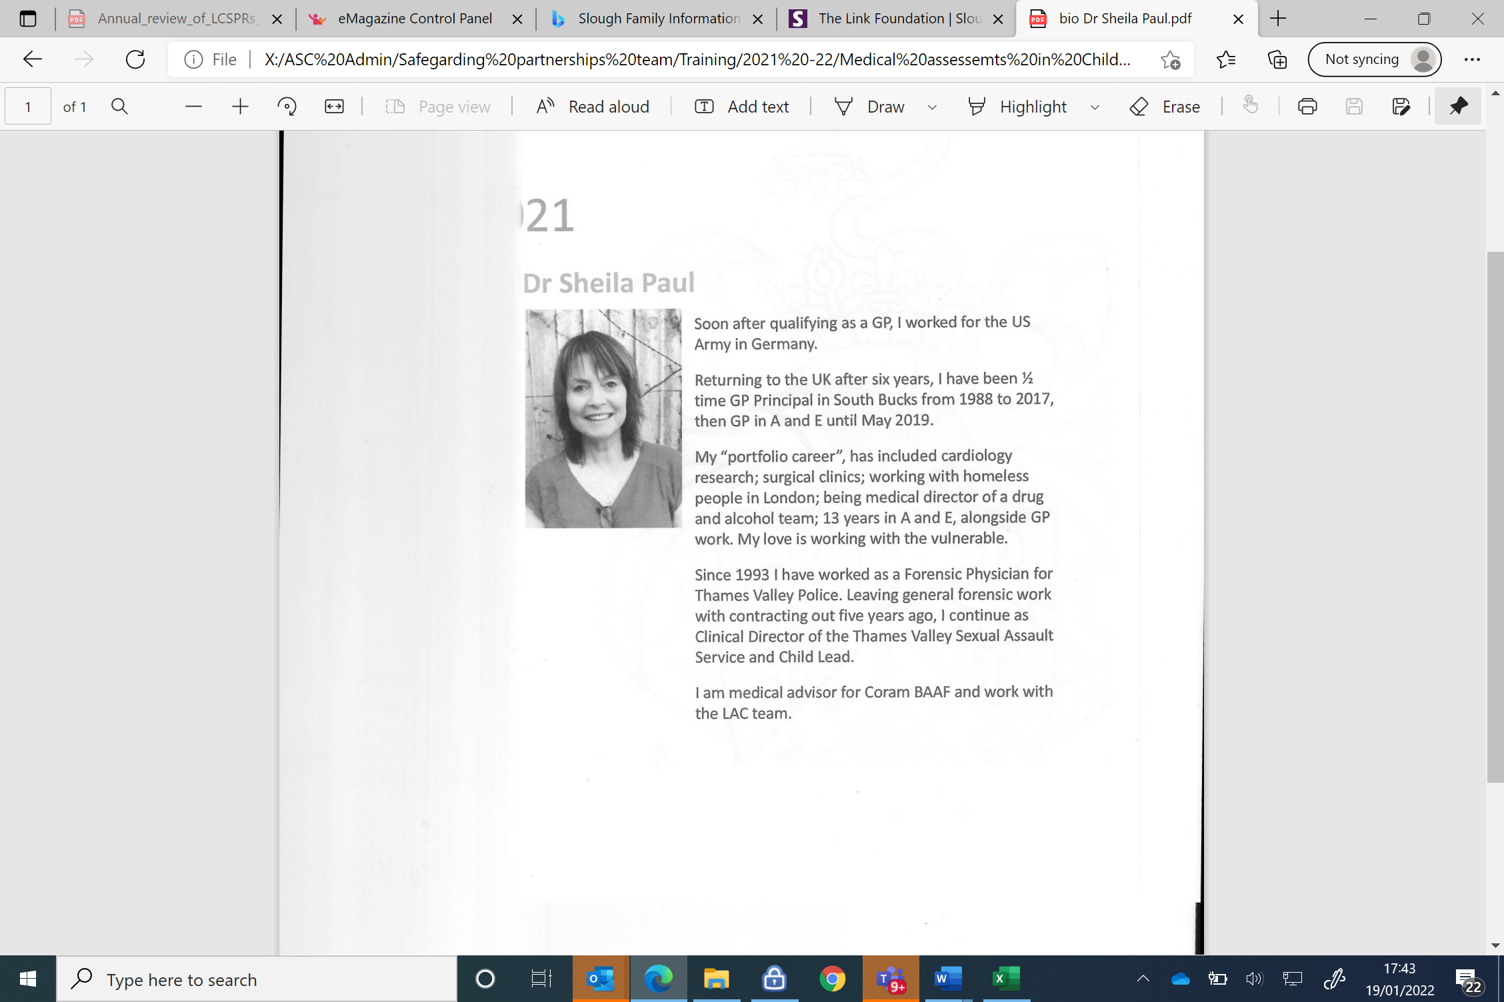
Soon after qualifying as a GP, Sheila worked for the US army in Germany.

She returned to the UK after six years and has been ½ time GP Principal in South Bucks from 1988 to 2017, then a GP in A and E until May 2019.

Her “portfolio career” has included cardiology research, surgical clinics; working with homeless people in London; being medical director of a drug and alcohol team; 13 years in A and E, alongside GP work. Her love is working with the vulnerable.
Since 1993, Sheila has worked as a Forensic Physician for Thames Valley Police. She is the Clinical Director of the Thames Valley Sexual assault service and child lead. She is also a medical advisor for Coram BAAF and works with the Looked after Team.

To book your place: Please email Shakir Hussain Shakir.Hussain@Slough.gov.uk
who will confirm your place.

Links and further information for the conference will be sent out 1 week before the conference date.

