Adult Integrated Respiratory Service (AIR Service) is going live on NHS e-RS –Frimley North (HWP facing practices) ONLY

We are writing to inform you that from the 28th^{t} of February 2022 the below service will be available on e-RS. Please note, there is no change from the current service offered, we have just moved the service referral process from ICE to eRS (ICE referral requesting will no longer be available from June 2022- further communications will follow to confirm date).

The Adult Integrated Respiratory (AIR) service provides a range of specialist respiratory services to patients with Asthma, COPD, ILD, Bronchiectasis and home oxygen needs in East Berkshire. The service includes outpatient appointments for Asthma, Severe Asthma, COPD, ILD, Bronchiectasis, specialist respiratory physiotherapy including dysfunctional breathing pattern disorder, home oxygen assessment and a Consultant Nurse clinic for diagnostic uncertainty. The service also offers Pulmonary Rehabilitation, admission Prevention for patients with COPD and domiciliary services where required.

The service can be accessed by selecting the RAS service below on e-RS. Frimley Health will contact the patient directly to book a virtual or face to face outpatient appointment, a secondary care diagnostic test, Domiciliary visit or management advice may be sent back to you. Those returned with management advice will appear on your Referrer Action Required Worklist. Please action in accordance with the comments on the worklist. Where a detailed response is required, the clinicians will write a dictated letter to you and copy in the patient. Advice & Guidance will also be offered alongside this service to provide specialist advice. This can be accessed by selecting the request type ‘advice’ on the eRS service below.

Please ensure you are referring to the correct service on NHS e-Referrals and please check the Directory of Services (DoS) before referring.

Frimley North GPs ONLY

Specialty | Service | Site
Respiratory | Respiratory Medicine Adult Integrated Resp (AIR) Triage - Frimley Health NHS Foundation Trust | King Edward

Frimley South GPs (FPH - facing GPs):

Please Note - There are no changes to the existing pathway for Frimley South GPs referrals to go through the SPA (Single Point of Access).
Please complete referral form on DXS and email to

NEHF - frimleyccg.nehfspa@nhs.net :Tel 0300 6149000
Surrey Heath - spa@nhs.net : Tel 0300 0030 050

Key Contacts (this can also be found on https://www.fhft.nhs.uk/gps/gp-centre/referrals/

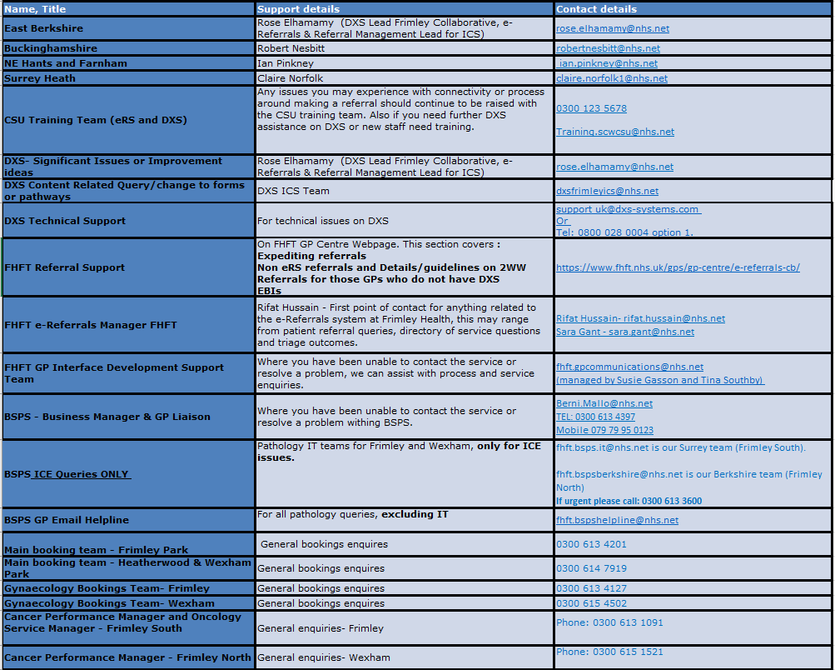

Key Pages within the FHFT website (GP Centre): https://www.fhft.nhs.uk/GPcentre. Key pages can also be accessed via the DXS home page and relevant speciality landing pages:
- Urgent Advice Service Directory: https://www.fhft.nhs.uk/gps/gp-centre/urgent-advice/
- Routine Advice Service Directory: https://www.fhft.nhs.uk/gps/gp-centre/routine-advice/
- SDEC Service Directory (including the Ambulatory Emergency Care Unit): https://www.fhft.nhs.uk/gps/gp-centre/sdec-including-ambulatory-care/
- Referral Support: https://www.fhft.nhs.uk/gps/gp-centre/referrals/. This section covers expediting referrals, non-eRS referrals and details/guidelines on 2WW Referrals for those GPs who do not have DXS
- Current status of services: https://www.fhft.nhs.uk/gps/gp-centre/latest-news-and-gp-newsletter/ – supporting advice including opening times of services etc:

