Physiotherapy Services going live on NHS eRS – Frimley North (HWP-facing practices) ONLY

We are writing to inform you that from the 21st of February 2022 the below Physiotherapy Services will be available on eRS.

Please note, there is no change from the current services offered by our Physiotherapy team, this is purely a change in our GP referral process. In preparation for Epic Go Live, we are starting to transition our referral requesting from ICE onto eRS. This will not have any impact on Radiology or Pathology requesting which will remain on ICE.

The services can be accessed by selecting the relevant RAS service below on eRS. Frimley Health will contact the patient directly to book a virtual or face to face outpatient appointment, a secondary care diagnostic test, or management advice may be sent back to you. Those returned with management advice will appear on your Referrer Action Required Worklist. Please action in accordance with the comments on the worklist. Where a detailed response is required, the clinicians will write a dictated letter to you and copy in the patient.

Please ensure you are referring to the correct eRS service and have checked the eRS Directory of Services (DoS):

Specialty | Service | Site
Physiotherapy | Physiotherapy - Neurological Triage Frimley Health NHS Foundation Trust | Heatherwood
Physiotherapy | Physiotherapy – Outpatient Triage Service, Frimley Health NHS Foundation Trust  For Frimley North, this service is for post-op follow-up service, walking aid assessment, amputee rehab (as described within the eRS DOS). For routine MSK /Orthopaedic referrals please continue to use the MSK TAS service in Frimley North. | Heatherwood
Physiotherapy | Physiotherapy - Pelvic Health (Obstetric/Urogynae/Colorectal) Triage - Frimley Health NHS Foundation Trust | Wexham
Physiotherapy | Hand Therapy Triage Service Frimley Health NHS Foundation Trust | Wexham
Physiotherapy | Physiotherapy - Paediatric Triage - Frimley Health NHS Foundation Trust | Wexham

Frimley South (FPH-facing practices) Physiotherapy Referrals

The Frimley South team are working to transition their services onto eRS. In the meantime, please continue to refer in the usual way to: fhft.therapies@nhs.net.

Key Contacts (this can also be found on https://www.fhft.nhs.uk/gps/gp-centre/referrals/)

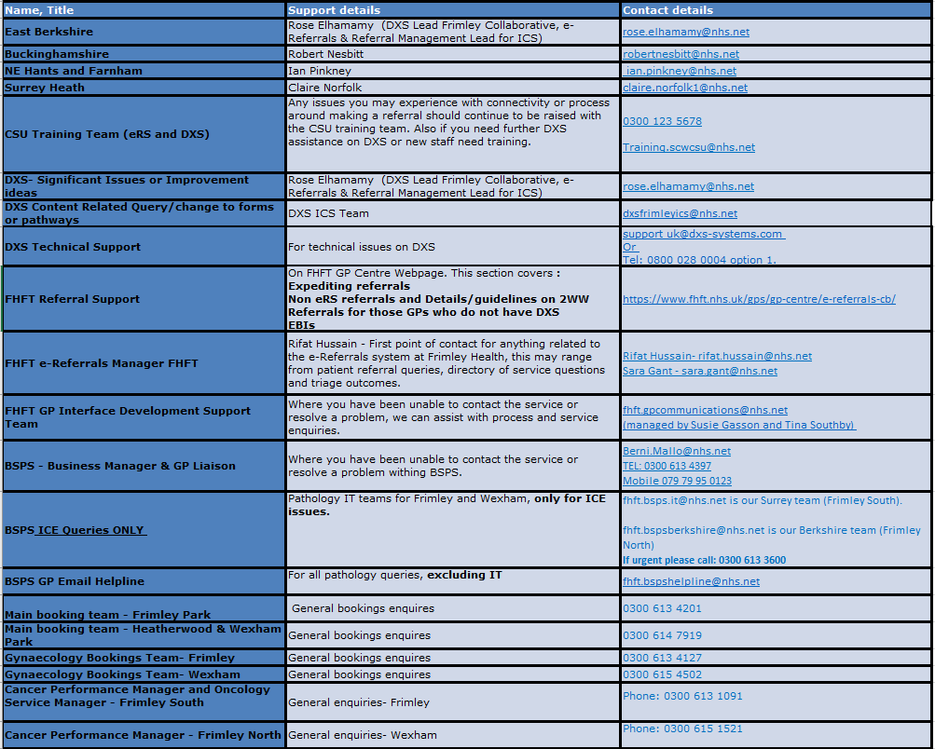

Key Pages within the FHFT website (GP Centre): https://www.fhft.nhs.uk/GPcentre. Key pages can also be accessed via the DXS home page and relevant speciality landing pages:
- Urgent Advice Service Directory: https://www.fhft.nhs.uk/gps/gp-centre/urgent-advice/
- Routine Advice Service Directory: https://www.fhft.nhs.uk/gps/gp-centre/routine-advice/
- SDEC Service Directory (including the Ambulatory Emergency Care Unit): https://www.fhft.nhs.uk/gps/gp-centre/sdec-including-ambulatory-care/
- Referral Support: https://www.fhft.nhs.uk/gps/gp-centre/referrals/. This section covers expediting referrals, non-eRS referrals and details/guidelines on 2WW Referrals for those GPs who do not have DXS
- Current status of services: https://www.fhft.nhs.uk/gps/gp-centre/latest-news-and-gp-newsletter/ – supporting advice including opening times of services etc:

