
Frimley ICS teleDermatology Service
Live from 5th September 2022
- What does the service provide?
- Assess to Cinapsis application to refer patients into the teleDermatology triage service
- Patients will be virtually assessed by a qualified consultant dermatologist
- Provision of Medical Photography clinics (see below)
  - Choice in Cinapsis application to send patients for imagery if unable to attach at practice
  - Provider will book patients, manage clinics and attached images for onward referral into teleDermatology assessment service
- Following triage all onward referrals will be made by the provider
- Outcome letter to primary care; content depends where patient is triaged to:
  - URBN number for any onward referrals into FHFT
  - Outcome of assessment and referral into appropriate local dermatology community service
  - Detailed management plan for patients returned to primary care
- Which patients are suitable for teleDermatology?
  - Patients 12 years and above
  - ALL suspected cancer referrals (TWW)
  - Urgent and routine patients – with the exception of Surrey Heath (to continue to use Sussex Dermatology)
  - NB: teleDermatology is unsuitable for community services; including housebound patients, patients in care homes and those requiring transport (these patients to be referred to FHFT via eRS)
- I am unable to provide images with my referral…
Dermatoscopic images are needed for suspected cancers and lesions.
If you are unsure whether your images are sufficient, please refer to medical photography
- Choice within the Cinapsis application to refer patients into Medical Photography
- The provider will book patients into a photography clinic
- Images will be taken including Dermatascopic images for lesions and suspected cancer
- Referral will be sent onward for virtual triage with images attached
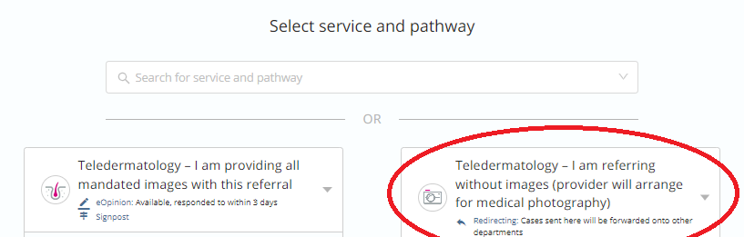

- teleDermatology timescales
Medical Photography Clinics
- 2 working days for suspected cancer referrals
- 5 working days for urgent patients
- 10 working days for routine patients

Virtual Triage
- Maximum of 2 working days on receipt (on referral with attached images)


- What do I need to do differently?
Use the Cinapsis toolbar to refer. The application is already uploaded on your practice desktop and is compatible with EMIS; choose between 2 referral forms:
- Via medical photography if you do not have adequate images to send with your referrals (suspected cancers and lesions require dermatascope images)
- Straight to virtual triage when you have the required images for upload
Please note if you prefer the form on DXS and wish to use this instead, you or your administrator can attach this to the Cinapsis referral.

- Training and How To Guides
Step-by-step guides for clinicians, administrators and medical secretaries are available via the Help Section within Cinapsis.
Useful links provided below (NB you will require a Cinapsis account to access these)
Clinicians
- Getting started – for Clinicians
- How to refer – for Clinicians
- Troubleshooting – for referrers

Practice Administrators
- Getting Started – for Practice Administrators
- Manually releasing cases to EMIS

Practice Secretaries
- Getting Started – for Practice Secretaries
- Referring – for Practice Secretaries

General Tutorials – for all users
- Tutorials

- I don’t have a Cinapsis account
Please speak with your Practice Manager who will be able to set up an account for you.
If you are experiencing issues with accessing or setting up your account please contact the Cinapsis helpdesk who will be able to provide you with support: support@cinapsis.org

- Useful Contacts
- Queries relating to the teleDermatology service or specific patient cases: xyla.frimleytelederm@nhs.net Please provide a Case ID or NHS number.

- Help and any technical support required in the use of Cinapsis: support@cinapsis.org

- For other queries or additional support please contact Philippa May, Frimley ICS Elective Care Project Manager philippa.may@nhs.net

