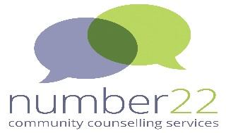

Support for Ukrainian Hosts
Number 22 Counselling Service will be running a session for Ukrainian Host families living in Maidenhead, Windsor and Slough
This will be an opportunity to connect with other Ukrainian hosts
When: Tuesday 13th September 2022 from 5.30pm – 7.00pm
Where: Maidenhead Community Centre
4 Marlow Road – The Quiet Room

Cost: Free
Refreshments available
There will be a presentation on Trauma followed by an informal chat about your experiences of being a host
To book your place please email sarah.luke@number22.org by 1st September
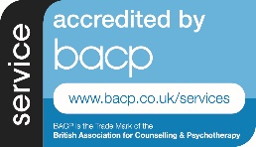
Windsor and Maidenhead Youth & Community Counselling Service -Number 22, Maidenhead - 4 Marlow Road, Maidenhead, SL6 7YR
Number 22 Windsor - Windsor Youth and Community Centre, Alma Road, Windsor, SL3 4HD
Registered Charity Number 1177138 - Supported by the Royal Borough of Windsor and Maidenhead

