FHFT - Request: Please refer any urgent USS Dopplers to exclude a DVT, to our Ambulatory Emergency Care Unit (AECU) and not direct to USS

Dear All,

Please be reminded that any patients requiring urgent USS Dopplers to exclude a DVT, should be referred via our Ambulatory Emergency Care Unit (AECU) service for assessment and exclusion of DVT, and not via a direct request to our Ultrasound department.

To refer to AECU, or any of our SDEC service, please find the phone numbers and inclusion / exclusion criteria within the following link https://www.fhft.nhs.uk/gps/gp-centre/sdec-including-ambulatory-care/ (or via the Urgent & Emergency Care page on DXS). Please see below extract for WPH AECU:

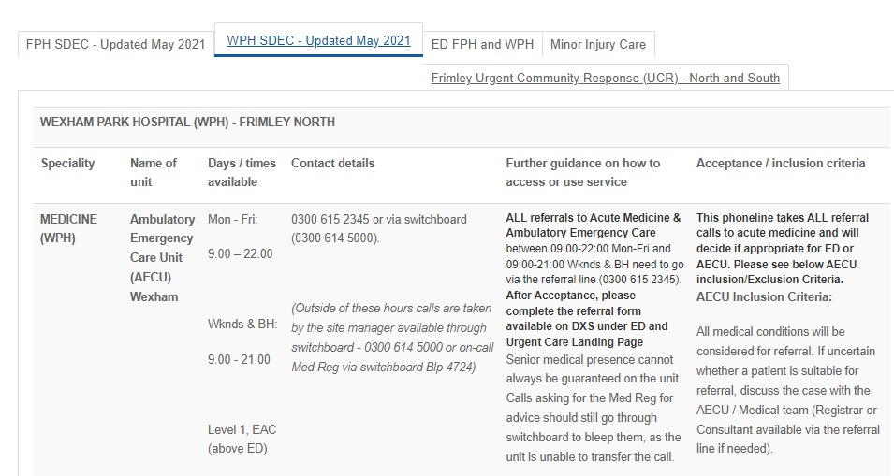

Please see below extract for FPH AECU:

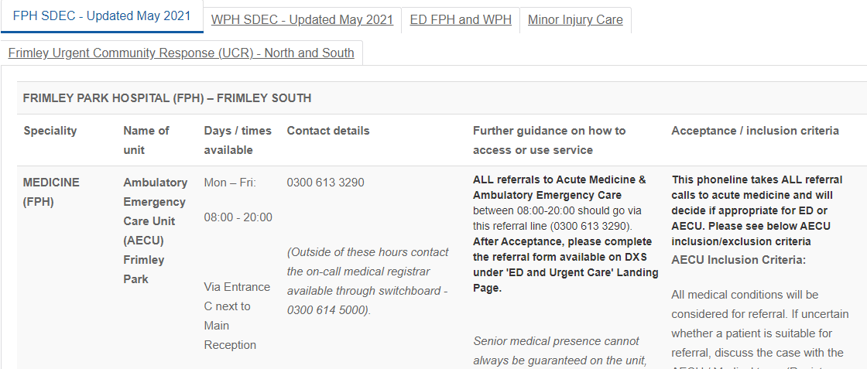

For Urgent Clinical Advice please find the following directory: https://www.fhft.nhs.uk/gps/gp-centre/urgent-advice/

