PCN Toolkit Delivery Programme and workshop Launch supported by Frimley ICB .
Launch Dates: 6 September 08:00hrs to 09:00 and 13 September 12:30- 13:30
Delivery: Virtual by Microsoft Teams Meeting
CHP and NAPC, on behalf of NHSEI, have produced a PCN Estates Toolkit, to provide PCNs with a flexible framework and support process for producing robust primary care investment plans with clear priorities that align to wider ICS strategies. The toolkit has been developed from the published guidance; Primary Care Networks: Critical thinking in developing an estate strategy, into practical tools for use and application. The South West region is looking to support the PCNs in the development of their strategies through a managed programme.
The purpose is to provide a national framework to support PCNs and systems to identify the future primary care estates investment requirements, whilst ensuring consistency in quality and outputs; to enable delivery of suitable, high quality estate provision for Primary Care, and to suitably support service development strategies across the wider health economy.
The PCN Service and Estates Planning Toolkit has two objectives:
i) To enable each PCN to identify and prioritise their estate optimisation, disinvestment and subsequent capital investment requirements to address population health priorities and future service needs.
ii) To support the production of capital investment plans for PCNs and Places and help Integrated Care Systems (ICSs) to aggregate and prioritise local primary care investment requirements against other system demands for capital.
The image below reflects the 6 different stages of the PCN Toolkit:
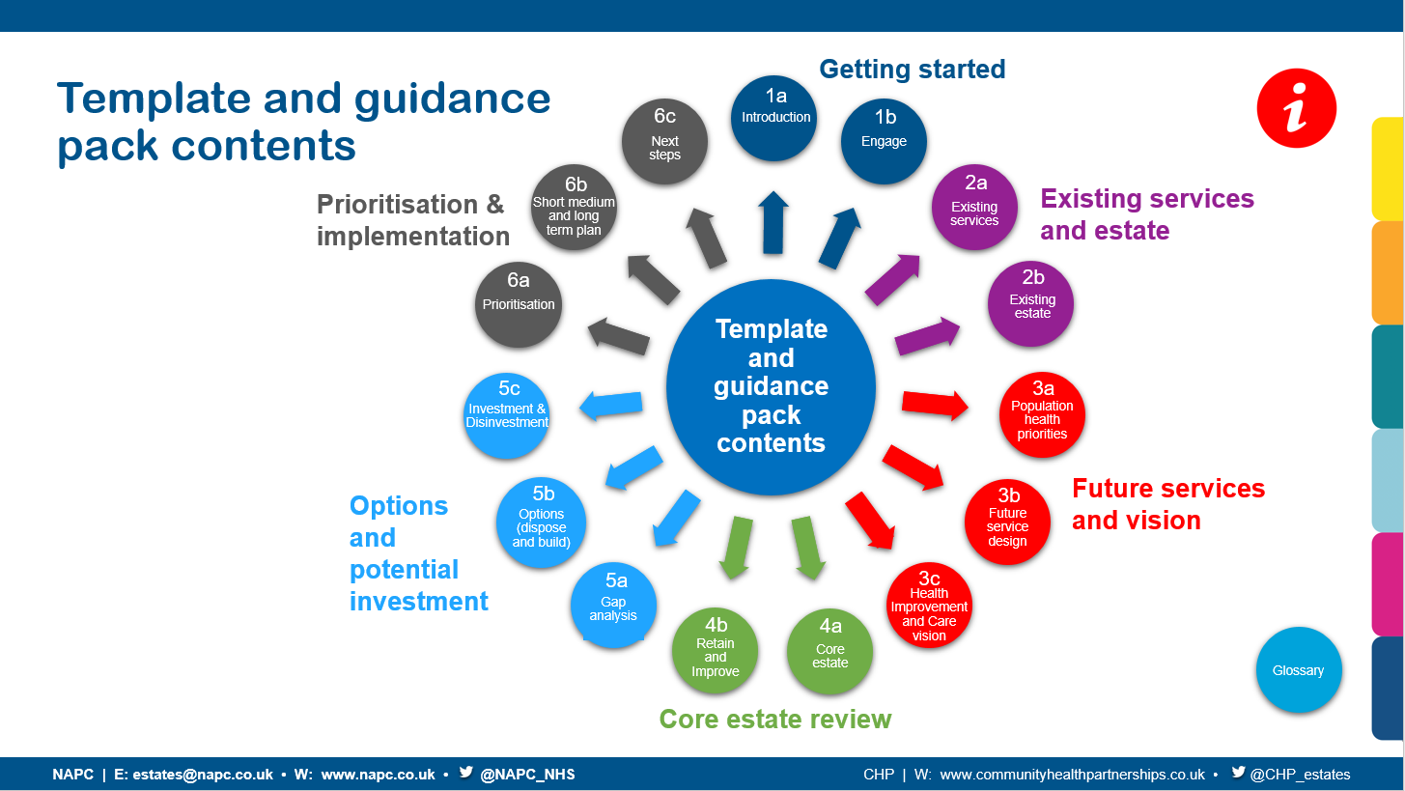
The toolkit starts with a focus on key stakeholder engagement and consideration of priorities in line with a population health led approach to care model design.
It has been developed in line with other key national work streams, emerging policies and emergency planning requirements. This toolkit focuses on clinical vision and strategic estate planning, and we recommend reference to other relevant policies and guidance for wider considerations such as the net zero agenda, digital and health technologies, which should all be taken into consideration in completion of the toolkit.
The Toolkit should be used to further develop existing clinical and estate strategies and plans as opposed to replicating or replacing what has already been achieved and should be used flexibly to meet that objective. It has been developed to align with the Primary Care Data Gathering (PCDG) datasets and SHAPE PCDG Atlas analysis and reporting tools, minimising duplication of effort in establishing the initial baseline.
The benefits of the PCN Toolkit are to develop and articulate a standardised and consistent approach in identifying and delivering Prioritised short, medium, and long-term primary care capital investment & disinvestment plans and key challenges to delivery (e.g. negative equity)
PCN Tool Kit Launch Workshops
Dates for the launch workshop has been sent to all primary care CD’s. PCN’s Manager and Clinical leads:
- Tuesday 6 September 8-9am
- Tuesday 13 September 12.30-1.30pm

Please ensure that you are able to attend one of these events. If you have not received the invitation or would like to attend please contact debbie.taylor36@nhs.net or anshuvarma@nhs.net.

