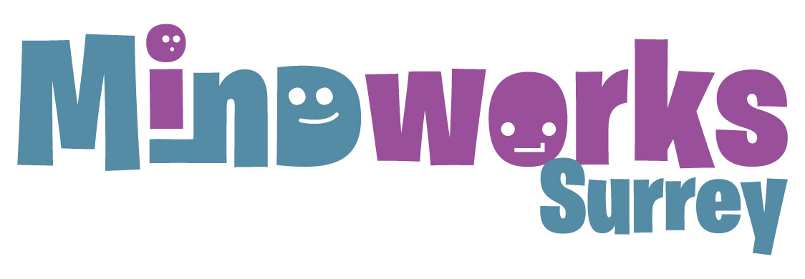

December 2021

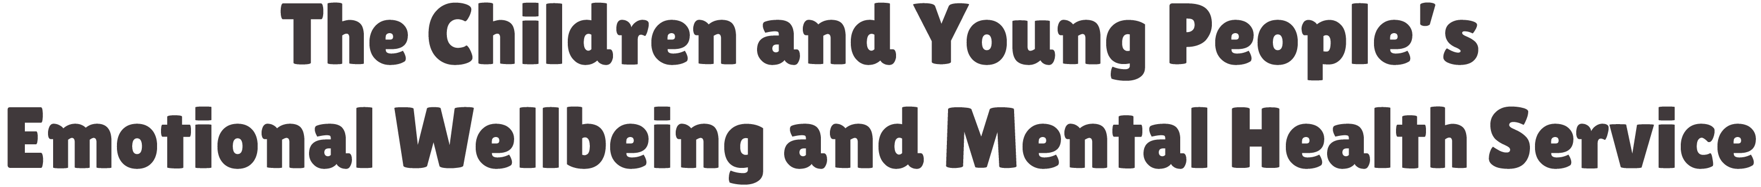

Dear colleague

As we approach the end of the year, we are writing to thank you for your support and cooperation since Mindworks Surrey launched in April, and send you our best wishes for a happy and healthy Christmas and new year.

We thought it might be helpful to share with you the various ways in which you and your patients can access support over the festive period:

24/7 crisis line for young people and families - for children aged from six years, young people and their families/carers who are in crisis. Please call 0800 915 4644 to talk with a professional who will provide advice, support and signposting to a range of community services. No formal request for support is needed. Open 365 days a year.

Out-of-hours advice line - for families struggling with behaviour or difficulties which could be related to neurodevelopmental need, such as autism or ADHD. Skilled and friendly advisers talk parents and carers through ways of calming down difficult situations and remind them of their coping strategies. It runs from 5pm - 11pm, 365 days a year. Please call 0300 222 5755.

Mindworks Surrey website (www.mindworks-surrey.org) has lots of helpful information, advice and signposting.

Mindworks Surrey Access and Advice – formerly known as the CAMHS Single Point of Access (SPA). It helps young people and their families, providing easy and early access to advice and signposting to existing support as well as acting as a doorway (gateway) to more specialist or clinical support as needed. Please call 0300 222 5755. It is open 8am - 8pm, Monday to Friday and 9am - 12pm Saturday. The service is not open on bank holidays.

Our partner Kooth (www.kooth.com) is a free and confidential online mental health and emotional wellbeing platform for children and young people aged 10 - 18 years. It provides access to live chat and messaging with emotional wellbeing practitioners, peer to peer support and a variety of mental health resources. Access to Kooth resources is 24/7 and live chat is available Monday to Friday 12pm - 10pm, and Saturday/Sunday 6pm - 10pm.

We will be sharing an update on the Mindworks Surrey services in the new year. In the meantime, Season’s Greetings from us all.

With very best wishes

Graham Wareham | Trudy Mills | Rachael Wardell | Hayley Connor
Chair of the Alliance Board | Executive Director for Children’s Community Services and ICS Strategic Lead for Women and Children's | Executive Director of Children, Families and Lifelong Learning | Director of Commissioning for Children, Families and Lifelong Learning
