

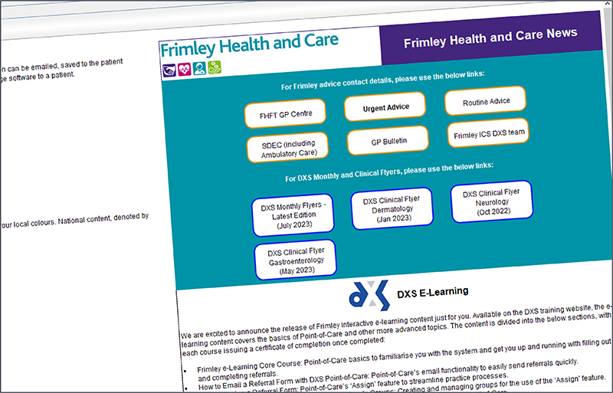
DXS Refresh for Frimley ICS
Over the past year the Elective Recovery & Transformation team at Frimley ICS have been working on updating the content for the below specialities within DXS Point-of-Care:

- Cardiology (includes updated FHFT General Cardiology Referral Form FHC1326)
- Dermatology (includes updated Dermatology Landing Page FHC1555)
- Diabetes (includes new Oviva Type 2 Diabetes Path to Remission Programme Referral Form FHC3334)
- Gynaecology (includes new Heavy Menstrual Bleeding Pathway FHC3227 and Post Coital Bleeding Pathway FHC3350)
- Endocrine (includes updated Thyroid Pathway FHC1857)
- ENT (includes updated documents in the ENT folder and ENT and Audiology Landing Page FHC1831)
- Orthopaedic MSK (includes updated FHFT Orthopaedic MSK Rheumatology Pain Referral Form FHC1830)
- Ophthalmology (includes new FHFT Hydroxychloroquine Referral Form FHC3321)
- Respiratory (includes new FHFT Sleep Clinic Review Referral Form FHC3337)
- Gastroenterology (includes updated FHFT Gastroenterology (GI) and General Surgery Referral Form FHC1009)

The Frimley ICS DXS team will continue to update content on DXS Point-of-Care on an ongoing basis. If you have any queries, issues, or feedback please email the team at:
DXSFrimleyICS@nhs.net
DXS has also introduced new SMART functionality for referral forms, which is being implemented in new and existing referral forms to make the forms more user-friendly and to improve the quality and efficiency of our referral and triage process – hence improving the patient pathway:
- Auto-populated fields from primary care systems, e.g. EMIS
- Mandatory fields (where agreed as a system)
- Passback codes (any reading changes made during a consultation that are recorded on the form are automatically saved back to the patient record)
- Validation rules (a warning message if the patient does not meet the requirements for the service e.g., the patient must be over 18 years old)
- Show/Hide functionality (when a checkbox is selected a form will shrink or expand so that only the necessary fields are shown)
Below you can find links to access the new Frimley e-Learning Course (which is free for all staff), training videos, user guides, DXS Monthly Flyer for August, and DXS Clinical Flyers for Gastroenterology, Neurology, Dermatology, and Respiratory.

  Frimley e-Learning Course
  Register to learn about the basics of DXS Point-of-Care and advanced topics for using referral forms.
  
  DXS User Guides
  Visit our training website for DXS Point-of-Care training videos and user guides.
  

  DXS Monthly Flyers
  On the DXS homepage you can find the latest edition of the Frimley Health and Care monthly flyer.
  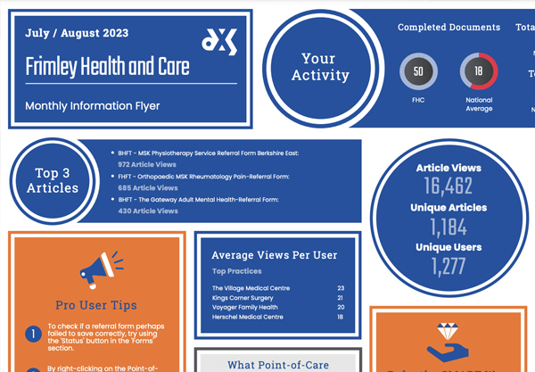
  DXS Clinical Flyers
  On the DXS homepage, find flyers for Gastroenterology, Neurology, Dermatology, and Respiratory.
  