

Saving Referral Forms to the Patient Record with SNOMED Codes

Good day,
We are aware that some Point-of-Care users are seeing an EMIS code, instead of the SNOMED code, when saving a referral form to the patient record from Point-of-Care.
To ensure a referral form saves back to the patient record with the SNOMED code and not an EMIS code, the preferred system should be selected in Point-of-Care.
EMIS Point-of-Care users have two systems available, the ‘SNOMED’ system and the ‘Read2’ system.
To change the system you are using, please follow the steps below:
- Click on the ‘Options’ button on the main Point-of-Care toolbar to open the ‘Preferences’ window
- Alternatively, click on the drop-down arrow on the 'Options' button and select 'Preferences' from the drop-down menu to open the ‘Preferences’ window
- Choose the system you would like to use from the ‘Coding System’ drop-down menu
- Restart DXS Point-of-Care

Option 1:
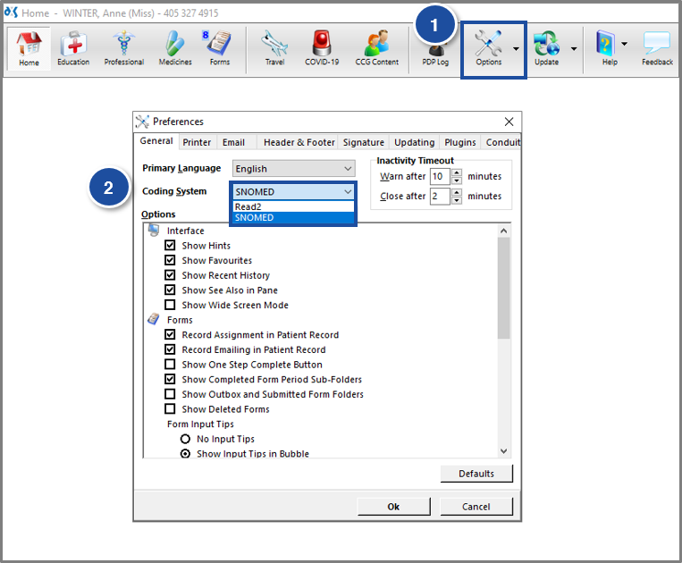

Option 2:
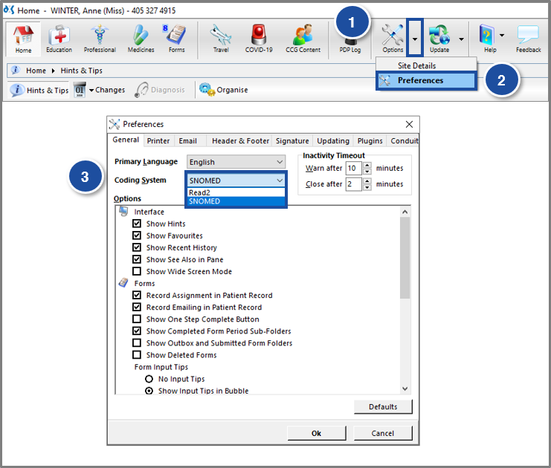

Frimley ICS DXS Team: dxsfrimleyics@nhs.net
DXS Technical Support: support-uk@dxs-systems.com; Phone: 0800 028 0004 Option 1.

