Reminder- BSPS- Booking of Blood Tests- Providing patients with Printed ICE Request Forms

Dear Colleagues

We have recently seen an increase in patients coming for a blood test without an printed ICE Request form. As you are all aware currently, printing facilities are not available at all sites, please see table below along with full details on the FHFT Website:
Booking your blood test | NHS Frimley Health Foundation Trust (fhft.nhs.uk)

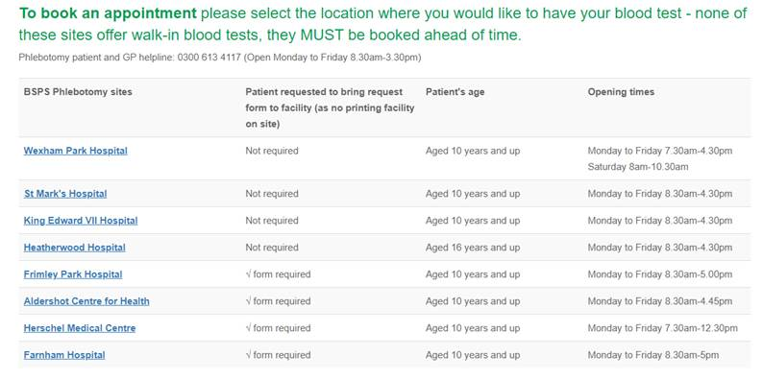
The online booking system does highlight if printing is not available at the point of booking for a blood test.

Thank you for all your support in providing a safe service and managing patient expectations.

Kind Regards,
BSPS Management Team

