Dear Colleagues,

Please find attached our jointly developed ‘FHFT and Primary Care Collaborative Working Reference Guide.’ The purpose of the document is to support strengthening the interface arrangements across Primary Care and Secondary Care and in turn optimise patient care.

The guide outlines agreed ways of working for the different clinical professionals within primary and secondary care and covers a wide range of interface situations summarised below:

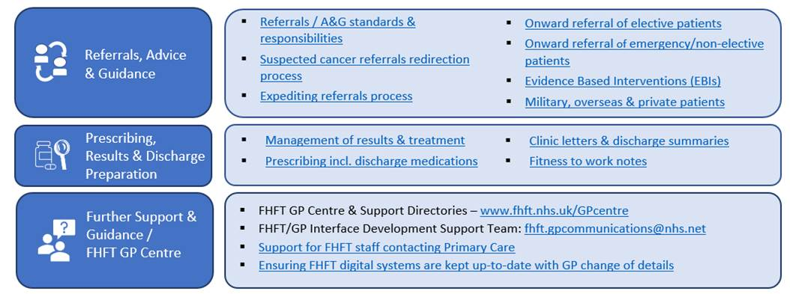

We ask that you read and share the document with all colleagues and adopt the principles within your teams.

If you have any questions, or need support resolving thematic FHFT / Primary Care interface issues, please see section six for contact support details (including contact details for the Interface Development Support team: fhft.gpcommunications@nhs.net).

Many thanks,
Dr Lalitha Iyer (Chief Medical Officer, NHS Frimley ICB) and Dr Timothy Ho (Medical Director, Frimley Health NHS Foundation Trust)

