WorkWell Social Media Campaign
Copy | Image
Facebook: Are you out of work due to a health condition or a disability?  Frimley Health and Care has a new initiative funded by the UK Government, called WorkWell, currently available in Slough, North East Hampshire, Farnham, and Surrey Heath.  WorkWell connects individuals with free, local, personalised employment and skills coaching that focuses on the barriers preventing people from starting, staying or returning to work.  If you’d like to find out more, or check if you are eligible, visit the Frimley Health and Care website for more information www.frimleyhealthandcare.org.uk/your-health/workwell  #WorkWellFrimley | 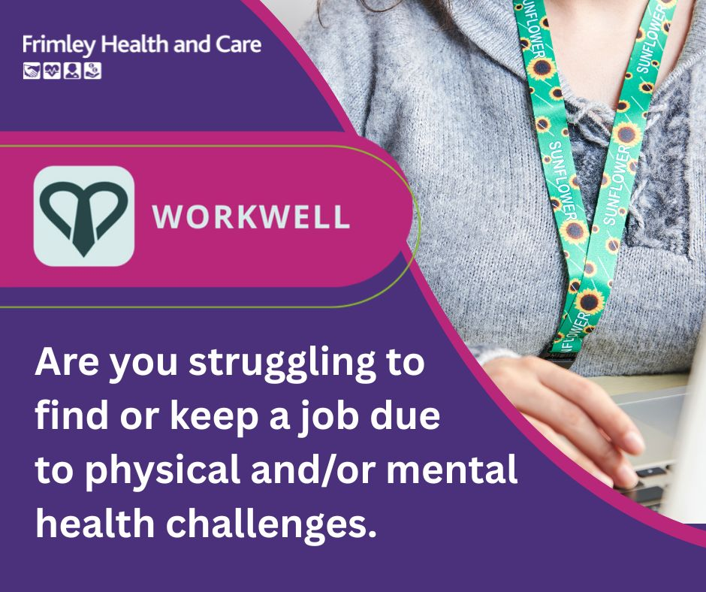
Instagram: Having trouble starting, staying, or returning to work due to a health condition or a disability?  WorkWell connects individuals with free, local, personalised employment and skills coaching that focuses on the barriers preventing people from starting, staying or returning to work.  Visit the WorkWell page on the Frimley Health and Care website for more information and eligibility in your area.  #WorkWellFrimley | 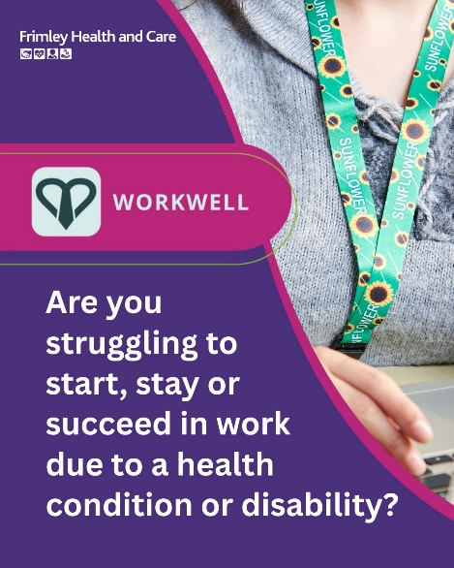
Facebook: Frimley Health and Care has launched a new, free Government-funded initiative to help people start, stay, and return to work.  WorkWell is currently available in Slough, North East Hampshire, Farnham, and Surrey Heath, and offers early intervention and light-touch support to individuals aged 16 and over.  WorkWell can help people get over facing health-related barriers to employment.  Click on the link to find out if you’re eligible and apply today www.frimleyhealthandcare.org.uk/your-health/workwell  #WorkWellFrimley | 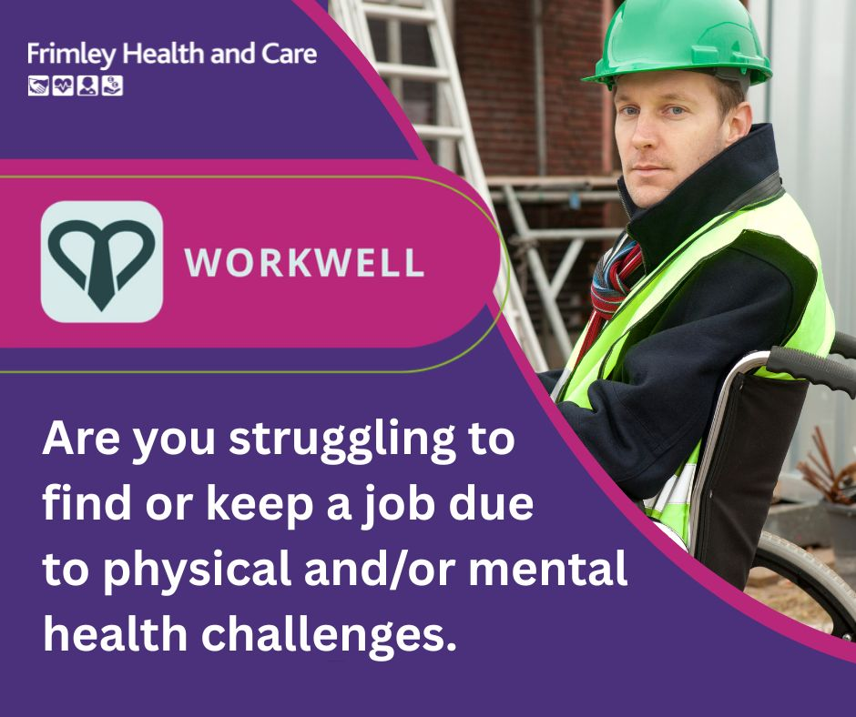
Facebook: WorkWell is a free Government-funded initiative to help people start, stay, and return to work.  WorkWell connects individuals with, local, personalised employment and skills coaching that focuses on the barriers preventing people from starting, staying or returning to work.  Currently available in Slough, Slough, North East Hampshire, Farnham, and Surrey Heath.  Visit the WorkWell page on the Frimley Health and Care website to find out if you’re eligible and apply today! www.frimleyhealthandcare.org.uk/your-health/workwell  #WorkWellFrimley | 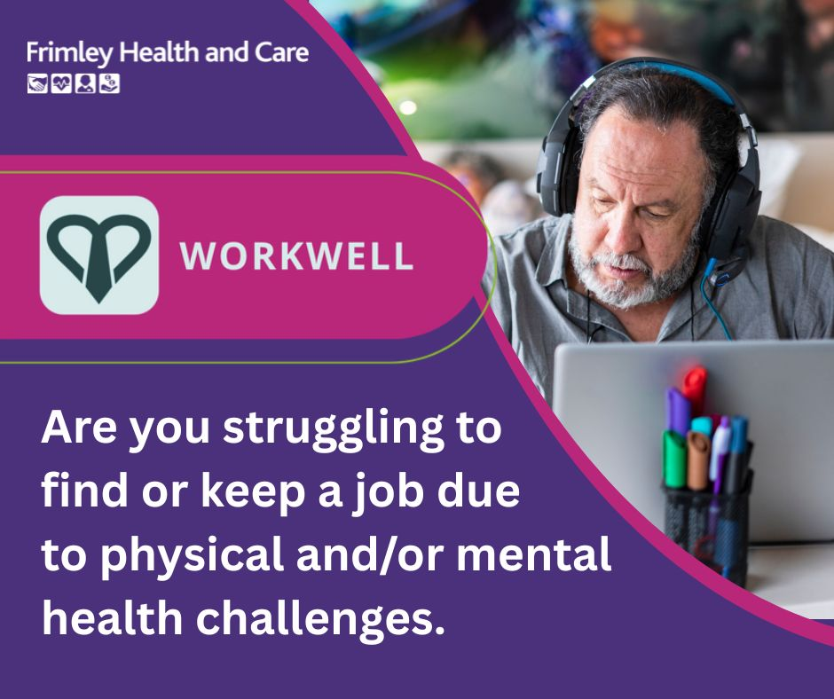
Facebook: Are health issues or a disability getting in the way of starting, staying or returning to work?  WorkWell is here to help. A new, free initiative available in Slough, North East Hampshire, Farnham, and Surrey Heath, WorkWell offers early intervention and light-touch support to individuals aged 16 and over.  Simply fill out a referral form and WorkWell will do the rest.  For more information on eligibility go to the Frimley Health and Care website www.frimleyhealthandcare.org.uk/your-health/workwell  #WorkWellFrimley | 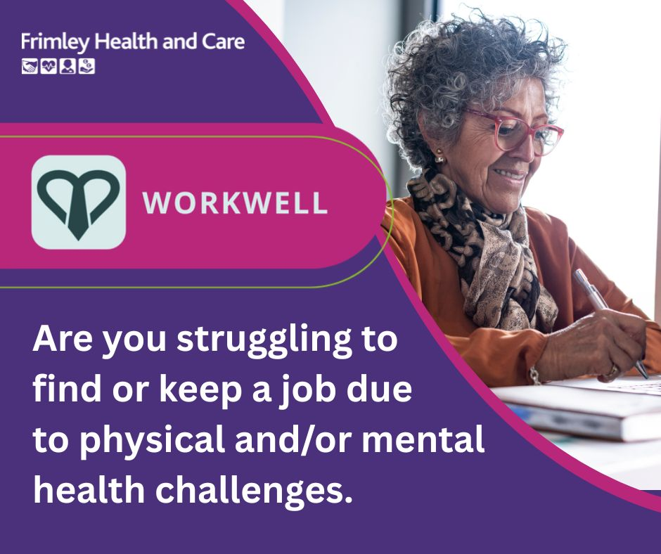
Instagram: WorkWell is a free Government-funded initiative to help people start, stay, and return to work.  WorkWell connects individuals with, local, personalised employment and skills coaching that focuses on the barriers preventing people from starting, staying or returning to work.  Currently available in Slough, Slough, North East Hampshire, Farnham, and Surrey Heath.  Visit the WorkWell page on the Frimley Health and Care website and simply fill out the referral form and WorkWell will do the rest.  #WorkWellFrimley | 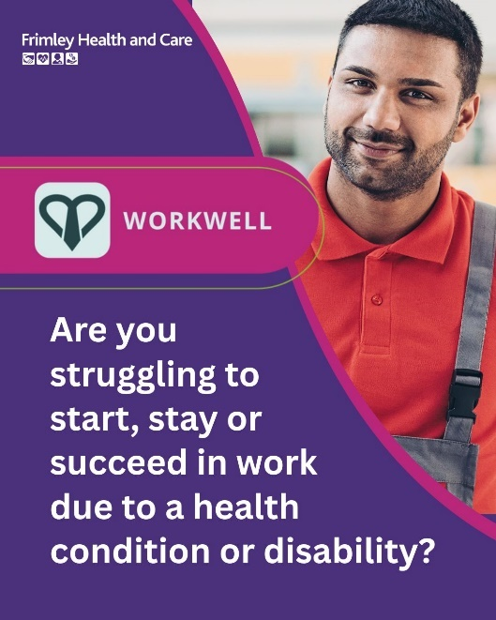
Instagram: Bored that a health condition or a disability is getting in the way of work?  If you are 16 years old or older and starting, staying, or returning to work is a problem, check out WorkWell today. Currently available in Slough, North East Hampshire, Farnham, and Surrey Heath.  Visit the WorkWell page on the Frimley Health and Care website to find out if you’re eligible.  #WorkWellFrimley | 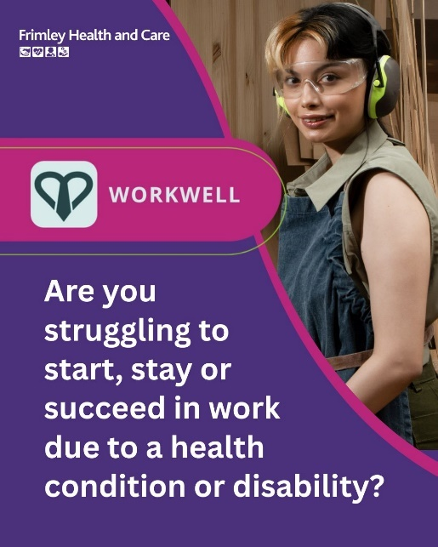
Instagram: Are you at risk of becoming unemployed because of mental health issues, musculoskeletal problems, or other health concerns?  Give WorkWell a try! Simply fill out the referral form, and WorkWell will do the rest.  Visit the WorkWell page on the Frimley Health and Care website to see if you’re eligible.  #WorkWellFrimley | 